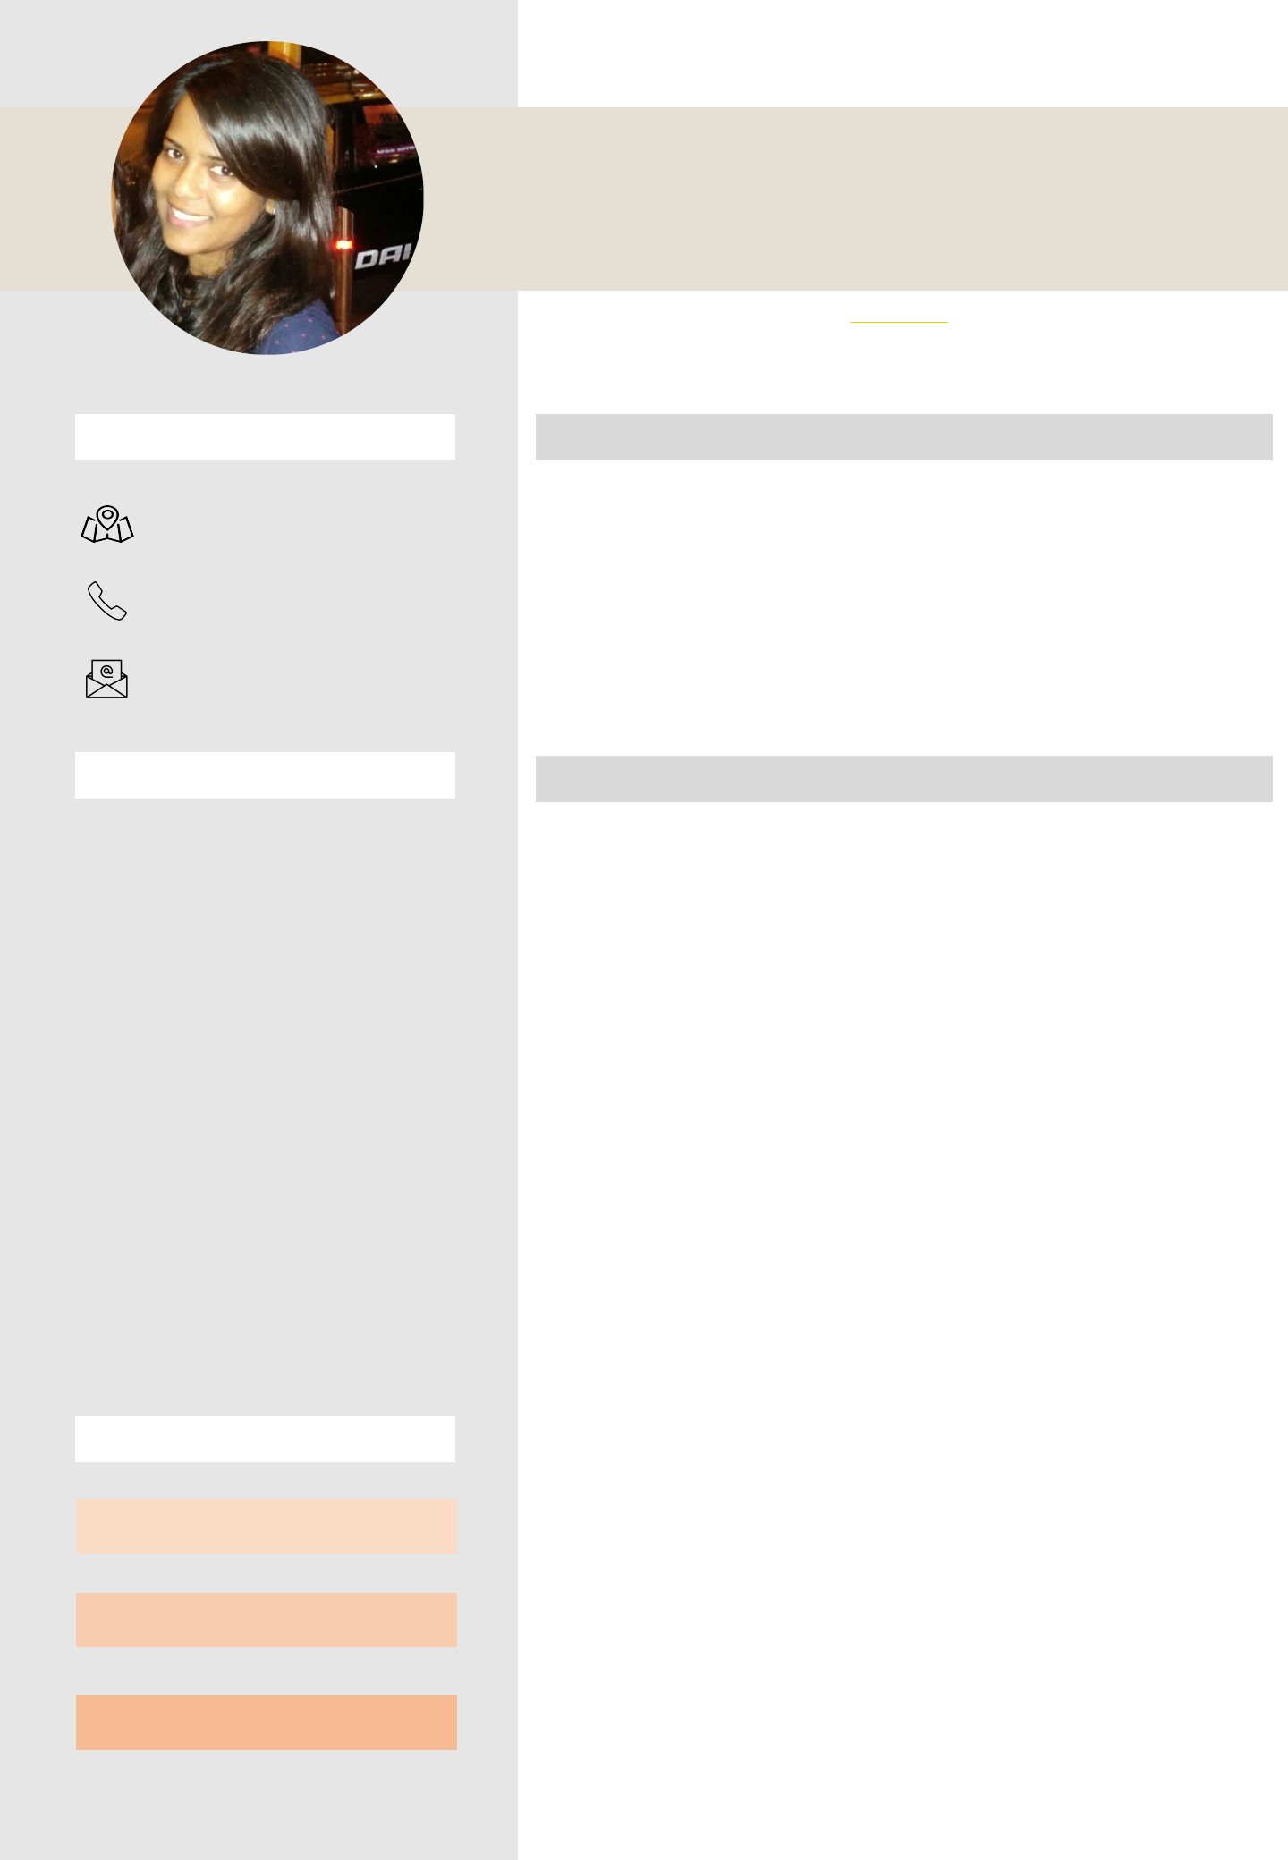
AALISHA KAMBLE

CONTACT

WADALA, MUMBAI

+91 9619 732 123

aalisha.kamble@gmail.com

EDUCATION

PG IN EVENT MANAGEMENT

EMDI Institute Of Media & Communication 2013 – 2014

BACHELORS IN MASS MEDIA (ADVERTISING)

Jai Hind College, Mumbai

2010 – 2013

JUNIOR COLLEGE (SCIENCE)

Jai Hind College, Mumbai

2008 – 2010

HIGH SCHOOL

Auxilium Convent High School, Mumbai 2008 Batch

EXPERTISE

PRESENTATION SKILLS

CLIENT COORDINATION &

COMMUNICATION

CREATIVE INPUT &
COORDINATION

PROFESSIONAL PROFILE

Efficient in making presentations and conceptualizing ideas and themes as per the brief by the client. I thrive to excel in the industry and contribute to the success of the organization I work for and gain experience from work.

EMPLOYMENT HISTORY

PENTAGON ACTIVATION & EVENTS

December 2018 – December 2020

Asst Manager – Client Servicing

DOME ENTERTAINMENT PVT LTD

June 2018 – October 2018

Manager – Client Servicing

BRANDWIDTH EVENTS

Feb 2016 – April 2018

Sr. Executive – Client Servicing.

NOTABLE EVENTS

1. Toyota Crysta Launch

Worked on the launch – a 4 city launch of the new car. Worked for the launch in Pune.
Helped organize the event – 2 parts – Press meet and Customer meet.

2. Transunion CIBIL events

Worked on multiple projects for Transunion.

- Was part of the Transunion Global Leadership Meet held in 2016 – 100 TU representatives from Chicago were flown to India for the event. A first of it’s kind event for TU.

- Executed and organized the Sales Meet for TU in 2018.

- Executed and organized the MSME Report Launch for Transunion CIBIL in 2018. A report launch in association with SIDBI with many a noted government officials as part of the guest list.

- Forbes India Conversations

Executed and organized the Forbes India Conversations in 2018 in association with CNBC and Network 18. A unique panel discussion forum focusing on the advantages of a sustainable environment and its effect on the economic growth of the country. To go along with the theme of the event, we constructed the entire event with recyclable materials like jute, canvas and coconut coir rope.


SKILLS

MS POWERPOINT CONTENT WRITING TEAM MANAGEMENT

CREATIVITY MS EXCEL

TRAITS

Strongly committed to assigned task

Reliable and responsible

Management skills

Capable and dedicated

Ability to complete work in given time frame Good communication skills

Ability to co – ordinate with team members

INTERESTS
- Interned at Viacom 18 in the Consumer Products and Licensing segment for 6 months as a Client Servicing and Business Development Executive.

- Worked on a web commercial for FlatChat with director Arjun Chatterjee, starring Purab Kohli, as a production assistant.

- Interned for 3 months at Salt Experiential and Management Pvt Ltd, Mumbai (August 2014 - November 2014) as a Client Servicing and Marketing executive.

- Worked part-time (3 months – April 2014 – July 2014) with WORDLOOM as a Workshop Coordinator and assistant to writer- director Tapobrati Das Samaddar.

- Worked with Percept for the Sunburn Arena – Dead Mau5 concert 2014 as a guest relation’s assistant at the box office.

- Worked with 70 EMG for Kala Ghoda Arts Festival 2014 in the Film department.

- Worked with Insperience for a wedding as hospitality volunteer.

- Worked with Procam for The Standard Chartered Marathon as a volunteer.

- Worked with Twisted Creations for the Enchanted Valley Carnival, Aamby Valley as hospitality volunteer.

- Worked with Events 999 for a wedding as a guest relations and hospitality executive.

- Interned for 2 months (September 2013 – October 2013) with The Indian Television Academy.

- Worked with Passion Recreated on the Mumbai Auditions of Dance India Dance.

- Worked with Stage Art Live for the 108th Annual Day of Bank Of India.

- Worked for an event as a food and beverage volunteer Event: Sankalp Pratisthan Worli Dahi Handi Utsav Organized by Shree Sankalp Pratisthan Sachin and Sangeeta Ahir Charitable Trust.

- Worked for 3 months as an intern at My Enshrine Pvt Ltd, an event and advertising company, as a junior marketing and operations executive.

