CURRICULUM VITAE

UMESH RAY
Present Address: Contact Detail:
2B BROJO KUMAR SETT LANE, Cell: +91-7278336394
JORABAGAN +033-25301828
KOLKATA E-mail: umeshray1994@gmail.com

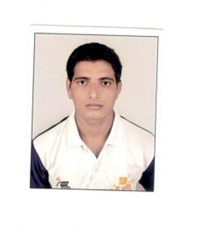

Career objective: To work In a challenging environment; contribute to the organization efficiently by leading from the front and to secure a growth-oriented position that will allow me to convert my academic knowledge to professional expertise.
Skill and Strengths:
        Hard working, Disciplined and Reliable
        Efficient Team Worker.
        Good communication skills
        To adopt with strenuous Environment
        Possess all the required leadership qualities
Work Experience:

(1) H.K.DAVE & ASSOCIATES (CHARTERED ACCOUNTANT) –
ADDRESS:- 285B, B.B.GANGULLY STREET, KOLKATA-700012
TENURE:- JULY 2014 TO MARCH 2020

Educational & Professional Qualifications:
S.No. | Examination | University | Year
1 | B.Com (General.) | Calcutta University | 2019
2 | Higher Secondary (10+2) | W.B.B.H.S.E | 2012
3 | Secondary Education(10th) | W.B.B.S.E | 2010

IT Skills:
Applications:
         Working on MS Office 2007
         Tally,Expert
        
        
Personal Information:
Languages Known:
        English
        Hindi
        Bengali
Extra Qualification:
1)State level Wrestler(kusti)2016 silver medal
2)State level Wrestler(kusti)2017 Gold medal
3)National Level Wrestler(kusti)2017
4)National level wrestler(participate) 2018
5)N.C.C B&C Certificate holder

Date of Birth: 12August, 1994
Nationality : Indian
Sex : Male
Marital Status : Unmarried
Family Information:
Father’s name : Sri Ashrafi Ray
   Mother’s name :Smt. Ramjhari Ray

Place: Kolkata

Date:19/06/2020__ UMESH RAY

