CURRICULAM-VITAE

Jayesh Vilas Mahajan  Mobile : 9579855181  E-mail : jayeshmahajan63@gmail.com  Passport No : R2933618  Address : C-308, Matru ami building,  Joshibaugh, kalyan (w). | 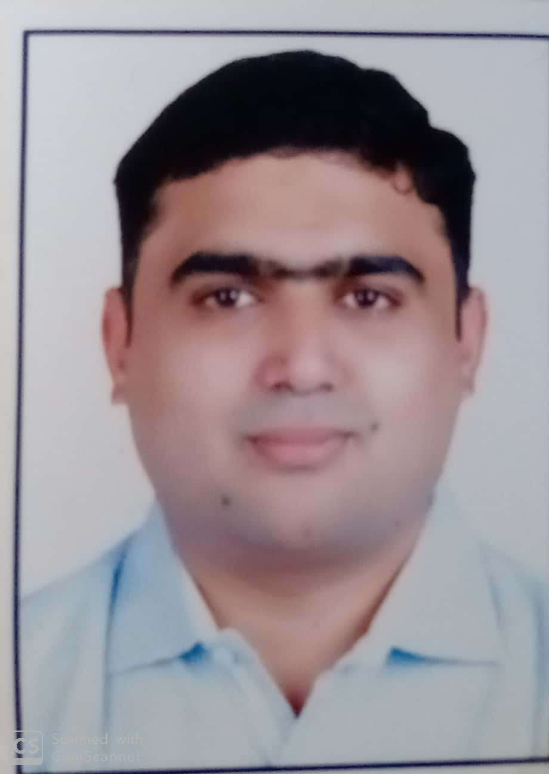

CAREER OBJECTIVE

I am looking for the great opportunity as a Purchase engineer that offers me challenging
assignment,professional development and career growth and having around 4 years experience in the field of inspection and expediting.
ACADEMICS

DEGREE | BOARD/UNIVERSITY | College | PERCENTAGE
M.B.A. (Operation) | Mumbai University | Welignkar College | First Class.
B.E MECHANICAL | Mumbai University | Yadavrao tasgaonkar college of Engineering & Management. | First Class.
H.S.C (Science) | State Board | K.M Agrawal college | Second Class
S.S.C | State Board | Shri Gajanan Vidyalay | First Class.

COURSES OF DESIGN:
- AUTOCAD 2D & 3D
- CREO 2.0
- Cad Fusion 360.

NDT COURSES:
- NDE LEVEL II – PENETRANT TESTING METHOD (PT)
- NDE LEVEL II – MAGNETIC PARTICLE TESTING METHOD (MPT)
- NDE LEVEL II – RADIOGRAPHIC FILM INTERPRETATION (RTFI)
- NDE LEVEL II – ULTARSONIC TESTING (UT)

Certification:
ISO 9001, 14001, 45001 Certified Internal auditor.

WORK EXPERENCE:

Company | Metito Pollution Control india Pvt ltd.
Period | May 2017 to Present
Designation | Engineer- QA & QC

Job Description:

- QA/QC Inspection of raw materials, Welding Inspection, NDT, Surface preparation & Painting, Pickling & Passivation inspection.
- Centrifugal pumps inspection (Witness FAT test, hydrotest, Dimensinal and visual check)
- Dosing Pumps inspetion (Witness FAT test, hydrotest, Dimensinal and visual check).
- Auto and Control Valves inspection Hydro test, FAT test.
- Air blower functional testing and Mechnaical runing testing at shop floor.
- Metallic Piping inspection at vendor shop and check orinetation of spool vs 3D view , prepare check list for orientation of spool vs 3D view excel sheet.
- Pressure vessel inspection – raw material identification, Dished inspection, fit up inspection, stage wise inspection, PMI testing of SS parts, Dimensional and visual inspection , Hydro test witness.
- Surface Prepartion and Rubber linining inspection at sub vendor place.
- Fittings and flanges inspection at vendor and sub vendor place.
- Fittings inspection (elbow, tee,stubend, couplings bellows).
- Set-up stage inspection, final dimension inspection, visual inspection of welds and report preparation.
- Inspection for bought out/subcontracted items such as Manual valves, Gates valves, Control valves, Ball valves, Butterfly valves.
- Inspection for RO Pressure tubes at vendor place..
- To ensure related activities are carried out in accordance with project specification & ITP.
- Witness & Carry out the NDT related activities.
- Hydro & Pneumatic of equipment witness inspection.
- Preparing project Quality plans, Inspection and test plans.
- Review of Vendors/sub vendors ITP & Procedure and material test certificates.
- Preparing Inspection requests and notifying the inspection witness stages to TPI/Client with documents packages, technical specification, data sheets etc. and maintaining records for completion.
- Conducting Pre Inspection Meeting, Weld procedure qualification tests, welder qualification tests, mechanical testing, Customer Specifications, ITP review and understanding.
- Preparing Inspection requests and notifying the inspection witness stages to TPI/Client with documents packages, technical specification, data sheets etc. and maintaining records for completion.
- Coordinating with project department and ensuring all related QC documents are available with vendors.
- Final Inspection release from TPI and maintaining Logs for the completion and pending orders.

Company | SYSCON ENGINEERS
Period | AUGUST 2016 TO MAY 2017
Designation | Production Engineer

Job Description:

- Preparing ITP, Weld Plan & Fabrication checklist.
- Carry out WPS, PQR & WPQ under Inspection Authority.
- Review of Material Test Certificate & Check Test Certificate of different types of material.
- Material identification of Pressure Parts & Non Pressure Parts.
- Incoming material inspection at shop level or at Vendor shop.
- Set-up stage inspection, final dimension inspection, visual inspection of welds and report preparation.
- To ensure related activities are carried out in accordance with project specification & ITP.
- Witness & Carry out the NDT related activities.
- Coordinating Third party inspection & Client (Like TUV, BVIS, IRS, NPCIL, EEE, IIB, Chempro).
- Inspection of Agitator assembly parts (Shafts, Housings, Lantern stools) after maching, Run-out check after assembling & Conducting load runing trail of agitator assembly.
- Preparing Final Documentation of job.
- Conducting Hydro & Pneumatic of equipments.
- Thermal treatment of material like pre heating, Stress reliving & post heat treatment witness.
- Various types of Heat exchnagers for M/s. ONGC- Under U certification (BVIL Inspection).
- LPG Mounted bullet tank- M/s. BASF- Under CCOE
- Ammonia Storage Tanks - for M/s. SEYA- under CCOE
- Various types of Reactors - for M/s. Biocon, Laxmi Organic, Godavari, Pidilite, Camphor & Allied.
- API Tanks- For M/s. Biocon, Lubrizol, Pidilite.
- Foam Modules – for Vimal fire, Fitech Equipments (Under U Stamp).
- Columns – for Dorf Ketal, Pidilite.

MAJOR PROJECT HANDLED :

Project | Customer/ Client | Company | Product
UNF | Mitshbhushi Heavy Industries. | Metito | WTP and WWTP
GAMA Rades | GPS trade ltd. | Metito | WTP , SWTP, EDI.
Bang Packong Combined Cycle | Black and veatch / EGAT | Metito | WTP and WWTP
JAWA | Samsung | Metito | WTP, WWTP
Ammonia Plant | Toyo. | Metito | RWTP, DM CPU, STP, Potable
LPG Mounted bullet tank | Kellogg’s | Syscon | Tanks.
Pressure vessel and Pipiing | Ion exchange | Syscon | Pressure Vessel and Piping.

PERSONAL DETAILS :

Name | : JAYESH VILAS MAHAJAN
Date of Birth | : 29th MARCH 1992
Permanent Address | : C-308 MATRU AMI BUILDING,NEAR NEW HIGH SCHOOL, JOSHIBAUGH, KALYAN(W).
Marital Status | : UN MARRIED
Nationality | : INDIAN
Language Known | : ENGLISH, HINDI & MARATHI

DECLARATION:

I hereby declare that all the above information is true to the best of my knowledge and belief.
Place:
Date: 30/07/2026 (JAYESH VILAS MAHAJAN)

