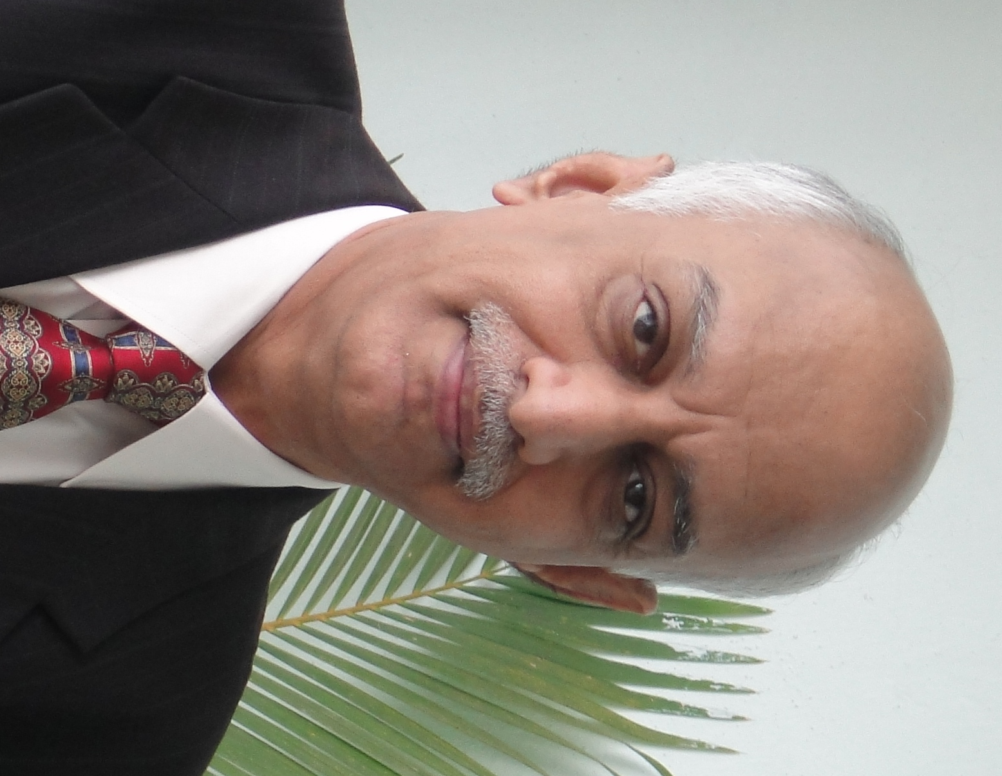
K.S. Ramachandran

Professional Qualifications

- Fellow Member of the Institute of Chartered Accountants of India
(Associate Member in 1978).

- Fellow Member of the Institute of Cost and Works Accountants of India
(Graduate Member in 1978).

Work Experience

More than 25 years of senior level corporate financial and accounting experience and the principal areas of work I have expertise, include:

- Corporate Finance, Accounting and Management & Internal Audit.
- Liaising with banks and financial institutions for obtaining various kinds of short and long term funds.
- Project Management.
- Financial Planning and Control.
- Costing Systems and Control.
- Managing Working Capital.
- Foreign exchange Management.
- Supervising and controlling financial accounting function.
- Management Information Systems and Reporting.
- Planning and managing tax.
- Coordinator for the SAP implementation.
- Sarbanes Oxley compliance and reporting.
- General Administration & HR.

The companies I have worked with are (present employment first):
- Presently as Vice President – Corporate Development in 3F Industries Limited, Chennai, from 1st April 2014.
- Financial Consultant from 1st February 2013 till 31st March 2014.

- Chief Financial Officer at Lookman Electroplast Industries Limited, Chennai from 2nd July 2012 till 31st January 2013.

- Financial Consultant from May 2010 till 30th June 2012 and have worked as Head of Finance & Accounts and also as Chief Financial Officer in Updater Services Private Limited, Forward Group of Companies and Secova eServices Limited from June 2007 till April 2010.

- Covansys (India) Private Limited, [formerly, Complete Business Solutions (India) Limited] effective May 1998 till May 2007, as GM – Finance & Accounts (through a transition from Computer Resources International India Pvt Ltd (Period of employment July 1997 till April 1998)

  - Entire gamut of finance and accounts including corporate financial accounting, investments, taxation, treasury, foreign exchange management, branch financials, management information and reporting, Sarbanes Oxley compliance, internal and statutory audits.

  - Critically looking at internal accounting procedures for improvement and operational efficiency.

  - SAP coordinator for the FICO module of SAP for the company, which went “live” successfully, on Oct 1, 2002.

  - Participated in the PCMM Level 5 certification, which was awarded to the company in December 2002.

  - Project Manager for the Sarbanes Oxley Section 404, US reporting requirements with effect from year 2004.

- Maxworth Group, Chennai, India, as General Manager, Management Audit, from April 1996 till 30th June 1997. The job involved continuous operational and financial audits of the group companies, Maxworth Orchards (India) Limited, Maxworth Orchards International Limited and Maxworth Green Harvest Limited.

- Rich Stones (India) Limited, Chennai, India, as General Manager - Finance and Administration from June 1995 till April 1996. The job was mainly on project management, corporate finance and accounting, costing, management reporting, working capital management, tax planning and management, public issue management and general administration.

- Overseas contractual assignments in Lagos, Nigeria, from June 1988 till April 1995 – (Financial Controller from June 1988 to November 1989 in John Edge & Company (Nigeria) Limited, Financial Controller from November 1989 to December 1992 in Amarilo Industries Limited and Group Financial Controller from January 1993 to 30th April 1995 in Alchem Group of Companies)

- Wiltech India Limited, Bangalore, India, as Chief Accountant, from March 1983 to June 1988. The job principally involved management and supervision of the financial and cost accounting functions, management information systems, tax planning and management etc.

- Aurangabad Paper Mills Limited, Mumbai, India, as Financial Controller from August 1980 to March 1983. The job involved extensive liaising with the All India Financial Institutions and Banks for project and working capital finance respectively, besides supervising and controlling the financial and cost accounting functions.

Date of Birth : 1st June 1952 | Passport Details: K 0351297 dated 6th February 2012 valid till 5th February 2022, issued at Chennai, India.

Academic Qualifications

- Bachelor of Science (1970 -72) from St. Xavier’s College, Calcutta University, Calcutta, India.
- Pre- University Science (1968 -69) from St. Xavier’s College, Calcutta University, Calcutta, India.
- School Final (1958 - 67) from National High School, West Bengal Board of Secondary Education, Calcutta, India.

Family details

1st Son - Praveen Bharatwaj (Date of Birth: 11th August 1983)
“Voice Over” artist and is also involved in English plays. Working in Bally Technologies Private Limited, as Technical Trainer, with effect from May 2014.

2nd Son - Pradeep Bharadhwaj (Date of Birth: 24th September 1991)
Employed in Deloitte, Hyderabad as Audit Assistant since August 2013 and pursuing CPA.

Significant Professional Achievements…

- SAP Coordinator for the SAP implementation in Covansys (India) Private Limited, Chennai on 1st October 2002 for FICO module and also Fixed Assets and Material Management modules in subsequent years.

- Successfully completed SOX audits (US reporting requirement) in Covansys (India) Private Limited.

- Involved in PCMM Level 5 certification for Covansys (India) Private Limited in December 2002.

- Successfully set up various financial policies and procedures for Covansys (India) Private Limited, including process work flows, establishing automated controls for control efficiencies and effectiveness in the SAP accounting system etc.

Successfully obtained long term funds from the All India Financial Institutions (ICICI, IDBI, IFCI and SICOM) and also working capital funds from Bank of Maharashtra, for the Rs 11 Crore Kraft Paper project of Aurangabad Paper Mills Limited, plant being situated in Aurangabad and registered office at Mumbai. Subsequently, obtained approval for rescheduling of loans when the company was in the “take-off” stage.

- Successfully set up the Accounts Department in Wiltech India Limited, Bangalore, duly installing systems and procedures, with efficient internal controls and meaningful management information systems.

- Successfully set up the Sodium Silicate and Air Freshener Plants, in Alchem Group of Companies, Lagos, Nigeria, within the targeted time schedule, which are presently operating with optimum efficiency, in terms of capacity utilization and productivity.

- Successfully obtained foreign exchange for the companies I had worked in Nigeria. Since almost all the companies in Nigeria depend on timely procurement of foreign exchange and Nigeria predominantly has an import-based economy, this is an important activity for the very success and survival of Companies.

- Developed interpersonal skills in dealing with employees, their problems and generally keeping the morale of employees in high esteem.

________________

