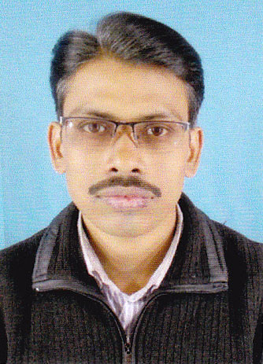
CURRICULUM VITAE

DEBABRATA GOLDER
Vill.- Radhagobinda Pally
P.O.+P.S.- Sonarpur, Kolkata – 150
West Bengal, India, Ph-9163220885
E- Mail.- sdgolders@gmail.com

Objective | - To seek a challenging and dynamic assignment in an organization that offers learning opportunities and professional growth while being resourceful in achieving a steady career.
Educational Qualification | - Passed Madhyamik exam under W.B.B.S.E. (Year 1998)  - Passed Higher Secondary exam, under W.B.C.H.S.E. (Year 2000)
Professional Qualification | - Air-Condition & Refrigeration Certificate Course in 1st Class with 75.45% marks from I.T.I. in the year of 2000.  - Computer Application. Year 2001  - Dos+Windows98+MS Office (Word, Excel, Access, PowerPoint)  - Internet Access  - (Completed) 1 year Computer Diploma Course .  - MS Office (Word, Excel, PowerPoint) Photo Editing and Multimedia.  - Internet Access
Personal Details | - Father’s Name : Sudhanshu Sekhar Golder  - Date of Birth : 5th January. 1982  - Nationality : Indian.  - Passport No. : G7464479  - Phone No. : 00919163220885
Experience | - I have been working Computer D.T.P. job in 2002 to 2004 COMPUTER WIZARD, Sonarpur Bazar, Sonarpur, Kolkata-150,  - HUTCH / VODAFONE EASER LTD. post paid connections verification  for 2004 to 2010. as a supervisor at (SMA Agency)  - I have been working Computer D.T.P., Chaln, Billing, Operator & hade of the Management Section, 4 year - as a Supervisor at SONARMAYA PVT.LTD.  - I have been working Computer job last 4 years COMPUTER  World, Sonarpur Bazar, Sonarpur, Kolkata-150,

Declaration

I do hereby declare that all information furnished by me are true and correct to the best of my knowledge and belief.

Place: Sonarpur Debabrata Golder
Date : 23/02/2020 Signature

