Resume of **Swadhin Kumar Sabat** 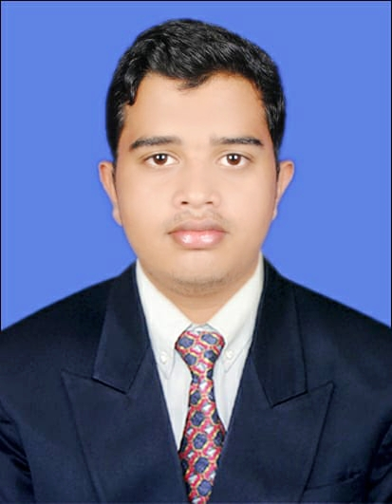

**Personal Details:**

Name: Swadhin Kumar Sabat

D.O.B: 03/08/1997

Mobile: (+91)8984332313

Email: [swadhinsabat1997@gmail.com](mailto:swadhinsabat1997@gmail.com)

**Objectives:**

With my amiable, caring and friendly nature and dedicated attitude, I would like to earn my special position in the service sector.

**Educational Details:**

|  |  |  |  |  |
| --- | --- | --- | --- | --- |
| **CERTIFICATE/**  **DEGREE** | **BOARD/**  **UNIVERSITY** | **INSTITUTION NAME** | **YEAR OF PASSING** | **% OF MARK** |
| **10TH** | **BSE** | **Saraswati sishu Vidya mandir,Jeypore** | **2013** | **56.70** |
| **+2 SCIENCE** | **CHSE** | **Vidwan’s Institute Of Basic Studies** | **2015** | **48%** |
| **Diploma course in aviation , hospitality, travel and Customer service.** | **Frankfinn Institute,KOLKATA** | **Frankfinn Institute Of Air hostess Training center** | **2016** | **COMPLETE** |

**Other Qualification:**

* Diploma in Computer Application (DCA), **At-NICET Jeypore, Dist.-Koraput, Odisha.**

**EXPERIENCE:**

* **DISH TV (SERVICE AND SALES) JOIN Dtd. 01.02.2016 TO 04.06.2017**
* **RELATIONSHIP MANAGER AT NEXA FROM Dtd. 06.07.2017 To 22.12.2019**
* **SALES CONSULTANT AT TRUPTI FORD FROM 06.03.2020 To TILL DATE**

**SKILLS :**

* Excellent oral and written skills in English.
* Excellent working knowledge in Microsoft Word, Microsoft Excel, Microsoft PowerPoint.
* Good communication skill.
* Good marketing skills.
* Creativity.
* Leadership.

**LANGUAGEKNOWN :**

* ODIA, English and Hindi.

**PERSONAL DETAILS:**

* **Date of Birth: 03 August** **1997**
* **Gender:** Male
* **Marital Status**: Single
* **Father’s Name :** Prasad Chandra Sabat
* **Category:** General
* **Permanent Address:** Bhupati Street Jeypore,
* **State:** ODISHA
* **Pin-**764001
* **Declaration:** I hereby declare that the above written particulars are true to the best of my knowledge and belief.In case any of particulars furnished by me are found to be false at any stage my candidature is liable to be summarily rejected.
* **Date**:
* **Place:**