**Resume**

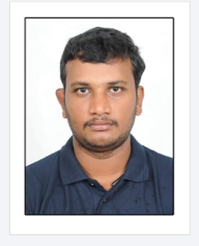

**C. Poorna Chandra**

Keelapatlla,Keelapatlla,

Palamaner, Chittoor (Dt).

Andhra pradesh-517408.

Mobile - +91-9600113602

Email – **poornachandra1619@gmail.com**

**Summary**

* A professional with over-all 10 years of experience in Assembly department , seeking challenging employment that will utilize my educational, professional and communicational skills in the field of Automobile to grow with the company.

**Professional Experience**

**Kia Motors India Private Limited, Andhra Pradesh (Green field project).**

Designation: Engineer – Aug, 2019 to till date.

**Roles and Responsibility:**

**Vehicle assembly**

* Identify issues in efficiency and suggest improvements.
* Maintains safe and clean work environment by educating and directing personnel on the use of all control points, equipment, and resources.
* Conducting daily Quality review meeting with internal shops on internal defects.
* Ensuring parts availability status on daily basis with internal departments for smooth production flow.
* Ensuring Work place 5s, 3c and safety environment.
* Ensure adherence to safety practices to achieve zero accident, zero near miss incidents.
* Training provided on importance of safety & critical process to new members.
* Monitoring and implementation of tools & equipment for main line production.
* Taking Care of main line manpower job allocation.
* Coordinator for new model trail run in mail line.
* Line balancing, OTS preparation & modification as per the line capacity.
* Monitoring and improving the FTTQ.
* Monitoring and verifying the online rework.
* APS checking and verification.
* Making Hourly job rotation plan.
* Monitoring equipment status on daily basis.
* Preparing spare Tools list for main line run.
* Counter measure preparation.
* Providing training to new manpower regarding part assembly.
* Evaluation of trainees on weekly basis to improve their skill level.
* Raising concern on daily basis during trial run and asking for corrective action plan to responsible team.
* Coordinator with IR and GA team to resolve member’s issues.
* Main line layout preparation by utilizing 4M.
* Ensuring manpower motivation by engaging them in new activities.
* Implementation of member’s effective suggestions on kaizen.
* Coordinator for new members training.

**Achievements:**

* Overseas training Kia Motors Slovakia (Europe – 12days )
* Completed Advance Pilot project for SP2I Model on overseas for 12 days (South Korea).
* Successfully done QY Proto build project in overseas for 12 days (South Korea).
* Successfully completed QY P1 Stage vehicle build 8 days (South Korea)

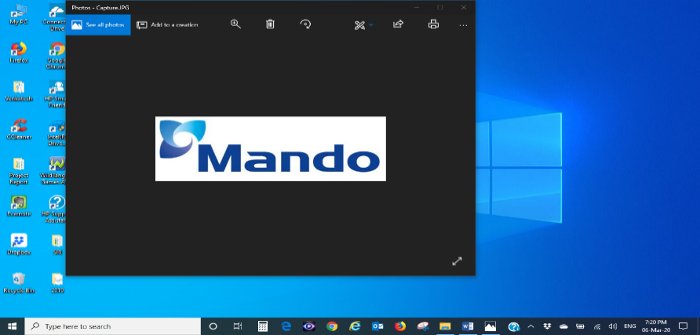**Mando Automotive India Private Limited, Chennai.**

Designation: Engineer – May, 2010 ~ Aug, 2019.As a shift in charge overall Company

**COMPANY PROFILE:**

Mando Automotive India Private Limited, Chennai is a JV company of Mando Cooperation Korea and Anand Automotive India, is a leading manufacturer and supplier of advanced, high performance Brake systems, suspension (Strut & shock absorber) and steering Systems in the country.

**Roles and Responsibility:**

Working as a shift incharge & focusing on

* Organizes production schedules.
* Achieving production targets as per customer schedule in a systematic Way and coordination with support departments (Purchase, QC, and PPC ect).
* Implementation of poka-yokes in assembly lines.
* More focus on production improvement & Waste Reduction
* Monitoring the O.Es Performance & providing training to employees
* Implementation and Monitoring of 5s & 3c Activities.
* Rejection analysis & Preparation/Implementation of Contaminant & permanent actions   
  (Counter Measures).
* More focus on production improvement & Waste Reduction
* Implement the Kaizens , Rejection reduction & cost saving projects
* Trouble shooting (Robots & Servo controllers)
* Manpower planning, production planning and work allegation.
* Efficiency Monitoring – OEE
* Monthly internal PPM cause analysis monitoring.
* Implement the SMED system to reduce the process change over time.
* Focusing on continual improvement of process and products through PDCA Cycle.

**Achievements:**

Successfully lead and coordinated team for the new projects from Gate reviews to SOP for the below following customers.

* Hyundai
* TATA
* M&M

**Professional training at South Korea**

* Advanced APQP process training in iPCS (Integrated Product, Process, Project system) at **Russia – 1 Months**

**Educational Qualifications**

* BACHELOR IN MECHANICAL ENGINEERING (B E) with 70 % in the year 2016.
* DIPLOMA IN MECHANICAL ENGINEERING in Govt. polytechnic college Nellore with 64.5 % in the year 2010.
* SSC in Govt. School Nellore with 74 % in the year 2007.

**Personal Strength**

* Quick adaptability, Self-Starter and Team Player, and Smart working.
* Adequate knowledge in automotive components.
* Sincerity and committed, Results by Planned approach and logical thinking.
* Good communication skills.

**Personal Details**

Name : C. Poorna Chandra

Father’s Name : C, Ananada

Permanent address : Dno: 20/6,

Ganagavaram , Palamaner , Chittoor – 517408

Date of Birth : 03th Mar 1992

Marital Status : Married

Languages Known : English, Telugu, Tamil, and Hindi

Nationality : Indian

**Declaration**

Note: The above information for your kind perusal is correct to the best of my knowledge.

Date:

Place: C. Poorna Chandra.