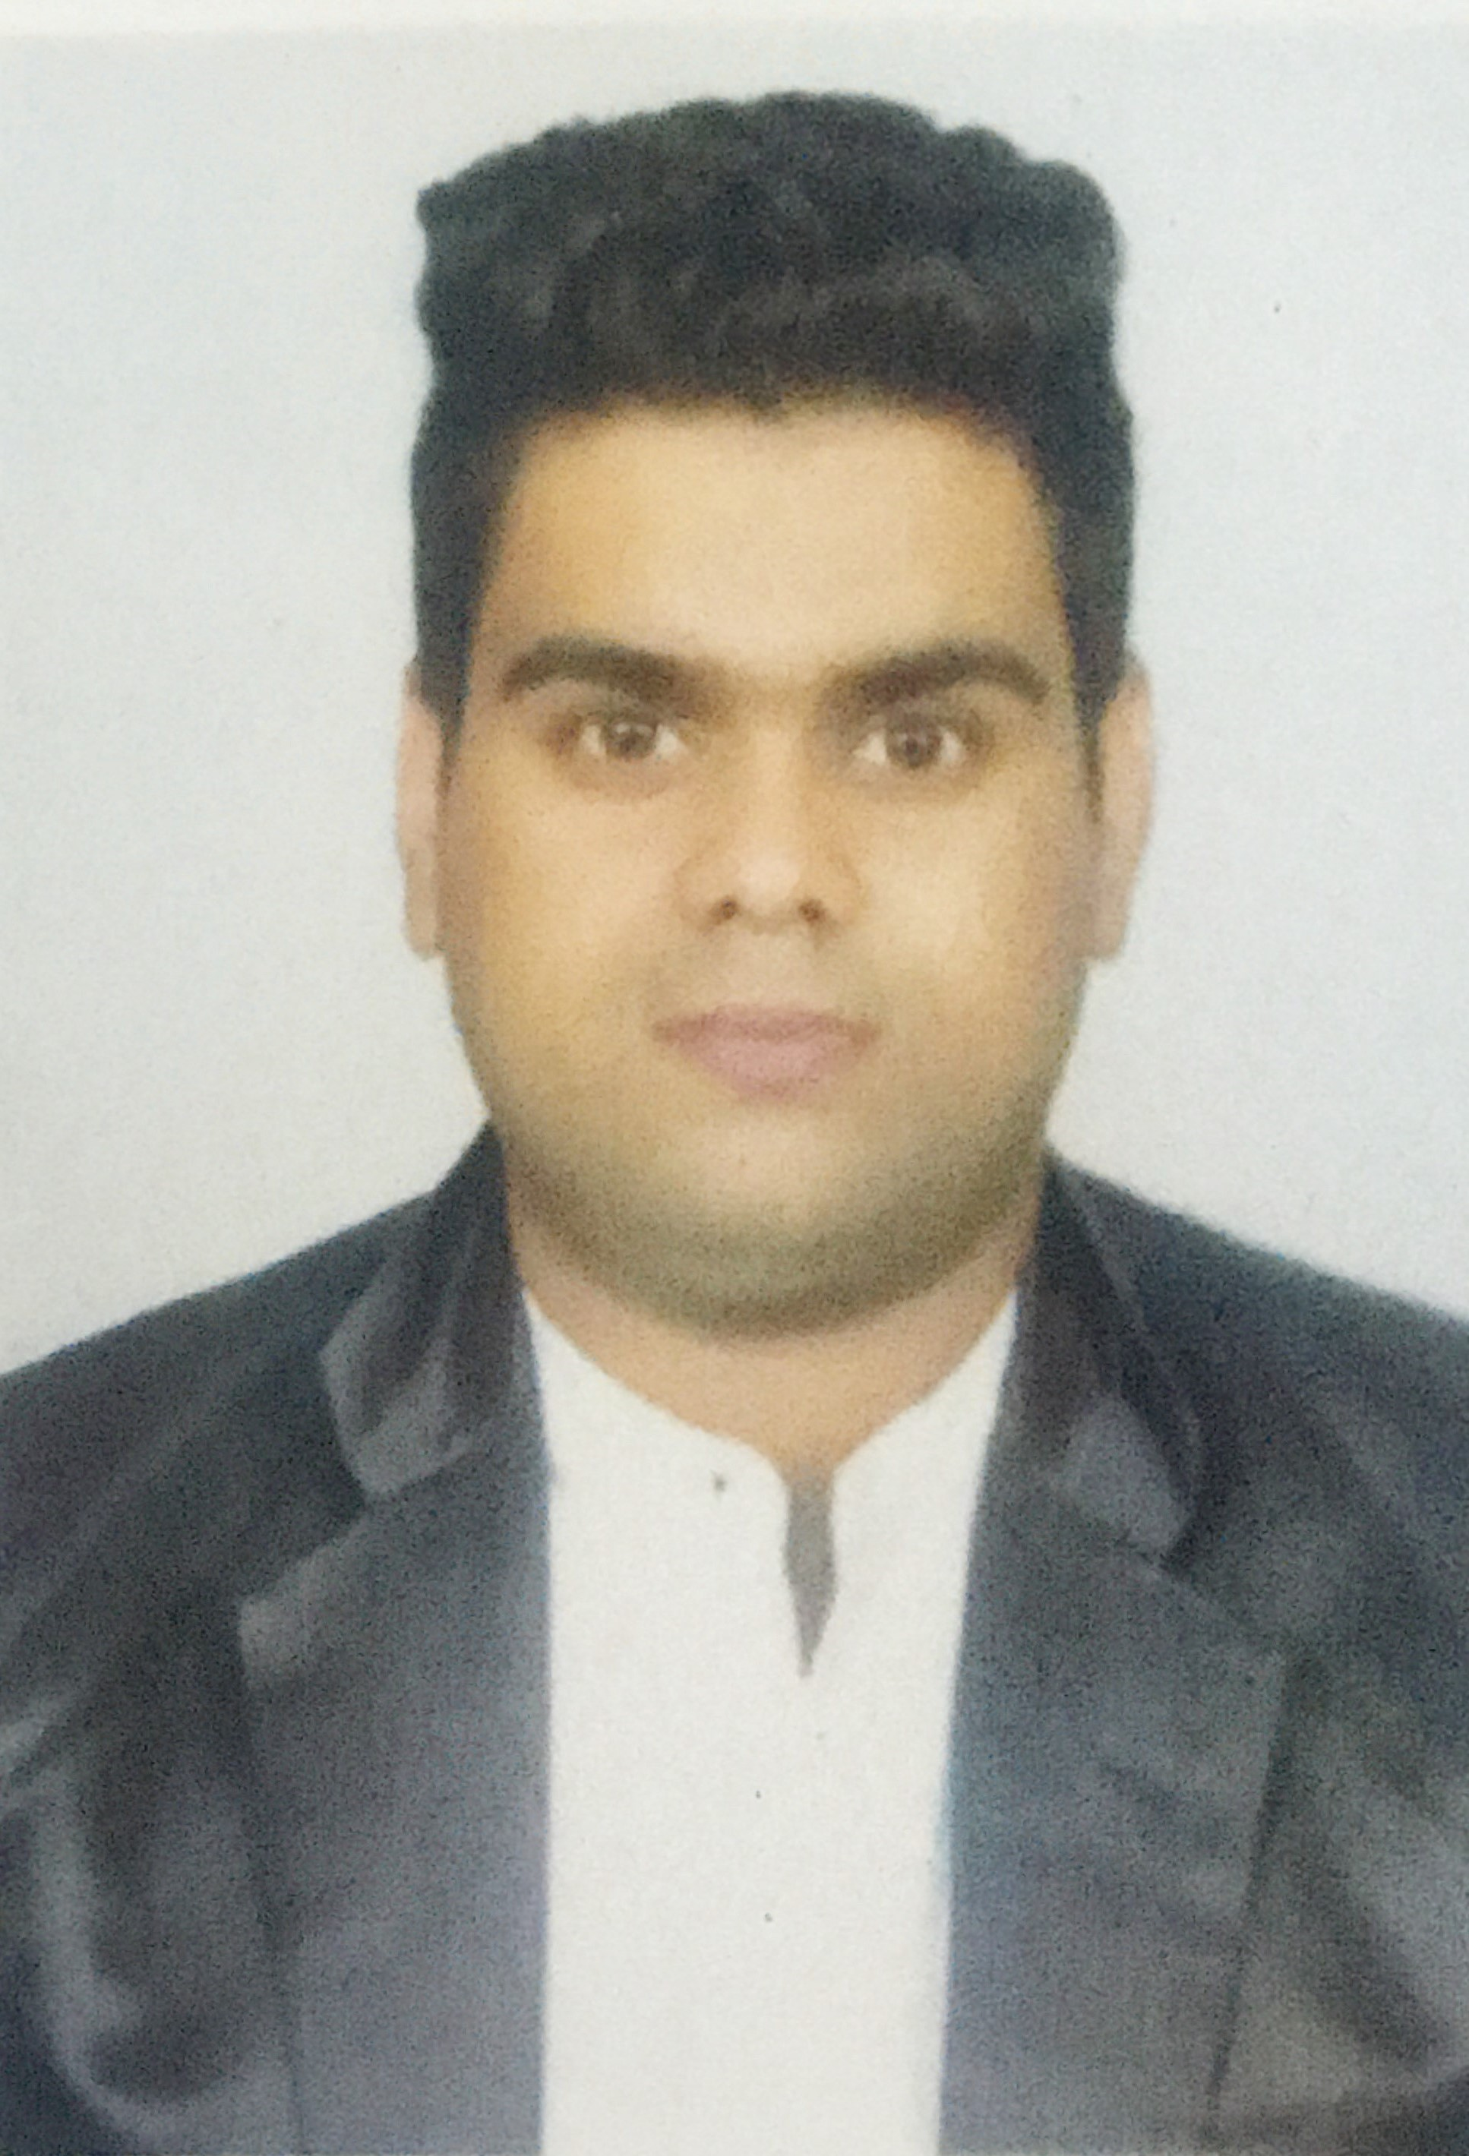

RAVI GANGWAL
gangwalravi5@gmail.com

OBJECTIVE
To enhance my capabilities and qualification so that I have the opportunity to prove myself as a competent employee.

EDUCATION

Year | Degree | Board/University
2019 | MSc-IT | MDSU
2014 | BCA | MDSU
2011 | 12th | RBSE
2009 | 10th | RBSE

WORKSHOP / SEMINAR ATTENDED
- Two Days workshop on Personality Development by Mr. Himanshu Buche.
- “I CAN I WILL” Seminar for Skill Development.

PROJECT DETAILS

Desk Projects:

Title:- Hospital Management system
Front End: - Visual Basic 6.0 Back End: - Microsoft Access
During: - BCA 3rd year Team Size: -3
Description: - The Hospital Management System is designed to store information of doctor, patients and staff member of hospital. It also stores the treatment details of patients. It calculates the bill for the patients. It shows the some reports like: collection report, patients Admission Report, Staff Reports and Ward Room Details Reports.

Title :- Restaurant Management System

Front End: - VB.NET Back End: - MS SQL Server 2008
During: - MSCIT Final Team Size: -1
Description: - Restaurant Management System is designed to automate common function like Kitchen order Ticket (KOT), Parcel, Table Booking, Billing, and Inventory& Sales Report.

WORK EXPERIENCE
Concat Solution, Ajmer, Rajasthan Nov 2017 – Mar 2020
Team Size: 7
Technology: HTML, CSS, Bootstrap

Nature of Clients: Worked for Railway Projects (DRM) as well as Private Company Projects.

HOBBIES & INTERESTS
- Adventure Sports
- Playing Games
- Listening to Music

PERSONAL INFORMATION
Date of Birth: Oct 02, 1992
Contact Number: 7568351110

REFERENCE for RAVI GANGWAL

Shantanu Singh Rao
Senior Associate
Tech Mahindra Company
Noida,Delhi
Shantanurao@gmail.com
8905098652
Shantanu Singh Rao is the managing director in my previous company.

Islam Ahmed
RIE (NCERT)
Ajmer
islamrie@gmail.com
9413039561

Ravi Gangwal
