CURRICULUM VITAE

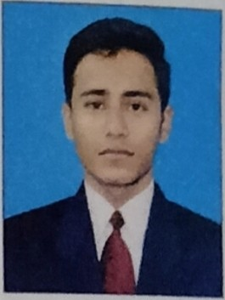
Roshan Shaha
Murgnsol S P.MukherJee Road Near Gopal Ghosh Kali Mandir P 0- Ushagram, P S- Asansol (South)
Dist Pasch1m Bardhaman, (W B ) Pin - 713303

Contact No +91 7583935712
Email ad- roshanshaha 123@grna1l.corn

OBJECTIVE

To apply my knowledge and ab1l1ty to produce opt1m1zed results 1n JOb entrusted and to work with a team so that team as well as my personal goals can be achieved

b CADEMIC QUALIFI CATION:

EXAM
!
GRADUATION

BOARD
IGNOU

YEAR OF PASSING
l / PP

POSITIVE QUALITIES -

Pos1t1ve attitude, Extrovert Nature, Strong Commitment towards task-undertak en good Communication skills

EXTRA QUALIFICATION -
, Basic knowledge in Computer.

PERSONAL BRIEF

Father's Name Date of Birth Nat1onal1ty Rcl191on Gender
Marital Status Strength Language Known
Amar Deep Shaha
. 26 02 1997
·Indian H111du1sm Male
- Unmarried
Honesty
: Hindi, English & Bengali

Working Experience

futor 1lo 8 class 3 years All Sub1ccls

DECLARATION

I hereby declare that above-mentioned 1nforrnal1on 1s correct <:lnd up to date according to be ::>l of my knowledge.

Place Asansol Dc1tc••.•..•••.•.•.•.•

Signature

