CURRICULUM VITAE
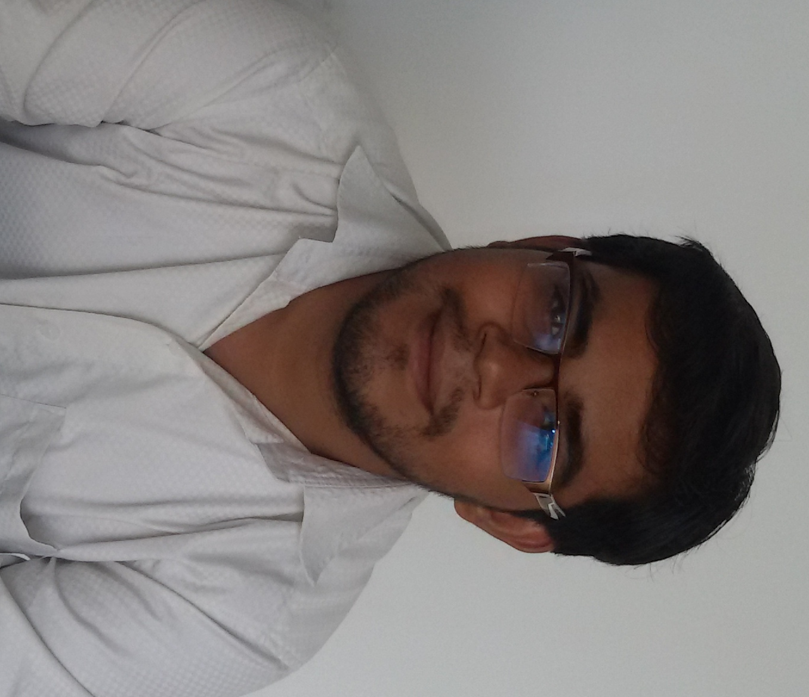
Ghanshyam M.Jadav
(DIPLOMA-MECHANICAL)
E-mail : jadavghanshym07@gmail.com
Contact : +91 9537834904
: +91 9723055922

CAREER OBJECTIVE
To do the job assigned to me with my almost sincerely and to use my skills and abilities effectively resulting in the growth of my company and me.

ACADEMIC QUALIFICATION

Examination passed | Institute | University | Year of passing | Percentage
DIPLOMA Mechanical | A.Y.Dadabhai Technical Institute,Kosamba | G.T.U. Ahmedabad. | Jun-2017 | 8.24 CGPA (UPTO-6THSEM)
I.T.I Draughtsman Mechanical | I.T.I. Ankleshwar | N.C.V.T., Gandhinagar | July-2012 | 70.63%
SSC | R.S.Dalal School, Bharuch | G.S.E.B.,Gandhinagar. | March-2008 | 50.62%
job | ABC BEARING  BHARUCH | PRODUCTION  ENGINEEAR | EXPIRIENCE  1 YEAR 5 MONTH

ABC BEARING: I HAVE A KIZEN THIS COMPNY TO MAKE ROLLER GREADING MACHINE FULL AUTO MASION MACHIN

ACADAMIC ACTIVITIES

- Diploma Engineering from Gujarat Technological University Ahmedabad.
- Specialization: Mechanical Engineering.
- Vocational Training:
I have completed an industrial training of two weeks duration at ABC Bering LTD, Dist. Bharuch. The training helped to get an insight into working of a company.
- Diploma Project:
- “Subcooling System in Refrigeration System.”

COMPUTER PROFICIENCY
- Microsoft Office.

STRENGTHS
- Positive Thinking Attitude
- Hard Working Nature
- Adaptable to Changing Environment
- Self Motivation at times needed

OTHER ACCOLADES

- Event organizer in all school and college functions and other technical event.
- Donated blood in donation camps at college level.

PERSONAL INFORMATION
Name : Ghanshyam.M.Jadav
Date of Birth : 24,12, 1992
Gender : Male
Marital Status : Single/Unmarried
Nationality : Indian
Present Address : 2428 Ayodhya Nagar Link Road
Behind Santoshi Mata Temple
Bharuch- 392001
Dist.: Bharuch (Gujarat)
Linguistic Abilities : English, Hindi&Gujarati.
Hobbies & Interests : Reading Books, Net surfing, Listening Music
Key Skill : An effective communicator with excellent relationship building & interpersonal skills. Strong analytical, problem solving & organizational abilities. Possess a flexible & detail-oriented attitude. Good Commutation Skill with Increase Relationship,GoodInterpersonalRelationship,Basic knowledge of computer.

DECLARATION

I hereby declare that the above information is true to the best of my knowledge and belief.
Place:- Bharuch
Date:- / /

Ghanshyam M.Jadav

