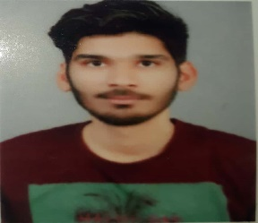**FAIZAN ALI**

# **Address:** 215/4,SOMWARIPETH

# **NAGPUR-**440009

**Mobile no: +**91 7083369950

**Email: fa6092330@gmail.com**

## Objective

To secure a challenging position where I can effectively contribute my technical, management and leadership skills in an Organisation, where there is a scope for professional growth while being resourceful, innovative and flexible.

## Educational Qualifications:

|  |  |  |  |  |
| --- | --- | --- | --- | --- |
| Examination | Year of Passing | School/College | Board/University | Percentage |
| B.E (Mechanical Engg) | 2020 | Anjuman College of  Engg and Technology,  Nagpur | Rashtrasant Tukadoji Maharaj Nagpur University | 62% |
| DIPLOMA  (Automobile Engg) | 2017 | Government Polytechnic, Nagpur | Government Autonomous | 79.20% |
| SSC | 2014 | R.S.Mundle English School,Nagpur | Maharashtra State Board | 89.20% |

**Project:**

1. Title: Performance Improvement Of Evaporative Cooler

This project is experiment based in which different types of material are used along with combining different arrangement of water supply to increase the efficiency of evaporative cooler.

## Extra-Curricular Activities:

* Passed the ‘A’ certificate examination of NCC with A grade under the authority of Ministry of Defence, Government of India.(2013)
* Participated in State Level Judo competition.(2010) (2011) (2012)

## Personal profile: Date of birth (DD/MM/YY): 06/01/1998

**Gender:** Male

**Father’s name:** AshfaqueAli Sayyad

**Mother’s name:** Mrs. Qudsiya

**Linguistic Abilities:** English, Hindi, Marathi

## Declaration

I hereby declare that above furnished details are true to the best of my knowledge and belief.

## Date: 10/02/2020

**Place: Nagpur ( Faizan Ali )**