Prakash Devisingh Bisht
Contact No: 7738414884  Permanent Address: Mumbai  Email: bishtp623@gmail.com | Personal Details  Father’s Name: Devisingh Bisht  Date of Birth: June 09, 1995  Gender: Male  Nationality: Indian  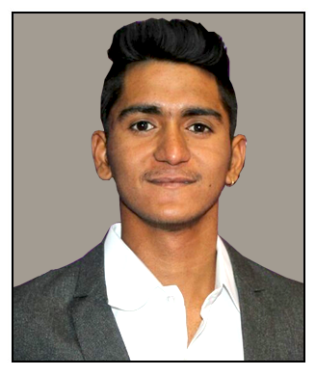  Marital Status: Single

EDUCATION | SKILLS
Masters of Business Administration  D. Y. Patil University  2018-2019 (Full Time)  Courses  - Finance | MS Office  Teamwork  Basic Excel  Leadership
Bachelors of Commerce  Mumbai University  2013-2016 (Regular)  Courses  - Commerce | Competencies  - MS-CIT  - Having hands on working knowledge with SAP FICO MODULES and Microsoft Office
XII Standard  Hume High School Mumbai  2012-2013  Courses  - Commerce | Extra Curricular Actitives With Group  - Started small buiness with less effort maximum profits
X Standard  Central Railway Employees High School Parel  2010-2011 | Languages  - English ✓ ✓ ✓ ✓   - Hindi ✓ ✓ ✓ ✓  - Marathi ✓ ✓ ✓   - Kumaoni ✓ ✓ ✓ 
Work Experiences  ICICI Bank  (Mar 2020 to Till Date)  AS Assistant manager  The job responsibilities include:  - Understand their protection and investment needs  - Identify and recommend solutions that fits their requirements the best  - Offer the prospect or existing customer the complete range of products  - Help complete the procedure necessary for processing the purchase of policy  - Keep in touch with customers to ensure that their policy service requests are managed properly. | Summer Internship  Ascent Health and Wellness Solution Private Limited (May 2018 To July 2018)  The job responsibilities include:  - Understanding of business models, financial statements, gathering analyzing various risks based on quantitative & qualitative information for the companies handled.  - Understanding the software of company “Pharma Assits”  - Close monitoring of the performance of the companies and industries in the portfolio and undertaking reviews based on any material updates.
Intrests
Fitness and sports

