**CURRICULUM VITAE**

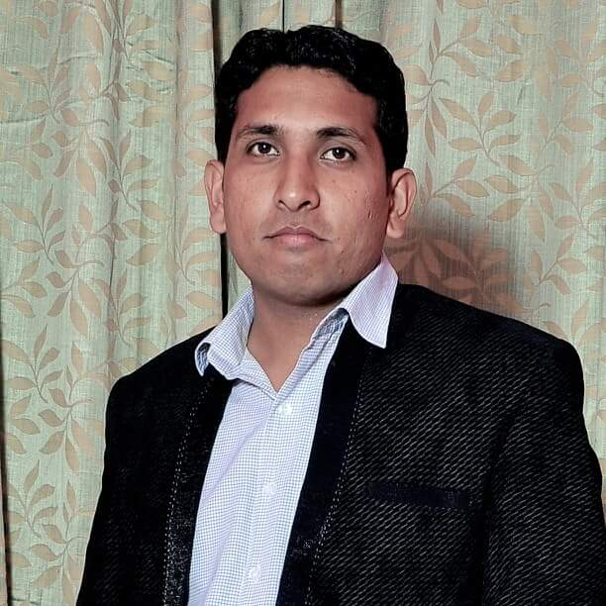**Address:** S/o Mr. Ashok Kumar Sharma

H. No.:- C-151, Street No.- 1,

Bhagirathi Vihar, Delhi-94

**Cont. No:** +91-9716879890

**E-mail :** kaushikavinash89@gmail.com

**PERSONAL DETAILS**

**Name AVINASH KAUSHIK**

**Date of Birth** 7th Feb 1989

**Gender** Male

**Marital Status** Married

**Total Years of Experience** Eight years

**Fathers Name** Mr. Ashok Kumar Sharma

**Nationality** Indian

**Languages Known** English, Hindi

**PROFILE**

Challenging determined computer graduated and ready to work in group as well as individual with the skills acquired during the course and through work experience.

**CAREER OBJECTIVE**

To learn best practices and acquire the latest knowledge through continuous efforts in order to work efficiently and serve the organization in a better way.

**QUALIFICATION**

2007-2010 Graduate in Arts Stream from **DELHI UNIVERSITTY.**

**Academic Qualification**

2007 Intermediate (10+2) from C.B.S.E Board

2004 High School (10th) from C.B.S.E Board.

**COMPUTING SKILLS**

Operating System : Windows: XP/W7/W8/W10

Word Processors : MS-Office 2007/10/16

**WORK EXPERIENCE**

1. **Workings with NRI VISION CARE as a BUSINESS DEVLOPMENT MANGER (B.D.M) join this organization on 1st Dec 2013 to 15th Feb 2015.**
2. **Working with JAWA PHARMACEUTICALS (I) PVT. LTD. as a TERRIOTY MANAGER. Join this organization from 20th Feb 2015 to 31st Mar 18.**
3. **Working with DEEPAK ENTERPRISES PVT. LTD. as an TERRIOTY MANAGER. Join this organization from 1ST June 2018 to 31st Jan 2020.**

**(We are Dealing Ophthalmic Eye Examination Instruments & Surgical Consumables products)**

**Responsibility:**

   • Good Performance in Market.

   • Making Good Relation with Doctors.

   • Product Discussing with Doctors & OT staff.

   • Generate requirement our products.

  **INTEREST & ACTIVITIES**

Reading News Paper, Surfing on Net, Listening to Songs, Watching Cricket, Traveling & Interacting with various people.

**Strengths:** **Positive thinking, Positive attitude & Dedication.**

I hereby Declare that all the statement given above are true, complete and correct to the best of my knowledge & believes.

**PERSONAL SKILLS:**

· Possess intrinsic abilities to shoulder responsibilities at the highest level of competence.  
 · Willingness to learn and implement.   
 · Possess analyzing & understanding capabilities for corrective decision-making.  
 · Possess excellent Verbal and Written Communication skills.

**DATE :**

**PLACE : DELHI (AVINASH KAUSHIK)**