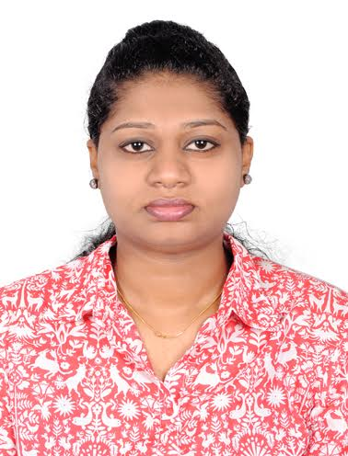

ARCHANA KARIYATTU AYYAPPAN
ARCHANA NIVAS
OTTAPALAM, PALAKKAD
KERALA, INDIA
Contact No: +91 7356339576
E-Mail ID: archanaka91@gmail.com

Career Objective:
Seeking a Flourishing career in Aviation that will enable me to utilize the skills and Experience I possess to the maximum extent.

Work Experience

Company : Qatar Airways – Hamad International Airport (Qatar)
Designation : Senior Security Agent -Terminal
Duration : (August 2014 – November 2017)

Company : Spicejet Ltd – Bangaluru International Airport
Designation : Customer Security Executive
Duration : (May 2013 – July 2014)

Previous Job Profile:

- Travel Documents Checks at Boarding Gate
- Passenger and System Profiling
- Preventing the use of fraudulent and illegally obtained travel documents to be used to enter or Transit a Country
- To ensure Passenger carry all necessary documents until final destination
- Conducting random search on arrival crew baggage
- Conducting Breathe Analyzer Alcohol text for all Departure Crew/Pilots & Ground Staffs
- Perform routine patrolling and carrying out visual search in order to prevent unauthorized activities
- Provide surveillance of QR property in all areas of Airport
- Hand Baggage search for Australian Flights.
- Office coordination, Answer telephone calls and emails from all stations
- Liaison with Duty Managers/Officers/Supervisors and Staffs on shift
- Allocate staffs for their duties and tasks on shift basis

Academic Qualification:
- BA – English Literature (Mass communication & Journalism) – Calicut University 2008 – 2011
- H.S.C – Computer Science – KANIKKAMATHA G.E.M.H.S.S – 2006 - 2008
- S.S.L.C - L.S.N.G.H.S.S – 2005 - 2006

Professional Qualification:

- Basic Knowledge in MS Office applications
- Basic Knowledge in ALTEA Reservations system
- Basic AVSEC Qualified (Oct - 2013)
- DGR COURSE
- One year Diploma in Aviation & Hospitality Management (2008 – 2009)
- Australian, Canadian, US, Schengen Documents Check Training
- Imposter Detection Training

Activities and Interests
- Travelling and Exploring Countries
- Cooking
Personal Details:
Date of Birth : 17th May 1991
Nationality : Indian
Marital Status : Married
Passport No : J3362125
Declaration:
I hereby declare that the above details, which are stated, are true to the best of my knowledge.
Date: 21-12-2019
Place: Ottapalam

Yours sincerely,
(ARCHANA.K.A)

