CURRICULUM VITAE

D JAYA KRISHNA REDDY

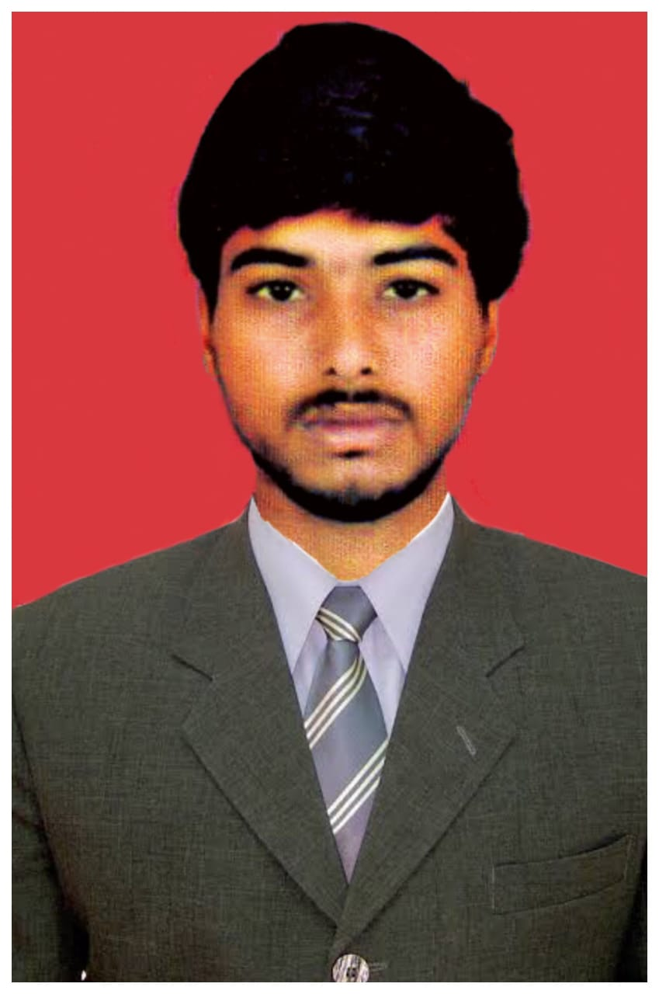
Email: jaya6747@gmail.com

Cell no:9912374524

Career Objective:

To begin career with the organization that offers challenging roles and learning opportunities for becoming a dynamic and competent professional and grow in career.

Academic Qualifications:

- MBA (MARKETING) with 64% from s.v university.
- B.sc (computer) with 65% from RVV university .
- MPC Intermediate with 52% from Sri chaitanya State Board Andhra Pradesh.
- Secondary Education with 64% fromsri chaitanya children's academy School.

Work Experience:

VARUN MOTORS PVT Ltd ( MARUTI SUZUKI ) from NOV 2014 - DEC 2015

Key Results Area
- Sale Executive
- Leads generating
- Calling on Data
- Working on Leads
- Event organiser

SARATH ELECTRICAL (V-GAURD SERVICES) from April 2017 - sep 2017

Key Results Area
- Senior Customer care executive
- Taking customer feedbacks
- Problem facing
- Handling entire Tirupati

ADITYA BIRLA HEALTH INSURANCE (Sales Manager) from Nov 2018- Till Now

Key Results Area
- Customer advisor
- Bancassurance type with AXIS BANK
- Handling 18 branch's in Bangalore
- As a sales manager

Certificate Programs:

- MS Office
- Hardware and Networking

Projects & Activities:

- Visited Amar raja factory

Skills Sets:

- Effective Communication and Interpersonal Skills
- Leadership Skills
- Keen Observer
- Singing, participated in debate competitions, anchoring

Personal Details:

Date of Birth : 05/04/1994
Gender : Male
Language Known : English, Hindi, Telugu
Hobbies : Singing, Composing songs
Permanent Address : D.No:14-3-352 kasturibai street
Tirupati,Chittoor Dt. - 517 501.
Present Address : 30/3 mangampalya Road bomanahalli , Bangalore
Marital Status : Married

Declaration:

I hereby declare that the above-mentioned information is correct up to my knowledge and I bear the responsibility for the correctness of the above-mentioned particulars.

Place:

Date:

(D Jaya Krishna Reddy)

