Curriculum Vitae

Vivek Kr sinha 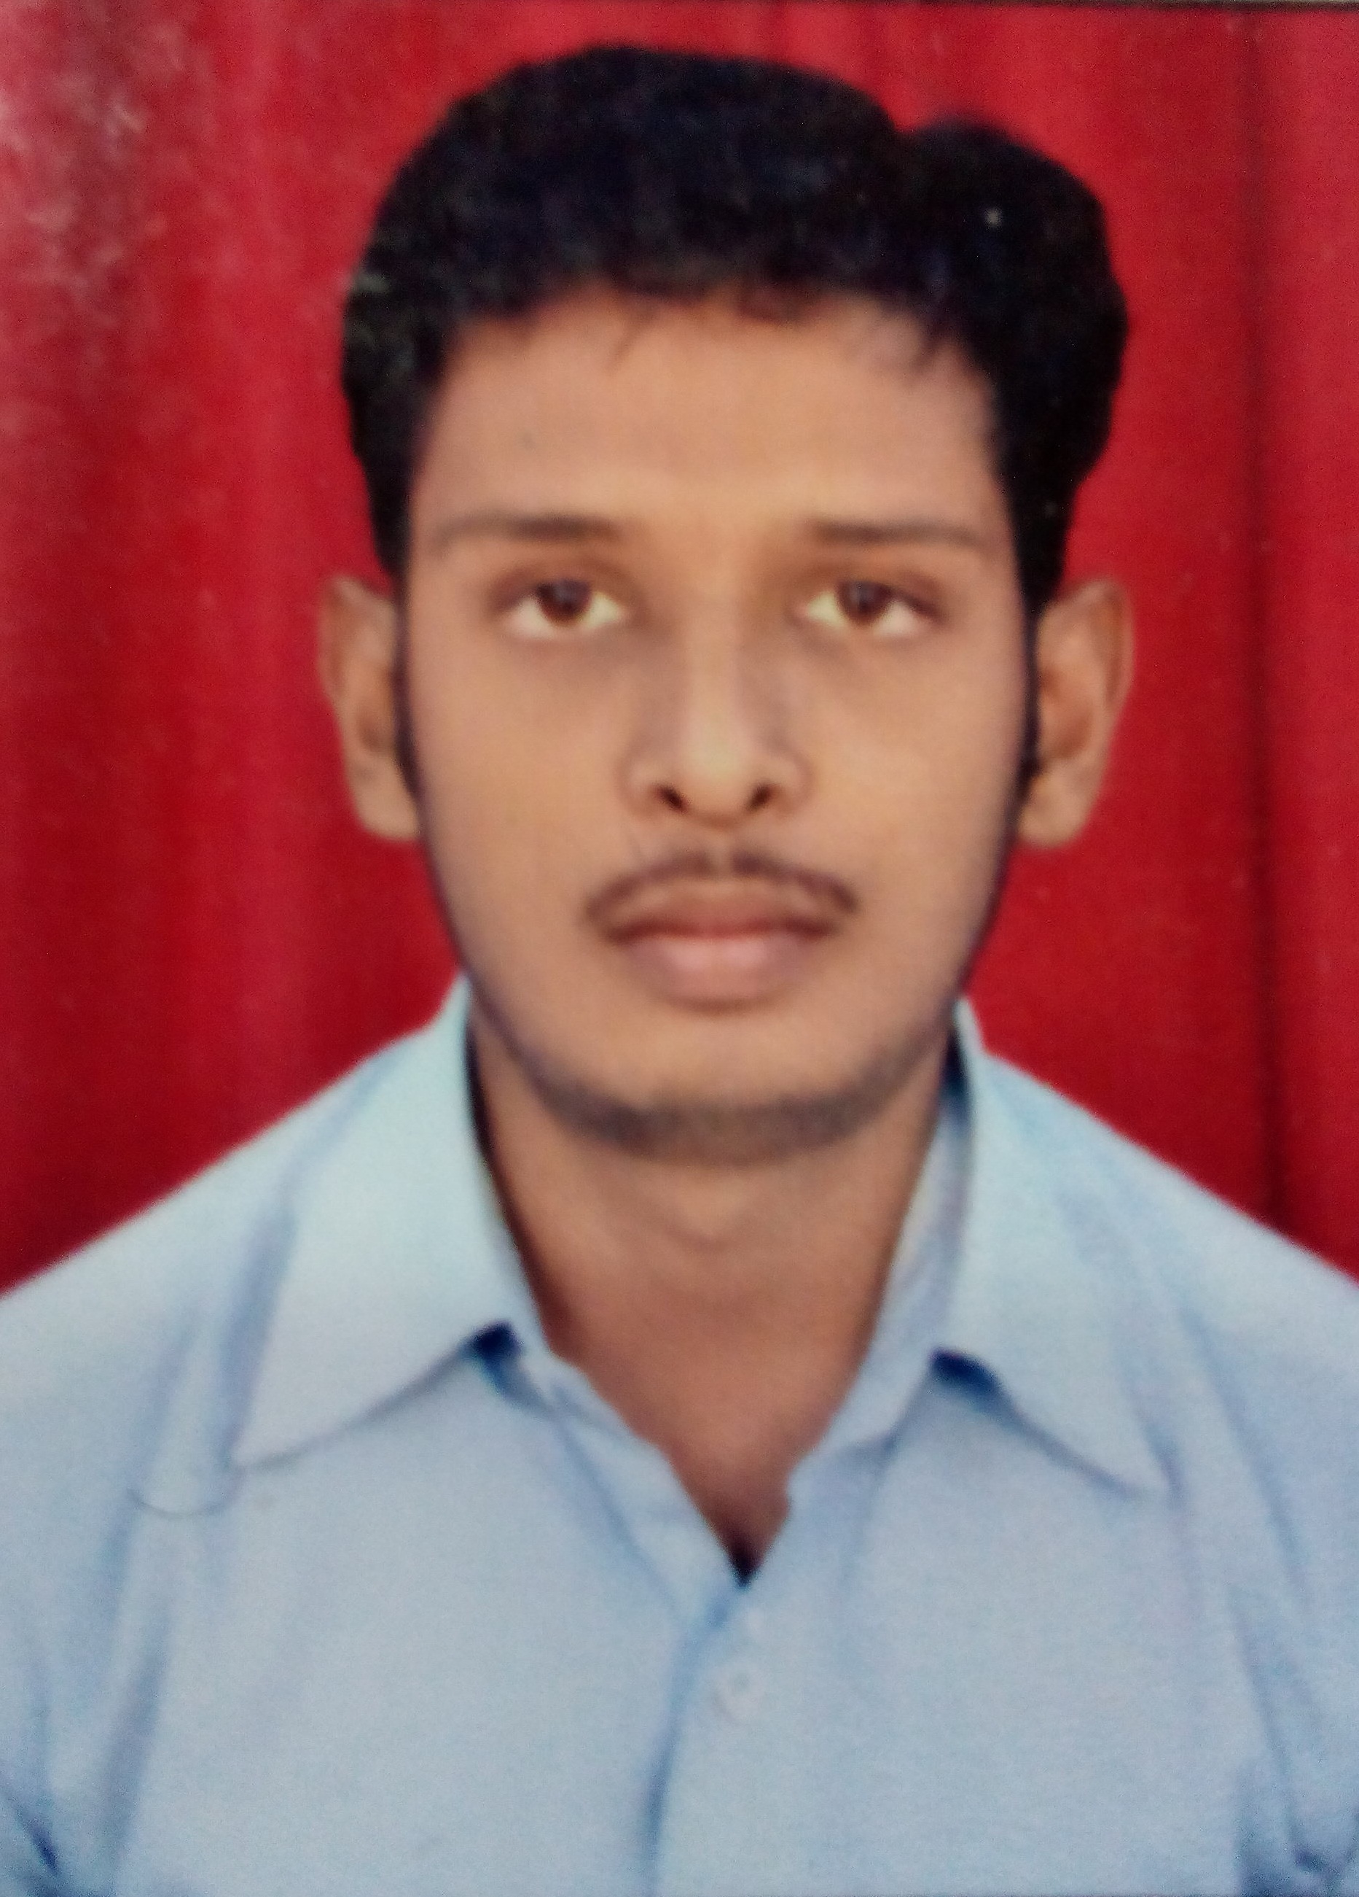
viveksinhaairtel@gmail.com
+91-9931966800 (M)

Career Objective:

Looking forward to work in a challenging environment which offers scope for continuous learning, where I can apply and improve my skills & ability so there is goal congruence and the strategic objective is achieved.
Educational Qualification:

- Bachelor Of Business Administration from Tilkamanjhi Bhagalpur University with 65%.
- Intermediate with Commerce from B.I.E.C Board with 52.75% aggregate.
- 10th from C.B.S.E. Board with 45% aggregate.
Hobbies:

- Listen Music
- Fast-Learner and Ready to learn new things.
Certificates:

- certificate course in DCA
Work Experiences:

- 33 months experience in Fino Paytech LTD as Tech Support Officer from 5th Jan 2015 to 28th Oct 2017.
Personal Details:

- Fathers Name: Shri. Binod Kumar Sinha.
- Date of Birth : 21st August 1989.
- Sex : Male
- Marital Status : Single
- Nationality : Indian
- Languages known : English, Hindi.
- Permanent Address : Q.No-355/CD Rampur Colony Jamalpur Munger  811214, (Bihar)
Declaration:
I hereby declare all that the above information is given by me is true to the best of my knowledge.
Date: __________________
Place: JAMALPUR (Vivek Kr Sinha)

