CURRICULUM VITAE

SAUMYA BISHT
MOBILE:  9711592319  EMAIL ID: saumya.bisht990@gmail.com  DATE OF BIRTH: 20th April 1990 | PERMANENT ADDRESS:  H.no-88 Sohbatia Bagh  ALLAHABAD  UTTAR PRADESH  PIN -211006 | 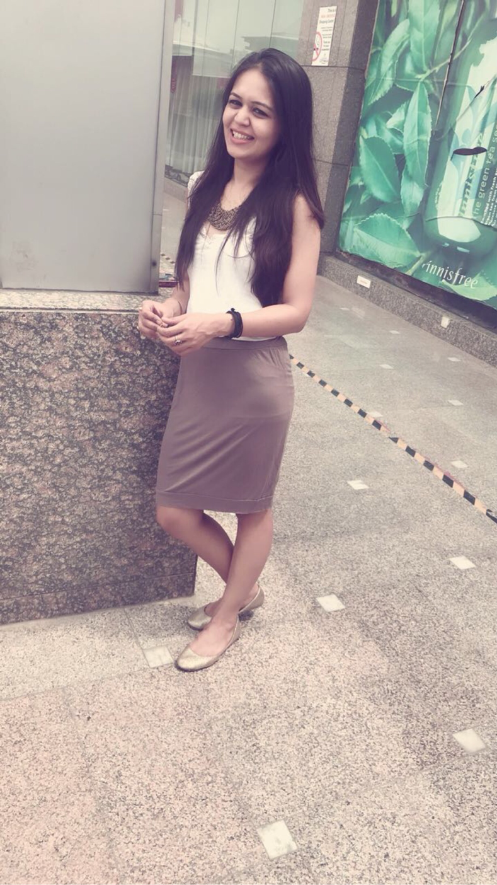

OBJECTIVE
An Endeavour to grasp knowledge and work efficiently with an esteemed organization.
ACADEMIC EXCELLENCE
 | Institute / Board | Year
B.Sc H&HA | IHMCT&AN Bangalore / Bsc in HHA | 2015
12th | Chandra Gupta Mauyra inter college / U.P | 2010
10th | St Mary’s convent/ NIOS | 2008

CORE COMPETENCIES
- Team player
- Analytical skills
- Winning attitude
- Self-motivated

EXPERIENCE
- Industrial Exposure Training in all the operational departments of hotel from the lalit Ashok, Bangalore
- Free lancer 2yrs experience in event management , P.R ,night life event & planning n concept managing for The Park hotel, The Royal orchid ,The Lalit Ashok , BANGALORE
- Served 1yr 11monts 4days with Reliance Brand LTD as Fashion consultant / Visual Merchandiser for STEVE MAADEN store at Saket from 18th June 2016 till 21st may 2017
- Served 1 yr 1 month 25 days with Major Brands Pvt Ltd. as a Store ingchare (Assistant Store manager) for ALDO Accessories a 300 square feet store at Saket Select City Mall
- Store manager for 700 square feet outlet of MTSAYA / BASANTI kaped our coffe by Utkarsh Ahuja at RARO house of fashion house , Naraania
- Currently running a personal start up (guest house ) in Nainital. Uttara khand.

RESEARCH PROJECT
- Food Production (Bakery)
LINGUISTIC PROFICIENCY
LANGUAGE | READ | WRITE | SPEAK
English
Hindi

ACHIEVEMENTS AND AWARDS
- Winner at Mocktail at ALFERSCO 2012 IHM Bangalore
- Winner at arm wrestling girls in IHM Bangalore
- 2nd place in Badminton mix double 2014 & 2015
- 1st place in badminton single girls 2015
- PES UNIVERSITY fest 2015 1st place in fashion show & group dance
- Scored 100% mystery audit

EXTRA CURRICULAR ACTIVITIES
- Playing basket ball
- Dancing
- Handicraft
- Travelling
- Gardening

INTERESTS
- Cooking / baking
- Swimming
- Reading / Writing
- Sketching
- Coffee
- Event organising
- Dyi creative

