**Curriculum Vitae**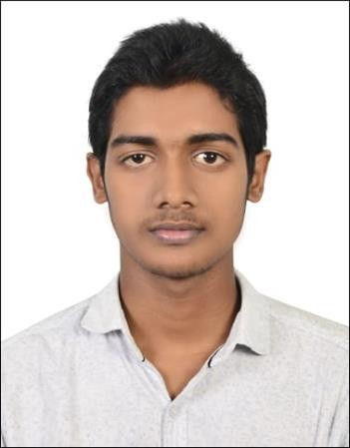

Ali Farhaan K

E-mail id: [farhaankaarakkunnu9014@gmail.com](mailto:farhaankaarakkunnu9014@gmail.com) Phone no: +91 9744889014

**Career objective**: My aim is to be recognized as a valuable asset to my organization and a reliable service provider for clients. I look forward to this work as an opportunity for

mutual development, employing my good command in English for the organization’s

growth, and personally benefitting from the work experience in turn.

# Educational Qualifications:

**Bachelor of Arts in Arabic** (Honours) (Ongoing), The English and Foreign Languages University, Hyderabad.

**Diploma in Arabic Translation 2019-2020 ,** The English and Foreign Languages University, Hyderabad

**12th Grade in science Stream** (84%), 2016-’18, MES HSS, Mampad, Malappuram, Kerala.

**10th Grade** (95%), 2016, GBHSS Manjeri, Malappuram, Kerala.

# Work Experience:

Currently working at E – Team Private limited as content moderator ( 10 months )

1-year and three months experience as Content Moderator in INFOESEARCH ITES PRIVATE LIMITED, Uppal, Hyderabad.

# Personal Strengths:

Excellent command over English and Arabic. Good interpersonal skills Ability to work under pressure and perform consistently

Ability to work as an individual as well as a team player

Self-motivated and target oriented Disciplined, dedicated, and punctual

# Computer Skills:

Working knowledge in Microsoft Office Quick adaptability to new software Intermediary computer knowledge

# Languages Known:

English – excellent command Malayalam –native speaker Arabic-good command

Tamil-basics

# Areas of Interest:

Outdoor and physical activities Football

Gaming

**Declaration:** I hereby declare that the above mentioned information is correct and I bear the responsibility for the correctness of the aforementioned particulars.