**CURRICULUM VITAE**

**SHUBHI RASTOGI**

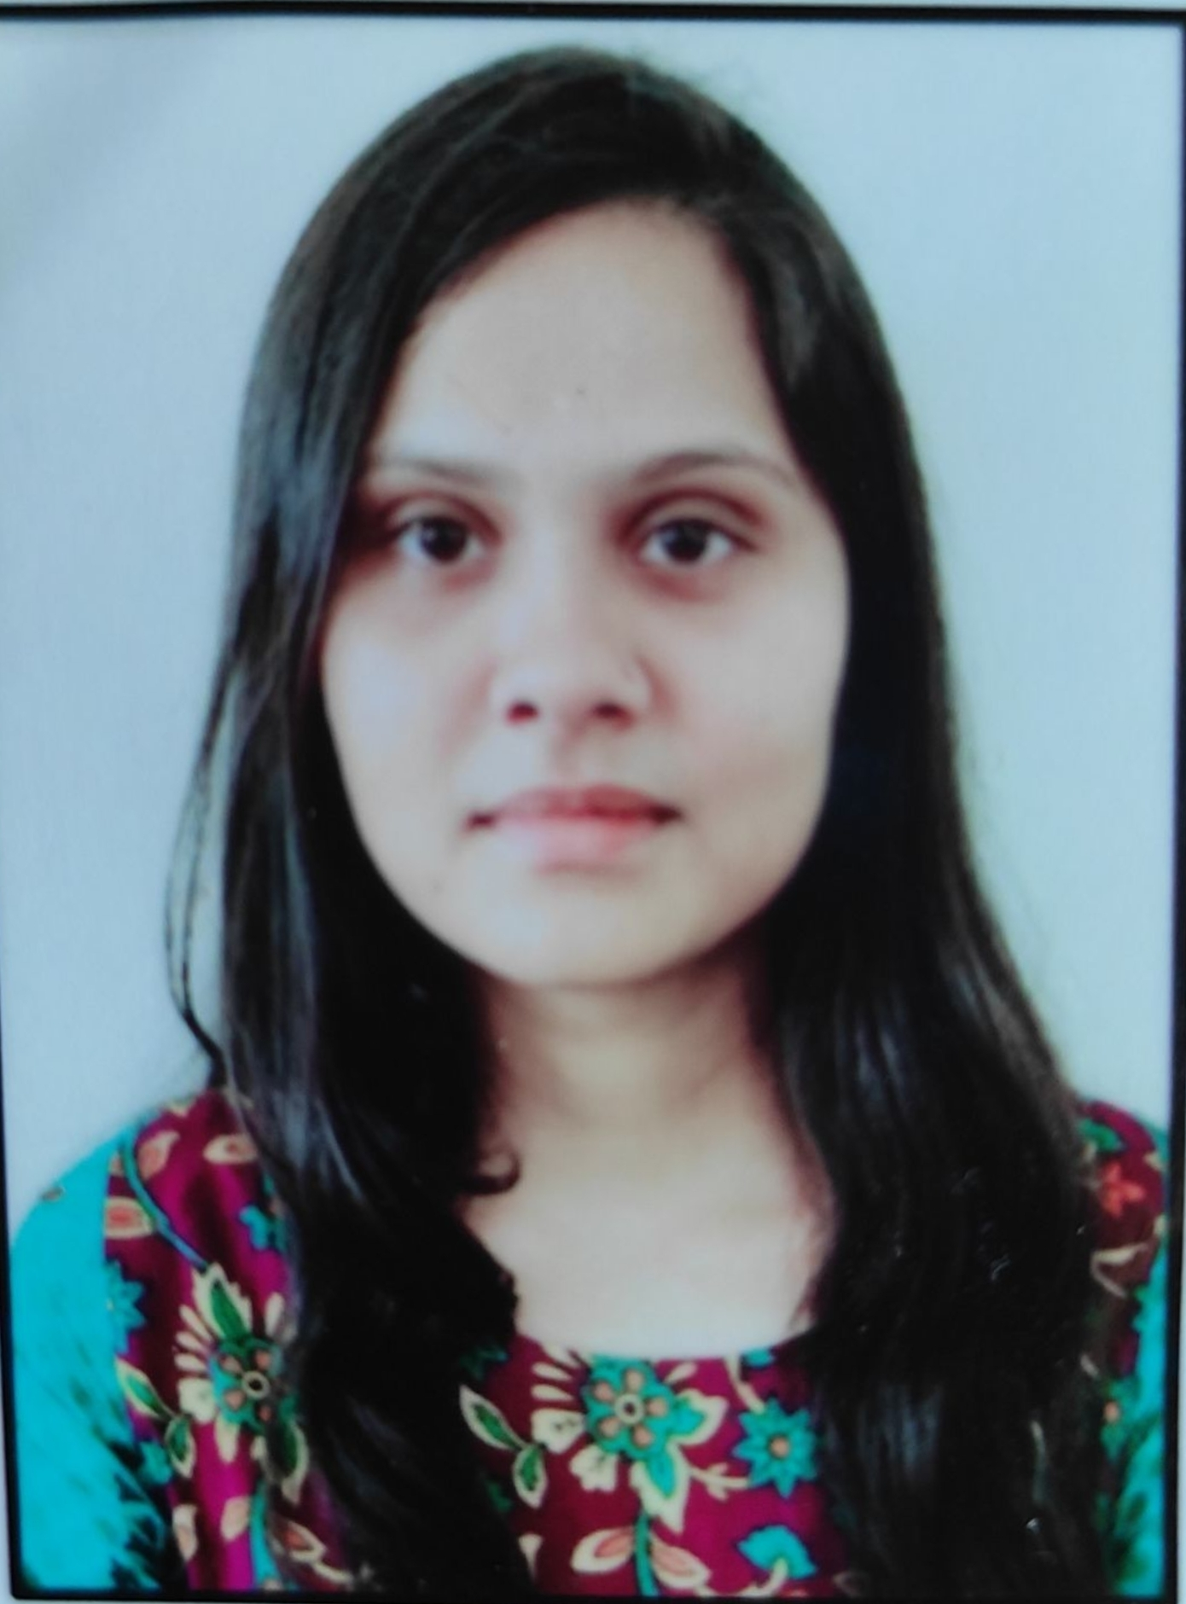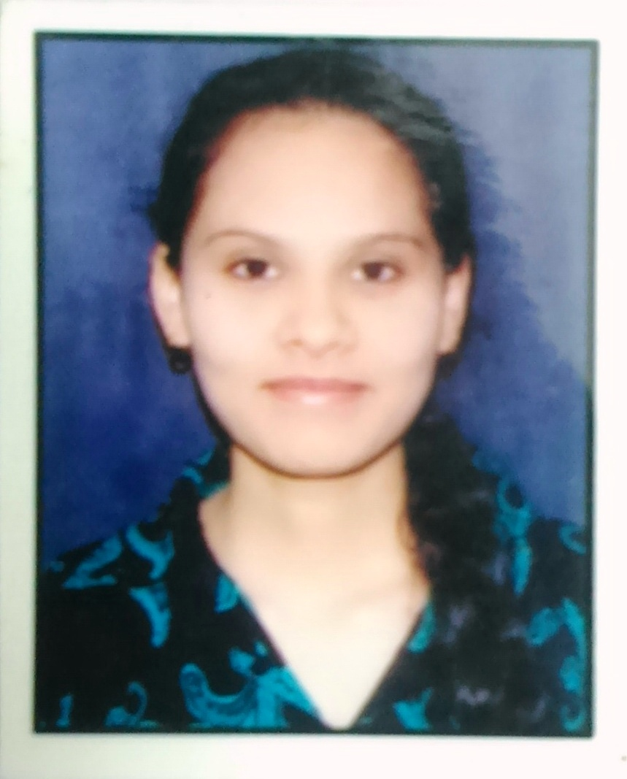

231/98

Bagh Makka, Raja Bazar

Lucknow

**Mob:** + 91-9628419000

**E-mail ID**: adoreshubhi08@gmail.com

**Date of Birth:** 8 Sep, 1994

**Career Objective:**

To be an integral part of stimulating career opportunities offered by *Biotechnology domain* and be recognized for change-evolving initiatives in the organization.

**Academic Profile:**

* **Ph. D.** in Biotechnology from AMITY UNIVERSITY UTTAR PRADESH, Lucknow Campus, Lucknow.(Thesis submitted)
* **Master of Science (M.Sc.)** Biotechnology, from AMITY UNIVERSITY UTTAR PRADESH, Lucknow Campus, Lucknow with Percentage: 88
* **Bachelor of Science (B.Sc.)** Biotechnology, from Lucknow University UTTAR PRADESH, with Percentage :55
* **Senior Secondary** in ZBC, Hindi ,English from U.P. Board withPercentage :70.2
* **Higher Secondary (all subjects)** from U.P. Board withPercentage :63.12

**Research Experience:**

* **Project:-“ Network Programme for enrichment and Update of Plant Chromosome Database for Spermatophytes and Archegoniate”(2015-2018)**
* **Institute**- Amity Research Cell
* **Details:** Network project involving 7 Institutions.
* **Sanctioned amount:** Rs. 26,13,200/- for each Institution (Approx.)
* **Funding Agency:-** Department of Biotechnology, Ministry of Science and Technology, Govt. of India

**Training Initiatives:**

* **Title*:-*“Exploitation of *Anethum sowa* leaf extract as an agent for the synthesis of metallic copper nanoparticles: An environmentally acceptable biological approach”.**

|  |
| --- |
| * **Institute**- AMITY University of Biotechnology * **Profile:** The objective was to conduct studies on the eco-friendly synthesis of copper nanoparticles from cupric sulphate by *Anethum sowa* and to see the maximum production of nanoparticles under optimize conditions.   **Competencies:**   * ***Self-appraisal****:* Proactive performer with target-driven approach, leadership skills, team oriented, positive attitude * ***Linguistic Proficiency:*** English, Hindi, German (elementary). * ***Soft skills*:** Effective Presentation and group interaction skills. * Command in UV-Vis spectrophotometer.   **Accomplishments:**   * ***Awarded with 1st position*** in academics from standard 1st to standard 12th. * **Achieved** - Tally and Basic certificates of computers.   **Publications:**   * IN VITRO STUDY OF ANTI-INFLAMMATORY AND ANTIOXIDANT ACTIVITY OF SOME MEDICINAL PLANTS AND THEIR INTERRELATIONSHIP. SHUBHI RASTOGI, MOHAMMED SHARIQ IQBAL*, DEEPAK OHRI in Asian Journal of Pharmaceutical and Clinical Research Vol 11(4), 2018,195-202. * B CHROMOSOMES IN GYMNOSPERM. S.Rastogi and D.Ohri* in Silvae Genetica Vol 68, 2019,51-54. * KARYOTYPE EVOLUTION IN CYCADS.SHUBHI RASTOGI, DEEPAK OHRI in The Nucleus,2019 * CHROMOSOME NUMBERS IN GYMNOSPERMS. SHUBHI RASTOGI, DEEPAK OHRI in Silvae Genetica 69: 13-19 (2020) * SEX DETERMINATION IN GYMNOSPERMS. DEEPAK OHRI, SHUBHI RASTOGI in The Nucleus 63: 75-80 (2020)   **Professional Pursuits:**   * Shubhi Rastogi, Deepak Ohri. Presented paper on **Gymnosperm Genomic Database Includes Anticancer Taxol Producing Taxus Species**. Biotech Breakthrough In Clinical Research and Diagnostics. Amity Institute of Biotechnology, AUUP. 26-27 Feb,2019. * Shubhi Rastogi, Deepak Ohri. Presented paper on **Database Development of Genome Related Information of Gymnosperm. Global Perspective in Agricultural and Applied Sciences for Food and Environmental Security**. Agricultural and Environmental Technology Development Society , U.S. Nagar, Uttarakhand,India. 1-2 Dec,2019. * Participated in the Workshop on “Recent Advancement in Computational Design of Drugs and Biologics” on 27-28 August, 2019 . * Shubhi Rastogi, Deepak Ohri. Presented paper on **Case Study of the Families of Gymnosperms with respect to Cytogenetics Data.** Young Scientist Conference-Frontier Area Science, IISF-2018.5-6 Oct,2018. * Participated in the National Conference on “**Biological Applications Of Nanomaterials**” on 9 January 2018 and presented a poster on “**Biological Applications of Copper nanoparticles: A Review.** * Attended International Conference on Electron Microscopy & XXXVII Annual Meeting of EMSI and presented a poster on “**Characterization of biogenically engineered copper nanoparticle using Transmission Electron Microscopy.”** * Participated in workshop on **“Molecular Biology Techniques- Hands On Training**” held at Amity University, Lucknow on 20-24 March, 2017. * Attended the seminar on “**INNOVATION: IMPROVING LIVES**” held on 26 April at Patent Information Centre, Council of Science & Technology U.P. * Attended Science and Technology Sensitization Program (Science Paper Writing/Sensitization for the Technological Empowerment Of Women) at CSIR-NBRI, Lucknow on 27-28 October,2017. * Attended Workshop on “Entrepreneurship and hands on Training for Skill Development,” jointly organized by The National Academy of Sciences, India (NASI) and Deendayal Research Institute Chitrakoot (DRI), at Udyamita Vidyapeeth, DRI, Chitrakoot, Satna (M.P.) 15-16 November,2017 * Particpated and co-ordinated in the International Conference on “Impact of Environment on Womens Health”. * Participant in National Conference on ***Woman Empowerment In The Cutting Edge Of Biotechnology.*** * Participated in National Conference on ***Bioengineering and Biotechnology and Industrial Perspective.*** * Participated in National Seminar on ***Changing Environment and Biodiversity.*** * Participated in ***Nurture Bioenterpreneurship*** workshop conducted by Association Of Biotechnology LED Enterprises. * Participated in Workshop on “DNA Analytics using JAVA” held at Amity University, Lucknow from 28-29 March, 2016. * Participated in Workshop on “Strengthening Research and Innovation” held at Amity University, Lucknow on 13th April,2016. * Participated in National Conference on “**Recent Trends in Applied Microbiology, Human Health and Environment**” organized by Department of Microbiology on March 27-28,2015 at Bundelkhand University, Jhansi. * Akhilesh kumar Singh, Shubhi Rastogi, Priti Pal, Shafaque Asif, Satrarudra Prakash Singh on **Plant mediated production of silver nanoparticles: a simple and eco-friendly approach. International** **Conference Of Nanoscience And Life** organized by Banaras Hindu University 28 February-2 march 2015M,P.7 (**UGC Networking Program**) * Shubhi Rastogi, Satarudra Prakash Singh and Akhilesh Kumar Singh on **Eco-friendly synthesis of copper nanoparticles by exploiting leaf extract of *Anethum sowa*  National conference on Recent Trends In Applied Microbiology, Human Health And Environment** organized by Bundelkhand University, Jhansi 27-28 March 2015. * Shubhi Rastogi, Satarudra Prakash Singh and Akhilesh Kumar Singh on **Anethum sowa Leaf cell Factories: A viable and Sustainable Approach for Copper Nanoparticles Production** organized by **Indian JSPS Alumimi Association,** sponsored by **JSPS** and co-sponsored by DST, India and MEXT, Japan at Banaras Hindu University, Varanasi, India.7-9 august 2015 .   **Extra-Curricular Activities:**     * Part of the *Core Coordinators committee* in the national conference organized by Amity Institute of Biotechnology. * Participated in Military Training Camp conducted by AMITY. * Participated in cultural activities of the college. * Volunteered in organizing events for AMIPHORIA 2014 held at AMITY. * Volunteered for conducting various student group events for AIB.   **Recreational Interests:**   * + - Interested in Performing arts (dance, music, dramatics,).     - Interested in travelling and exploring. |