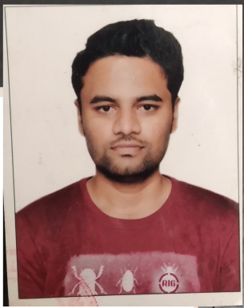AVINASH HANUMANT KHILARE

Email: [avinashkhilare](mailto:avinashkhilare69@gmail.com)68@gmail.com

Mobile no.: 7387138618

Address: 38/582, Lokmanya Nagar, opposite

Joggers park, Sadashiv Peth,

Pune- 411030

**Career objectives:**

To work in an organization where I can use my skill to achieve the organization objective and get conductive environment to learn and grow

**Academic credentials:**

|  |  |  |  |  |
| --- | --- | --- | --- | --- |
| EXAMINATION | INSTITUTE | BOARD/UNIVERSITY | RESULT/PERCENTAGE | YEAR |
| M.Sc.(Microbiology) | FERGUSSON COLLAGE,PUNE | Savitribai Phule Pune University | 49.5 | 2019 |
| B.Sc (Microbiology) | P.E.S. MODERN ARTS,SCIENCE AND COMMERCE COLLAGE SHIVAJINAGAR, PUNE | Savitribai Phule Pune  University | 55.15% | 2017 |
| Higher Secondary School | CHILDREN'S SR ACADDEMY MILAP NAGAR ROORKEE, HARIDWAR UTTARAKHAND | CBSE | 63% | 2012 |
| Senior Secondary school | KENDRIYA VIDYALAYA BEG&C ROORKEE HARIDWAR UTTARAKHAND | CBSE | 54% | 2010 |

**Strength and skills:**

* Leadership quality and team working person
* Able to take challenges
* Hardworking
* Willing to learn new things

**Hobbies:**

* Like to play football
* Drawing/sketching
* Reading

**Personal details:**

|  |  |
| --- | --- |
| Name | Avinash Hanumant Khilare |
| Date of Birth | 25 dec,1993 |
| Age | 26 |
| Gender | Male |
| Nationality | Indian |
| Marital status | Unmarried |
| Language known | Marathi, Hindi, English |
| Address | A/P Anant classic, flat no 11,MIDC Baramati, tal: Baramati, dist: Pune - 413102 |

**Declaration**

I hereby declare that the above stated information is true to best of my knowledge

Place: Pune

Date:24 jan,2020 Avinash Hanumant Khilare