**PULKIT MANOCHA**

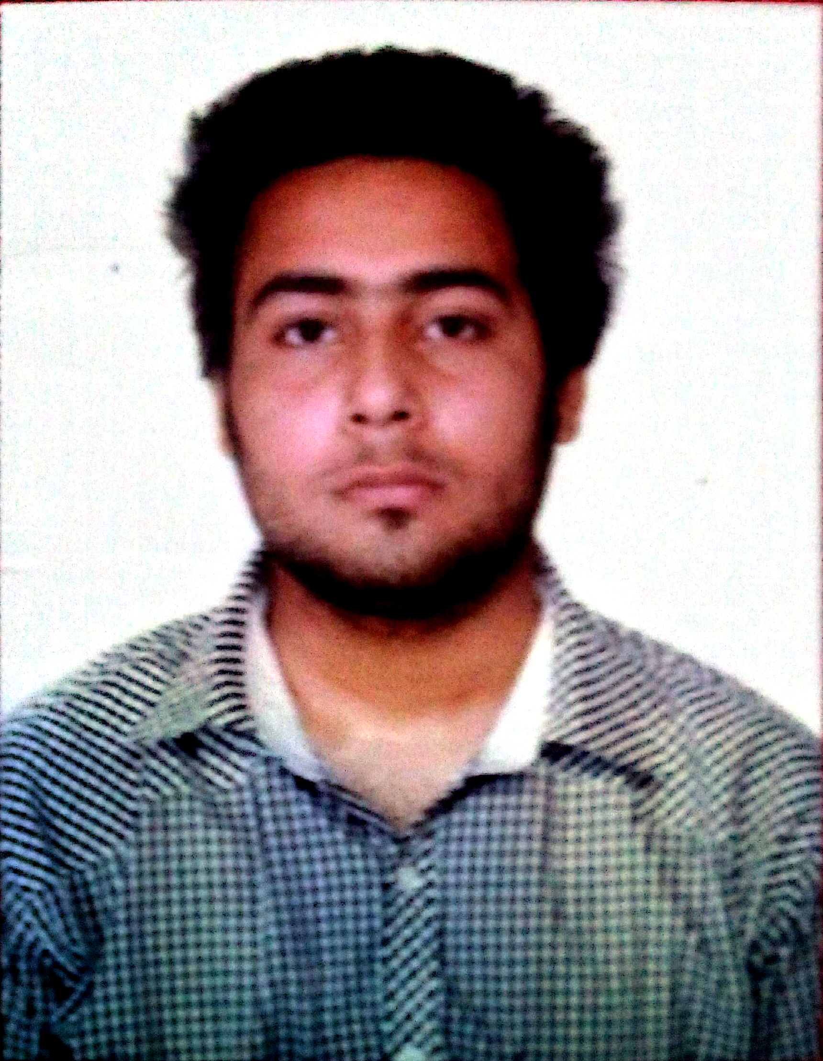

Mobile No.: 8427895457

Address: #824 Sector 78 Mohali Punjab

E-mail:[pulkitmanocha1@gmail.com](mailto:pulkitmanocha1@gmail.com)

ACADEMIC QUALIFICATIONS

|  |  |  |  |  |  |
| --- | --- | --- | --- | --- | --- |
| **Examination** | **Specialization** | **Percentage** | **College/School** | **Board/**  **University** | **Year** |
| BTTM | Tour Operations | 67.00 | UIHTM, Panjab University, Chandigarh | PU | 2019 |
| 12th Board | Commerce | 76.60 | KBDAV, Sector 7, Chandigarh | CBSE | 2014 |
| 10th Board | ***** | 64.60 | GMSSS, Secgtor 16, Chandigarh | CBSE | 2012 |

|  |
| --- |
| INDUSTRIAL TRAINING   * 45 Days industrial training at Sheetal Travels, Sector 17, Chandigarh * Under which I learned basics of Galileo software for ticketing, domestic ticketing, preparing itineraries for popular domestic destinations and tour packages, handling customers related to domestic air ticketing and a bit of sales and promotion techniques   IT SKILLS |

|  |  |
| --- | --- |
| **Languages** | * Certified course of Internet and Web Page Designing from National Institute of Computer Technology (ISO 9001-2008 certified) |
| **Software Packages** | * Have knowledge of MS-Office (MS-Word/Excel/PowerPoint) |

|  |
| --- |
| ACHIEVEMENTS & ACCOLADES |

* 3rd position in inter-school football competition during my 10th standard
* 1st position twice in inter-department football sports day competitions
* Participated in Gymnastics competition as inter-school level

|  |
| --- |
| EXTRA-CURRICULAR ACTIVITIES AND INTERESTS |

* Was a part of a certified Leadership Development Camp (LDC) in Manali
* Went to Goa as a part of a project, which comprised report creation on Medieval Indian Architecture
* Went on Churdhar Peak Trek twice, that takes you to the highest peak outside Himalayan range
* My interests are:
  + Playing football, travelling, trekking, playing basketball and watching movies

|  |
| --- |
| REFERENCES |

* Dr. Prashant Gautam, **Director Principal**, UIHTM, PU, Chandigarh, Mobile No.-9815976444
* Dr. Amit Katoch, **Assisstant Professor**, BTTM, UIHTM, PU, Chandigarh, Mobile No.-8091735835

**DECLARATION**

I hereby declare that above-mentioned information is correct to the best of my knowledge and belief.

**Date: SIGNATURE**