**BIO DATA**

1. Name : ASHWINI KUMAR

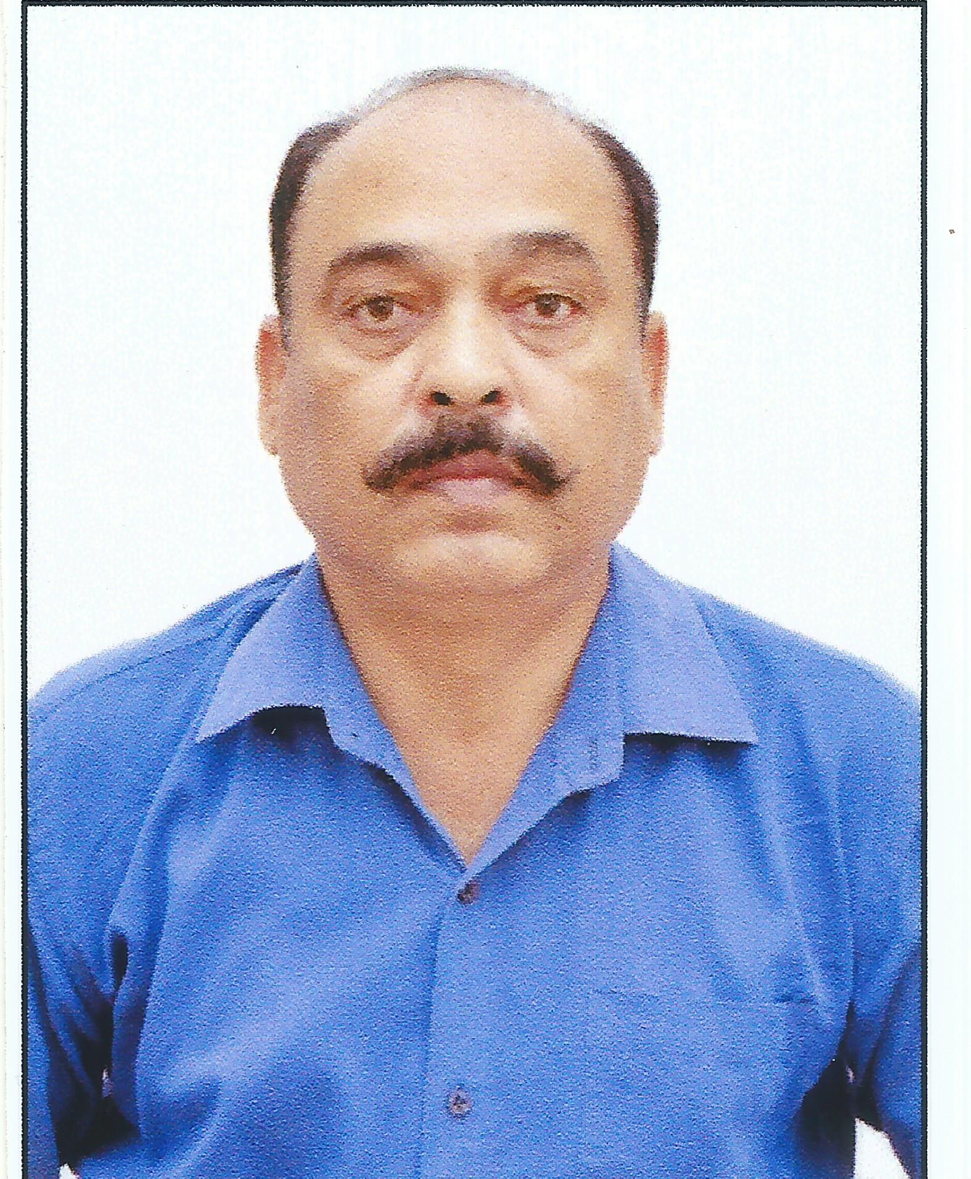

2. Gender : Male

3. Age : 51 Years

4. Email Id : [navdeepson@gmail.com](mailto:navdeepson@gmail.com)

5. Mobile No : 8092484473

6. Religion : Hindu

7. Nationality : Indian

8. Correspondence Address : Room No 402, A Wing, Sena Bhawan,

IHQ of MoD(A)New Delhi

9. Permanent Address : VPO : Rampur Haler, Tehsil : Dasuya,

District : Hoshiarpur (Punjab) - 144223

10. **Education Qualifications Details**

|  |  |  |  |  |
| --- | --- | --- | --- | --- |
| **Exam** | **%age** | **Year of Passing** | **Board/**  **University** | **Subjects** |
| Matric | 63 | 1985 | CBSE | English, Hindi, Maths, G Science, Social Science, PH Education, SUPW |
| PGDCA | Distinction | 1995 | MSB Data Systems, Bangalore | Computer Applications |
| Associate  Diploma | 82 | 2012 | IGNOU | Security of Strategic Installations, Accounting and Office Management, Commerce. |
| BA (Psychology) | 76 | 2017 | IGNOU | General Psychology, Development Psychology, Theories of Personality,  Social Psychology,  Industrial and Organisational Psychology  Forensic Psychology |
| PG Diploma in Counselling and Family Therapy | Results for Practical awaited | 2018 | IGNOU | Mental Health & Disorder  Counselling and Family Therapy  Family Relationships |
| PG Diploma in Human Rights | 71 | 2019 | Indian Institute of Human Rights, Delhi | Human Rights |

2

11. **Skills**

* Office Management
* Inter Communication Skills
* Man Management
* Handling of Accounts
* Security Management (Security of Material, Equipment, Cyber Threats, Official Security)
* Handling and operating of Arms (Holding a Valid Arms Licence)
* Adequate knowledge in Industrial Psychology,

Counselling and Family Therapy

* Event Organise and Management
* Served in Army for 30 years and have the following experiences :-
  + Account Clerk - 14 years
  + Accounts Office Superintendent - 5 years Handled Budget, CTS Fund (Canteen Trade Surplus Funds), QD Fund (Quantitative Discounts Funds), Purchase Boards, Auditing, Planning of Social events.
  + Accounting of Various Grants from Public and Institutional/Regimental Funds
  + Supervision over Office Staff,
  + Experience in Security Maintenance.
  + Preparation, planning and execution of expenditure

12. **Work Experience**