YELE VAMSHI SAI

contact# 8121657919

Email:[yelevamshisai3@gmail.com](mailto:yelevamshisai3@gmail.com)

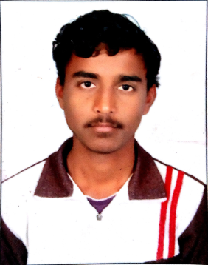

**Personal Profile**

I believe in the structure of our prolific education system, and have been part of the instructors’ team in Udemy platform before embarking as a trainer/instructor. I am a hard worker with good communication skills who works effectively in a team and has the ability to meet the deadlines. Communication is a medium and I use it to expand and discover the untapped talent in the country.

.

**Career Objective**

To work hard with full determination and dedication to achieve organizational and personal goals.

**Experience**

* Recruitment associate with Abhayajyothi(4 months)
* Worked with Accenture Sol. Pvt. Ltd. as Business Process Delivery New Associate (8 months)

**Education**

|  |  |  |
| --- | --- | --- |
| **Qualification** | **Board/University** | **Percentage** |
| B.Tech (Electronics&communication Engineering) | Vignana Bharathi Institute of Technology ( JNTUH) | 68% |
| Intermediate | New Era Junior Collage  ( B.I.E) | 75% |
| High School | Neo Chem High School  ( S.S.C) | 75% |

**Achievements**

* Won first prize in state level project expo “AKKAR”.
* Won third prize in inter college project expo ‘PADARTH”.
* Played many cricket tournaments in schooling and won many medals.
* Awarded the best project of the year 2017.
* Have been the Internshala Student Partner of my college(2017).

**Memberships**

* Actively participated in various sports activities for inter school.
* Worked as a marketing team member for IEEE for six months.
* Worked as a mentor for IEEE-COMSOC Colloquium for two years.

**Skills**

* Microsoft Office
* Internet researcher
* MS- Excel
* MATLAB

**Personal Strengths**

* + Ability to rapidly build relationship and set up trust.
  + Confident and Determined.
  + Eye for detail.
  + Ability to cope up with different situations.

**Personal Profile**

|  |  |  |
| --- | --- | --- |
| • | **Name** | **: Y.Vamshi Sai** |
| • | **Date of Birth** | **: 05-09-1997** |
| • | **Languages Known** | **: Telugu, Hindi, English** |

**Hobbies and Interests**

My hobbies include making podcast episodes,writing blogs, running YouTube channel, cycling,going for a long walk with friends.

**Conclusion**

I hereby declare that the above written particulars are true to the best of my knowledge and belief.

Date:

Place: Hyderabad **(YELE VAMSHI SAI)**