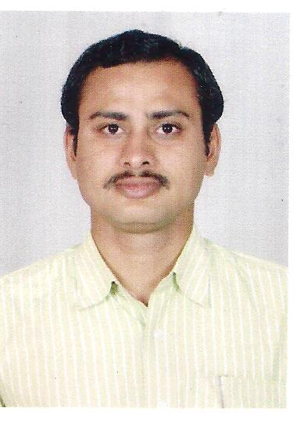
V RAGHURAM PINNAMARAJU
E-Mail: pvsraghu123@gmail.com
Contact Address: 9704966551/ 9603920455.

Objective

Intend to build a career with leading corporate of hi-tech environment with committed and dedicated people, which will help me to explore myself fully and realize my potential. Willing to work as a key player in challenging and creative environment.

ACADEMIA

Qualification | Place of study | Year
Master of Business Administration (Finance& Marketing) | PRIME MCA COLLEGE  Visakhapatnam | 2012
Bachelor of Commerce  (B.com computers) | HARSHINE DEGREECOLLEGE  Ongole | 2009
Intermediate  (M.P.C) | AADITYA JUNIOR COLLEGE  Nellore | 2006

Software Exposure

Applications : MS-Office,Internet,
Accounting Packages : Tally9.0,Focus5.5 and Jeeva.,ERP. And IDS

EXPERIENCE: 1

1.Working For “ Rain Entertainments Pvt Ltd. ”(Mall ) as a “Accountants Officer” , Nellore. From 05 th Oct 2017 to till date.

EXPERIENCE : 2

1.Worked For “Minerva Grand ”- A Unit of Secunderabad Hotels Pvt Ltd. as a “Account Executive” Dargamitta , Nellore, From Dec 2014 to Oct 2017.

Responsibility and Area of working:

- Debtors Management.
- Preparation of “Debtors Ageing Analysis” on monthly basis and keep a complete track on each and every bill.
- Coordination with Billing& Realisation team towards timely submission of Bills.
- Maintaining coordinal relations with customers.
- I Preparing Luxury tax Returns.
- I Prepared MIS Reports and Daily reports.
- Bank Reconsalation Statament.
- Purchases and Sales reports prepared.
- Monthly Service tax Statement Prepared and Paid.
- I Did Sales report prepare and posting in Tally and Daily purchase bills Rates checking and posting in Tally .
- Monthly Comparison of Tally to IDS For Sundry debtors and sundry creditors ageing summary .

EXPERIENCE: 3

- Worked For “ CARE HOSPITALS. ” as a “Account Asst., Visakhapatnam,
Aug 12 to Nov 14

Personal Profile

Name : V Raghuram Pinnamaraju
- Date of Birth : 05 July 1988
- Father’s name : PV. Krishna rao
- Sex : Male
- Marital Status : Married.
- Languages Known : English, Telugu
- Nationality : Indian
- Permanent Address : V Raghuram Pinnamaraju
          - S/o PV Krishnarao,
          - D.NO:22-2-15/1,
          - Sainagar,Kandukur,
          - Prakasam (dist).

Hobbies/Traits

- Hardworking.
- Self-confidence.
- Ability to work in a team as well as independently

Declaration:

I consider myself familiar with Accounting Aspects. I am also confident of my ability to work in team.

I hereby declare that the information furnished above is true to the best of my knowledge.

Date :
Place V Raghuram Pinnamaraju

