**Curriculum Vitae**

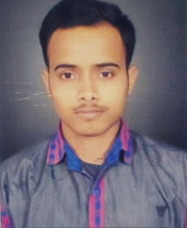

**FRANSHU MISHRA**

E-mail : <franshumishra17@gmail.com>

Mob. no: (+91)- 8177089810, 9807112008

**Career Objective**

To work in a dynamic environment that provides me the ample scope of growth and Also, it would help

me to utilize my skills and my knowledge area to contribute significantly to the organization, where I work.



**Academic Qualifications**

* High School from U.P Board in 2011
* Intermediate from U.P Board in 2013
* B.com from M.G.K.V.P.
* Diploma in Computer Application



**Key Skills**

* MS Word
* MS Excel
* TALLY ERP 9
* Typing (Hindi & English)



**Work Experience**

* 6 Months Experience as a **Cashier** in **BIG Bazaar Pvt. Ltd.**
* **5+ Yrs**. Experience Sales in **SAMSUNG MOBILE INDIA Pvt. Ltd.**



**Personal Details**

Name

Date of Birth

Father’s Name

Mother’s Name

Marital Status

Languages Known

Permanent Address

: **FRANSHU MISHRA**

: September 28th, 1996

: Mr. Ashok Kumar Mishra

: Mrs. Rani Mishra

: Married

: English & Hindi

: C.7/157-A Senpura, Chetganj-Varanasi (U.P.) 221001

I have the ability to work in competitive environments. I possess good communication and interpersonal skills.

**Franshu Mishra**