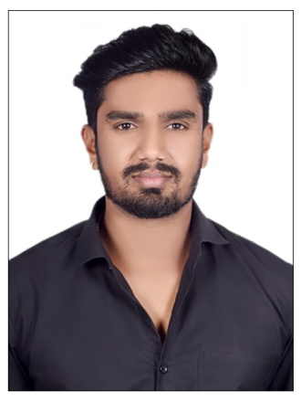 |  | SATEESH  CHOUDHARY
Profile  An avid Electronics Engineer, proﬁcient in C and C++ seeking career in an environment where my skills and knowledge reflects the growth of the company and enhance my knowledge as well as my experience.  CONTACT  PHONE:  +917987706822  ADRRESS:  Indore, MP, India  EMAIL:  Sateeshchoudhary04@gmail.com  HOBBIES  - Cricket  - Gardening |  | EDUCATION  B. Tech (ECE)  RGPV University  07/2016 - 06/2020 5.82 CGPA  Senior Secondary School  Nav Adarsh H S School  03/2016 62.8 %  Higher Secondary School  Shri Tagore Vidhya Mandir High School  03/2013 74%  Languages-TOOLS & PLATFORM    MS-Power Point  MS-Excel  C++  C  MS-Word
REFERENCES  Mrs. Sadhna Tiwari  HOD, ECE Department  RGPV University  Mr. Suvigya Pradhan  Associate Manager,  Accenture  Detailed information will be available upon request. |  | PROJECTS  An IOT Based Smart Agriculture System : - Is an Extremely Versatile Devise Design To Help Farmers To Moniter Their Farm Fields Easily

STRENGTHS

Quick Learner, Energetic, Conﬁdent & Hardworking

LANGUAGE

English & Hindi

I conﬁrm that the information provided about me and my achievements are true to the best of my knowledge.

Yours Truly,

Sateesh Choudhary
+917987706822

