CURRICULUM VITAE

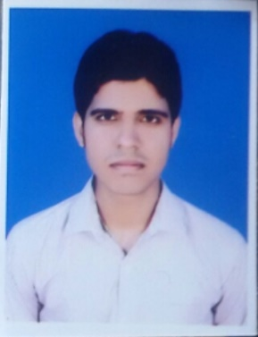

# *Name* : AAKASH MUKHERJEE

# *E-mail* : [amitakash9000@gmail.com](mailto:amitakash9000@gmail.com)

***Mobile No* : +91 7004070364**

**CAREER OBJECTIVE**

Want to involve myself in a challenging environment offering scope for growth, development & an opportunity to apply my learning to effectively contribute towards the achievement of the organization objective.

**ACADEMIC QUALIFICATION**

**ADDITIONAL QUALIFICATION/CERTIFICATION**

|  |  |  |  |  |
| --- | --- | --- | --- | --- |
| Examination | Institute | Board/University | Year | %/CGPA |
| B.Tech  ( Mechanical Engineering) | Bankura Unnayani Institute of Engineering | Maulana Abul Kalam Azad University Of Technology (formerly known as WBUT) | 2016 | **70%** |
| Intermediate  (12th) | Saraswati Vidya Mandir | Central Board Of Secondary Education | 2012 | **65%** |
| Matriculation  (10th ) | Lions Public School | Central Board Of Secondary Education | 2010 | **75%** |

* ***Auto cad***
* ***Solid Works***

**INDUSTRIAL TRAINING**

* ***ACC*** *Cement Works in* ***Sindri***
* ***SAIL*** *in Chasnalla,* ***Dhanbad***

**EXTRA CURRICULUM**

* **Playing & Watching Cricket**
* **Playing Carrom**
* **Listening Music**

**PROJECT REPORT**

**MICROCONTROLLER BASED SCISSOR LIFT**

1. **SCOPE OF THE STUDY**: The design and construction of the microcontroller based powered scissor lift.
2. **IMPORTANCE OF THE STUDY**: The design and construction of a microcontroller based powered scissor lift is to lift a worker together with the working equipment comfortably and safely to a required working height not easily accessible.
3. **AIMS OF THE STUIDY**: The project is aimed at designing and constructing a microcontroller based powered scissors lift to lift and lowers worker and his working equipment with ease and in the most economical way.
4. **PRINCIPLE OF MECHANICAL SCISSOR LIFT**: A Scissors lift is a type of platform that can usually only move vertically. The mechanism to achieve this is the use of linked, folding supports in a criss - cross “X” pattern, known as a SCISSORS MECHANISM.

**EXPERIENCE DETAILS**

1. **SBICAP SECURITIES PVT. LTD : 01/06/2017…… till date.**

**PERSONAL INFORMATION**

* **Date of Birth :** 04.11.1994
* **Gender :** Male
* **Nationality :** Indian
* **State :**  Jharkhand
* **Father’s name :** Mr. Ashish Kr. Mukherjee
* **Languages Known :** English, Hindi & Bengali
* **Postal Address :** Sk4-117 Sindri Dhanbad Jharkhand Pin: 828122

**Declaration:**

**I hereby declare that the information & facts furnished above are true and correct to the best of my knowledge & belief.**

**Date:**

**Place:** Signature