Bipin K Singh

Address: Room No.301, A-wing, Vitthaldham Apartment,
Near F- Cabin Rd, Milind Nagar, Near Sai swastik Multispecialty Hospital,
Vitthalwadi, Kalyan (E).

E-mail: vipinsingh0001212@gmail.com

Phone: +91- 8268033294

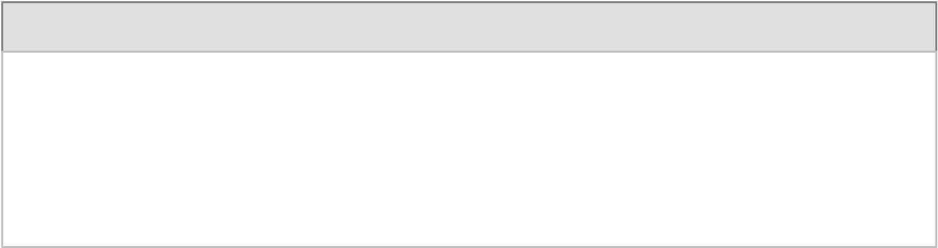
Objective:

Intend to build a career with Leading Corporation of hi-tech environment with committed and dedicates people who will help me to explore myself and relies my potential willing to my work as key player in challenging and creative environment. I assure my honesty and sincerity toward my work & will proof myself as good candidate to become a part of your reputed form for long time.

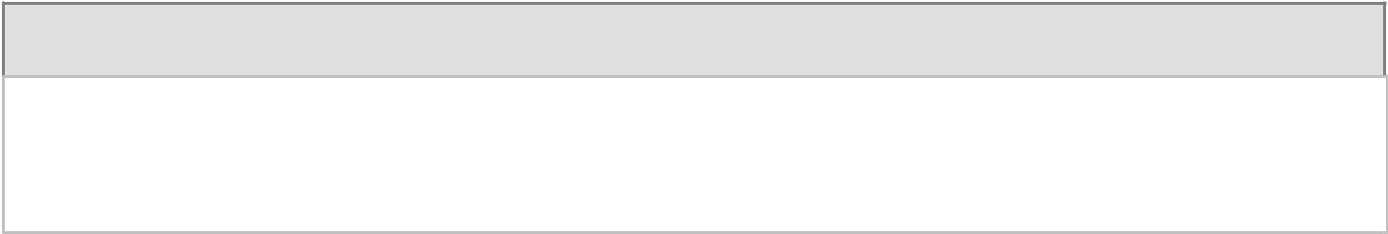

Educational Qualification:

- B.SC (Chemistry) from Mumbai University in year 2017.

- HSC from Maharashtra Board in year 2014.

- SSC from Maharashtra Board in year 2012.

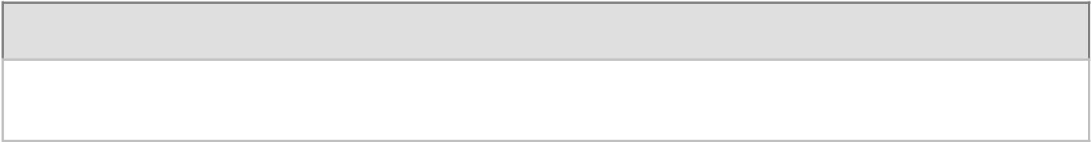
Technical skills:

- Basic Computer Knowledge.

Professional Experience:

Organization | Duration | Designation

Wipro Pvt Ltd. | 6 Months | As a CSA
Gebbs Healthcare Pvt Ltd. | 1.5 years | As a Senior AR

Name | Bipin K Singh
Father Name | Kripashankar Singh
Date of Birth | 30/11/1996
Gender | Male
Marital Status | Single
Languages Known | English, Marathi & Hindi.
Hobbies | Listening Music & Singing.
Nationality | Indian
Religion | Hindu
Date: | (Bipin Singh)
Place -----------------------


Personal Profile:

