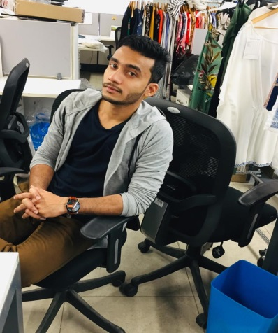

**Syed Sajudeen A**

A -27/2, DLF phase 1

Gurugram, Haryana-122001

**E-mail:** syedsajudeen66@gmail.com

**Call Me:** 9629538545



**CAREER OBJECTIVE:**



To be potential resource to an organization where I can utilize all my skill and knowledge



which would help the organization in order to meet business objective and customer satisfaction with high level of service.



**WORK EXPERIENCE:**



* **PDS MULTINATIONAL FASHIONS LTD (** September2018- April 2020),Udhyog Vihar, Gurgoan.
* **PRIMEX APPAREL SOURCING SERVICES** (April 2016–September 2018), Suncity, Sector 54, Gurgaon
* **FRONTIER KNITTERS PVT LTD** (March 2013- April 2016), Kongu main road, Tirupur.



**JOBS & RESPONSIBILITIES:**



* To prepare an order plan according to the right product, and adhering to SOP’s and brand manuals.
* Able to handle all approvals process and maintain records for buyer protocol.
* To follow up on production and shipment process according to the buyer instructions.
* Partner with Buyers/Designers/Quality departments & Vendors on Seasonal product Development plans & Protos, Seasonal Buy Plans and Finalize Order Bookings.
* Taking responsibilities for all kind of procurements, coordinating with the vendors.
* Assisting business head in day to day merchandising activities.
* Monitoring production from the sampling to final shipment.
* Preparing and attending buyer meeting and discussing about the orders with the buyers independently.
* Scrutinize and analyze various W.I.P , TNA ,Production Reports and initiate corrective measures
* Proactive, Pre-Alert Systems and approach mechanism to solve problems and Steer Businesses Smoothly.
* Extend support & training to new and existing Merchandising team members
* Vendor Management and Sourcing Plans from India. (South and North)
* Following up with south vendors for executing the orders and constantly visiting south factories every month.



**BUYERS HANDLED:**

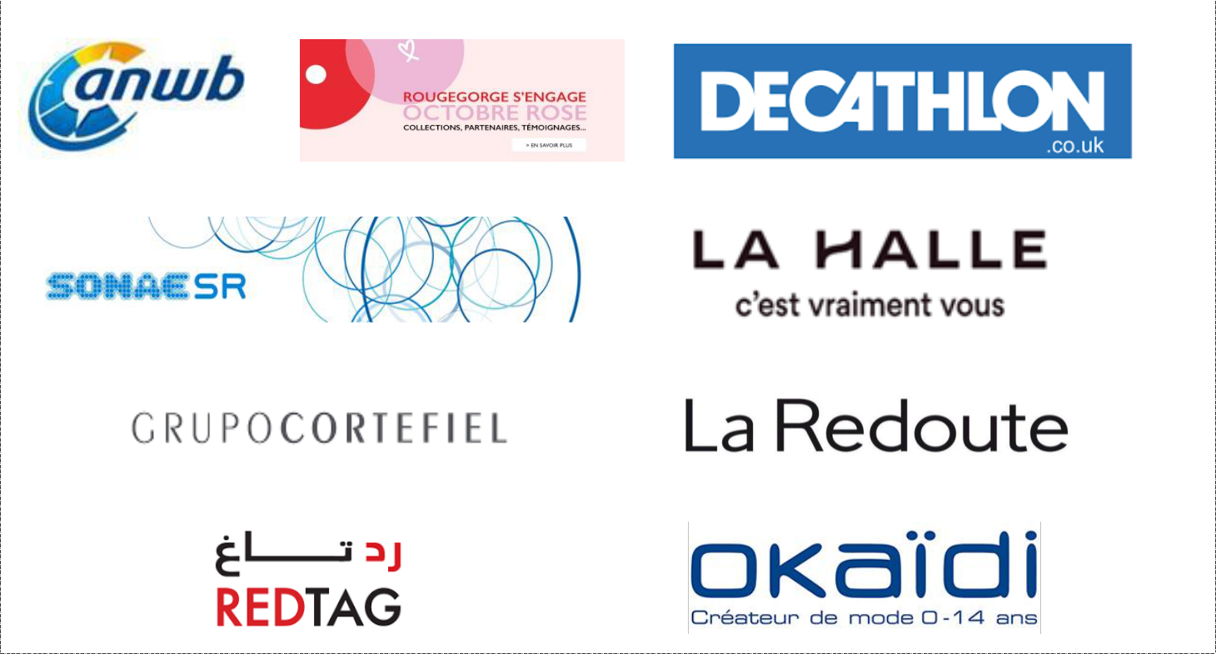

**KNITS CATEGORIES:-**



* All types of Baby garments like Romper, Sleep suit, Pyjama set, tops and bottom, bip.
* All types of women’s garments like tops, leggings, hoodies , sweat shirts, big shirt,nighties.
* All types of men’s garment like tops, joggers, hoodies, sweat shirts.



**WOVENS CATEGORIES**



* Men’s wear Y/D shirt, Trousers, Denim shirt.
* Girls Woven Tops, Tunic tops, Denim tops, Sweaters, etc.
* Women’s beachwear, women’s dresses, combi short’s and tunique’s.



**CERTIFIED COURSES:**



* Completed Knitwear Manufacturing technology (KMT) professional course in Textile oriented area under the control of AEPC.



**ACADEMIC CREDENTIALS:**



* Completed **BBA** from SRM University, Kattankulathur with a percentage of 60 (2010-2013).
* Completed 12th from Century Foundation Matriculation Higher Secondary School with a percentage of 69(2010).
* Completed 10th from Century Foundation Matriculation Higher Secondary School with a percentage of 62(2008).



**CO-CURRICULAR ACTIVITIES:**



* Participated in State Level Inter-Collegiate Seminar “Role of service Sectors in India” (Bizard 2010).
* Volunteered in an “Internal Business Administration Fest” on 22nd March 2012 (Bizard 2012).
* Participated in the International conference on “Contemporary issues in Management” (Bizard 2013).
* Undergone a five-day workshop on “Employability Enhancement” conducted by “Speed Learning Recourse” at
* SRM University, Kattankulathur.



**KEY COMPETENCIES AND SKILLS**



* Comprehensive problem-solving abilities.
* Excellent verbal and written communication skills.
* Ability to deal with people diplomatically.
* Willingness to learn, team facilitator and hard work.



|  |  |  |  |  |
| --- | --- | --- | --- | --- |
| **PERSONAL DETAILS** | |  |  | |
| Date of Birth | | | : 28 - Oct – 1992 | |
| Languages | | | : English, Tamil, Hindi. | |
| Marital Status | | | : Single | |
| Nationality | | | : Indian | |
| Father Name | | | : Akil john | |



**DECLARATION**



I hereby declare that the information and the facts stated above are true and correct to my knowledge.



**Place:** Gurgaon



**Date:** **(Syed Sajudeen A)**

