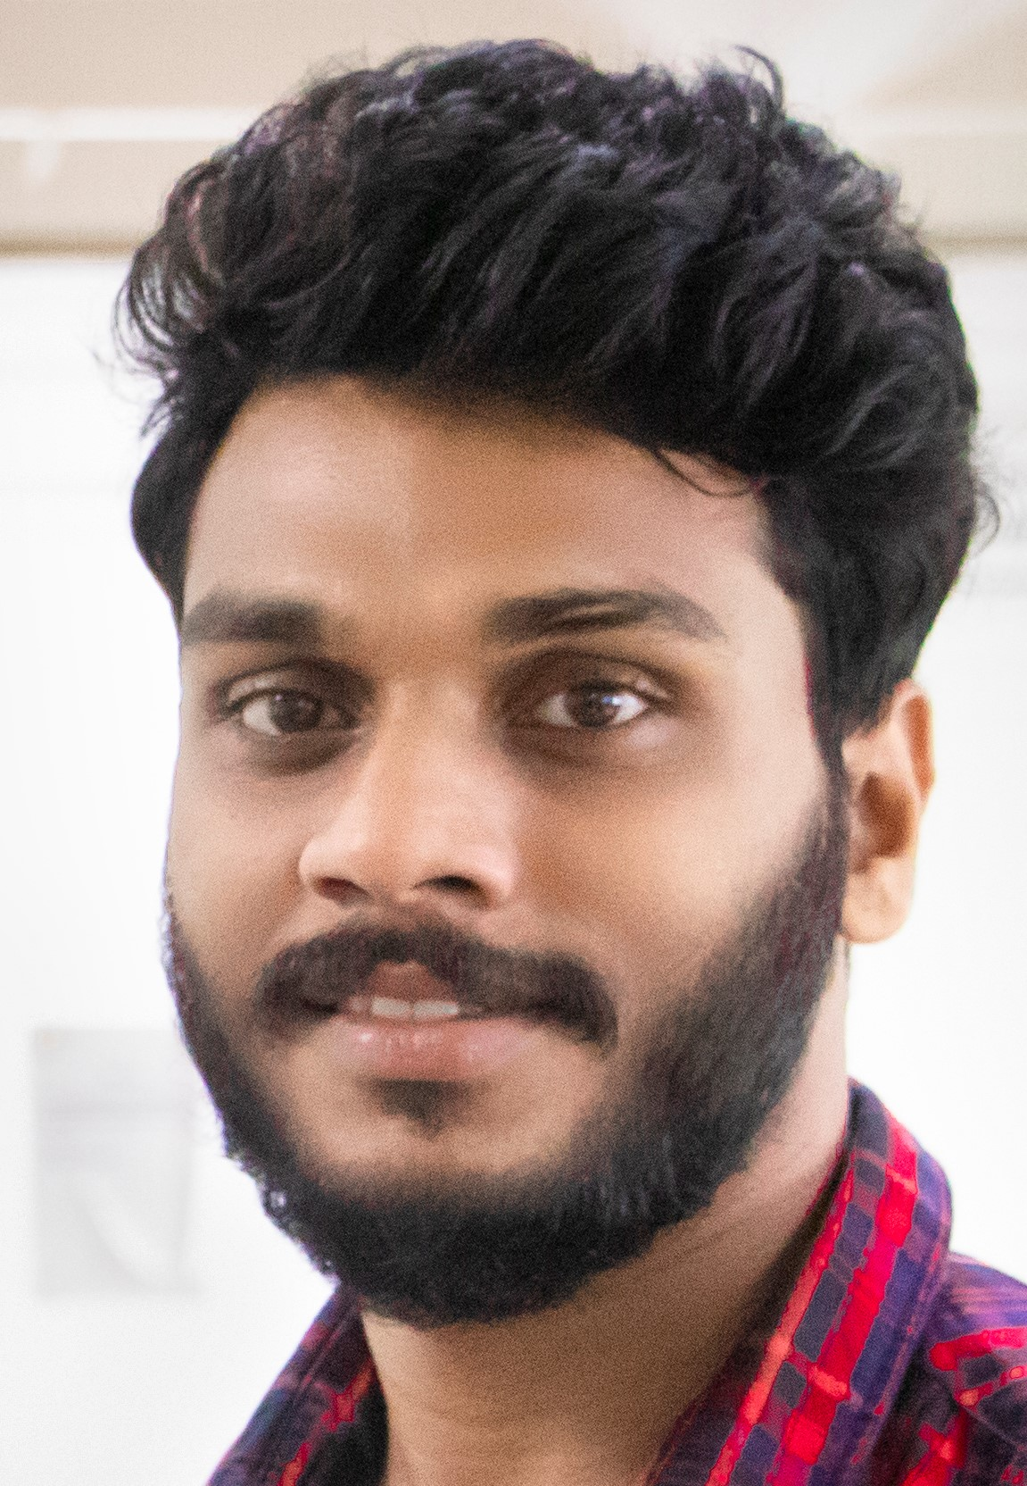 CURRICULUM VITAE
RAHUL CHANDRAN K
Mob: 9539834479
E-mail:rahulrcrahul3@gmail.com

CAREER OBJECTIVE

- My objective is to encounter a firm that will enable me to grow as a professional and as an individual and to adoptable in the working environment and to contribute my knowledge and work experience towards the growth of the organization and myself.

Educational Qualification

Academic qualification | institution | university | Year of Passing
B.Com with Finance | Christ College, Kerala India | Calicut university | 2013-2016
Plus Two (CBSE) | Kendriya Vidyalaya, Kerala India | CBSE Syllabus | 2012-2013
CBSE | Kendriya Vidyalaya, Kerala India | CBSE Syllabus | 2010-2011

Computer skills
Database management – MySQL
Advanced Skill – Manual AND Automation testing
Accounting Software – Tally 7.0
Office applications – Microsoft Office
Packages – Adobe Photoshop, Page Maker, Photo Editor

WORKING EXPERIENCE

Dec 2016 – Aug 2017 - ICICI Prudential Insurance, Kerala India
Department: Insurance Role: Financial service consultant
Responsibilities: Claims screening & preparing financial statements etc.

Aug 2017 – Nov 2018 - Indian Cement House
Department: Accounts Role: Junior Accountant
Responsibilities: Collection, Receipts, Payment Vouchers etc.

Feb 2019 – srit india PVT
Department –IT Role : Implementation Engineer
Responsibilities: communicate with project stakeholders,Identify & understand clients requirements
& expectations.
- Assigning clients requirements to team
- preparing RFP, UAT ,Reports & demonstrate / training of product to client
- Supporting and giving solution to clients query
- Working on UAT,ST,IT,UT,MT and the modules and the quality assurance of the application
- Coordination with client understand the requirements and communicate internally
- travel as per the project requirements

COMPETENCY
- Sensing underlying needs and opinions of individuals.
- Excellent listener, patient and sensitive to clients needs.
- Quick learner with proven problem-solving skills with result orientation.
- Belief in teamwork both as a team leader and team player.
- Quick decision making and having strong implementation knowledge

ACHIEVEMENTS
- Participated in under19 National Cricket
- Event organizer in school and college functions
- Participated in management meets conducted by college.
- Participated in College and School literary competitions.

PERSONAL DETAILS
Date of Birth : 16/05/1995
Gender : Male
Nationality : Indian
Marital Status : Married
Blood Group : A+ve

LINGUISTIC ABILITY
Languages Known | Can Speak | Can Read | Can Write
English |  |  | 
Tamil | 
Hindi |  |  | 
Malayalam | 

Declaration
I do hereby acknowledge that all the information given above is true to the best of my knowledge and belief.

RAHUL CHANDRAN K

