|  |
| --- |
| **MOBILE :** *+91 8085700682*  **EMAIL :** *yash7khare@gmail.com*  **DATE OF BIRTH :** *07 Sept 1995* |

**YASHASWI**

**KHARE**

**CAREER OBJECT**

To work with a company which appreciates innovation so that I can enhance my knowledge and skills to give my best for the growth of the company.

PROFILE

* Comprehensive knowledge of primary development languages for instances C, C++, JAVA.
* Deep understanding regarding data structure and SQL.
* Excellent in presenting and make people understand.
* A detail oriented & multitasking professional with basic coding techniques having bachelor of engineering degree in computer science technology.

**PROJECT UNDERTAKEN**

**BUS RESERVATION SYSTEM** The focus of the project is to computerize travelling company to manage data, so that all the transactios become fast and there should not e any error in transaction. It replaces all the paper work. It keeps record of all bills also, giving to ensure 100% successful implementation of the computerized bus reservation system.

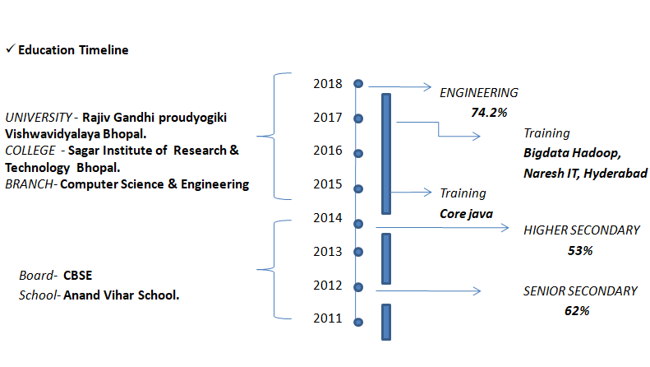

TRAINING & CERTIFICATION

* Vedisoft, Bhopal – CORE JAVA
* Vedisoft – C,C++
* SQL Database
* Data Structure

EXPERIANCE

Working in R1Rcm, pvt. limited, Gurgaon, from 1 year as a ANAYST.

PERSONAL QUALITIES.

* + Strong leadership and patience full skill.
  + Good communication and presentation skills.
  + Able to give the best result in pressure situation.

WHO AM I?

**LANGUAGE**

DECLARATION: I hereby declare that all the above mentioned information given by me is true and correct to the best of my knowledge and believe.