CURRICULUM VITAE
NAME : SUJAY DEBNATH 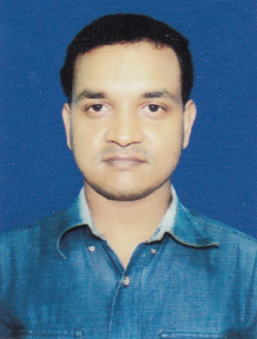
FATHER’S NAME : LATE DULAL DEBNATH
DATE OF BIRTH : 8TH OCTOBER 1987
SEX : MALE
RELIGION : HINDU
CAST : OBC – B
ADDRESS : VILL = UTTARAYAN (NEAR BAKE TAKE)
P.O = ALIPURDUAR COURT
DIST = ALIPURDUAR,
PIN =736122 (M) : 9641034421,
EMAIL ID: sujaydebnath.apd@gmail.com
CARRIER OBJECTIVE :
Exploring Career progression opportunities with challenges in a leading organization, where I can utilize my professional skill and leadership quality to make a tangible contribution to the growth of the organization and my self.
ACADEMIC QUALIFICATION :

COURSE NAME | NAME OF BOARD/UNIVERSITY | FULL MARKS | MARKS OBTAINED | PERCENTAGE | DIVISION
M.P | WBBSE | 800 | 506 | 63.25 | 1ST
H.S | WBCHSE | 1000 | 621 | 62.1 | 1ST
B.A | N.B.U | 1550 | 784 | 50.50 | 2ND
M.A | B.U | 800 | 334 | 41.75 | 2ND

PROFESSIONAL QUALIFICATION:

NAME OF COURSE | NAME OF BOARD/ UNIVERSITY | FULL MARKS | MARKS OBTAINED |  | PERCE-NTAGE | GRADE
MBA | SIKKIM MANIPAL UNIVERSITY | 5000 |  | 2850 | 57
CIRTIFICATE IN INFORMATION TECHNOLOGY APPLICATION (CITA) | YOUTH COMPUTER TRAINING CENTRE |  |  |  |  | "A+”
ADVANCED DIPLOMA IN SOFTWARE TECHNOLOGY (ADST) | ECIL-ECIT  (HYDERABAD) | 400 | 267 |  | 66.75 | “A”
CIRTIFICATE IN ACCOUNTING (TALLY) | SWAMI VIVEKANANDA VOCATIONAL COMPUTER TRAINING CENTRE |  |  |  |  | “B+”

PROFESSIONAL EXPERIENCE:

PERIOD/ TIME | DESIGNATION | COMPANY NAME | SKILL
From 12th July, 2012 to 7th December, 2013 | As an Office Executive | Vikdas Industries Pvt.Ltd. | Maintained office management and cash accounts.
From 9th December, 2013 to 31st January, 2015 | As an Assistant Accountant With Tally | The C.A Firm & Forest Office of Buxa Tiger Reserve Conservation Foundation Trust (BTCFT) | Maintained Accounts in C.A Firm & Compiling Accounts In the BTCFT.
FROM 3rd March,2015 to 23RD JANUARY, 2016 | As an Accountant & Office Administrator | Youth Computer Shaksharta Mission (YCSM) | Maintaining Accounts & Administrator of the Corporate Office & also handling the Staffs and Accounts of Main & others Branch of YCSM.
From 23RD Feb.2017 to Dec, 4th,2017 | B.D.E & Branch Coordinator | Mahatma Gandhi Youth Computer Education | Maintain Branch and office
From 5th Dec,2017 to till date | Accountant | Kaysons Automotive Pvt.Ltd. | All types of accounts maintaining

PLACE: ALIPURDUAR DATE: SIGNATURE OF APLICANT

