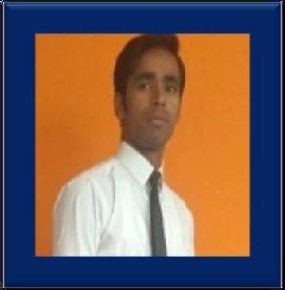

**DOB- 25.05.1998**

**Strengths& Hobbies**

* **Strong Mentality**
* **Situation Handling**
* **Self believe**
* **Keep Silent**
* **Quotes Reader**

**Study Programs**

**Course University Marks Passing Years**

**B.Tech RGPV(MP) 6.84(CGPA) 2021**

**I.Sc BSEB(PATNA) 261/500 2017**

**Matric (10th) BSEB(PATNA) 297/500 2015**

**Programming**

* **C / C++**
* **Python**
* **HTML**

**Profession :**

**Name Height(Ft) Weight(kg)**

**Mohammad Nehal 5.3 Ft. 48.00**

**Blood Type Civil Status Religion**

**O+ Single Islam**

**Financial Works,**

**Social Activity (CSC),**

**Online Documents Working**

**(Pan, Passport, Voter Id Reg., Form Filling, Resuming & Many More)**

**EXPERIENCES: APPROX 02 YEARS**

**HINDI**

R(high) W(high) S(high)

**ENGLISH**

R(high) W(normal) S(low+)

**URDU**

R(normal) W(normal) S(normal)

**BR. LOCAL**

R(high) W(normal) S(high)

**Key Points**

* **R- READING**
* **W- WRITING**
* **S- SPEAKING**
* **Ms Office,**
* **Google Doc,**
* **Editing,**
* **Pdf Handling**

**At. Bherihari,**

**Po- Murli Parsauni,**

**Ps- Purushottampur,**

**Dist- West Champaran, Bihar- 845307 (IND)**

**Pro Skills :**

**Address :**

**MOHAMMAD NEHAL**

Mob: **+91 8651711925 / 8789352653**

Email: [mdnehalizak@gmail.com](mailto:mdnehalizak@gmail.com) , [mdnehalmo@gmail.com](mailto:mdnehalmo@gmail.com)

**Profile :**

**Extra Activities**

**Educations**

**Overview**

**Languages :**