|  |  |  |
| --- | --- | --- |
| E:\New Volume\brochure\achievements\IMG_20180712_083757015.jpg | **Challa Raghunath Reddy**  23-6-202/5, Dwarakanagar, Hunter Road, Hanamkonda  Warangal 506001, Telangana  Telephone +91.09866101718  challaraghu4srv@gmail.com |  |

|  |  |
| --- | --- |
|  | **About Me** |

I have rendered my services in the field of education for more than 20 years as a teacher, lecturer and principal/correspondent having essential qualifications MA in English and B.Ed. I have established and run two schools successfully with a vision to avoid psychological as well as physical burden of the children. My experience, skills, competencies, passion and commitment will surely help me to dedicate to continuously improve our educational system for the benefit of our children and the institution I work for.

|  |  |
| --- | --- |
|  | **Skills** |

* Dedication to ensure the quality of education for the benefit of the children
* True passion towards education
* Excellent in planning academic and co-academic areas, motivation and decision-making
* Ability to communicate well and maintain good rapport with the parents and other staff
* Knowledge to monitor and supervise the school accounts.
* Basic computer knowledge and can work on word, excel etc.,

|  |  |
| --- | --- |
|  | **Education** |

**Bachelor of Arts (History, Economics and Civics)**

|  |  |
| --- | --- |
| Government Degree College Warangal, Telangana | May 1991  Division II |

**Master of Arts (English)**

|  |  |
| --- | --- |
| Kakatiya University Warangal, Telangana | May 1993  Division II |

**Bachelor of Education(English and Social Studies)**

|  |  |
| --- | --- |
| Kakatiya University Warangal, Telangana | August 2005  Division I |

|  |  |
| --- | --- |
|  | **Work Experience** |

June 2011 - April 2019

**PRINCIPAL**

LEAD INDIA SCHOOL

Warangal, Telangana

The founder of LEAD INDIA SCHOOL (CBSE) and served the institution as a Principal/Correspondent.

June 2001 - April 2011

**PRINCIPAL**

SREE RUSHI VIDYALAY

Warangal, Telangana

One of the main founders of the reputed school SREE RUSHI VIDYALAY and maintained it as a Principal/Correspondent for 10 years.

June 1994 - May 2001

**Teacher and Junior Lecturer in English**

Private Colleges

Warangal, Telangana

Taught English to the students from grades 8th to 12th.

|  |  |
| --- | --- |
|  | **Accomplishments and Achievements as a Principal/Correspondent** |

I have got a vast experience of 24 years in the teaching field.  I have been a passionate teacher for the entire tenure and an able Correspondent/Principal for more than 15 years.  I have established and maintained successfully two schools SREE RUSHI VIDYALAY with 1200 students and LEAD INDIA SCHOOL (CBSE) with 750 students which stood among the top reputed schools in our district.

* Established two schools with an innovative concept of ‘***No carrying of heavy loads’***. We introduced a complete semi- residential system for the day scholar children so that all the home work was done by the children in the school itself under supervision of the tutors/teachers. Resultantly, no carrying of heavy loads of books to take home.
* Constructed own school buildings with all official procedure and permissions.
* Maintained buses for safe transportation for almost 600 students
* Maintained hostel with 600 students with mess and accommodation.
* Involved in financial aspects like preparing the budget plans and income and expenditure.
* Conducted timely review meetings with teaching personnel soon after every test/exam to have results analysis.
* Held regular meetings with teaching and non-teaching staff for an effective execution of academic and co-academic aspects.
* Planned and implemented several co-curricular activities which re-energized the children to concentrate on academic subjects.

**Some of the successful milestones in my journey as a principal in the service of better education:**

**NATIONAL LEVEL SELECTION** of a Science Fair project prepared by the children on ‘***Recycling of Polluted Water***’.

**INTERNATIONAL SCHOOL AWARD (ISA)** by British Council, UK, in Chennai in 2017.

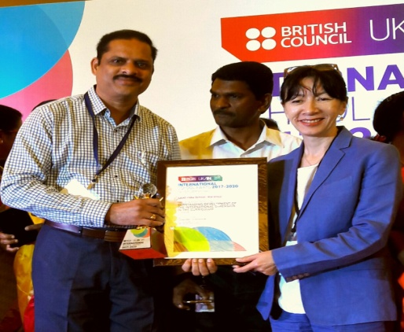

**BEST TEACHER AWARD** at Dist. Level by Telangana State Government in 2016.

**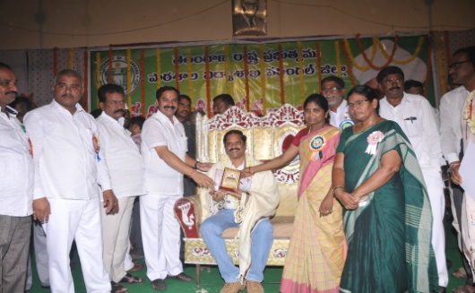**

**SCHOOL EXCELLENCE AWARD** by Brainfeed Magazine in New Delhi in 2016.

**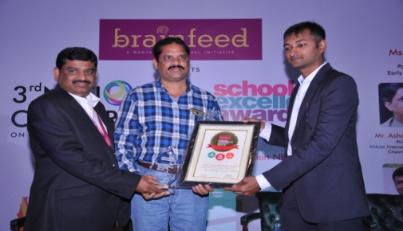**

**WIPRO EARTHIAN AWARD** by Wipro Technologies in Bangaluru in 2015.

**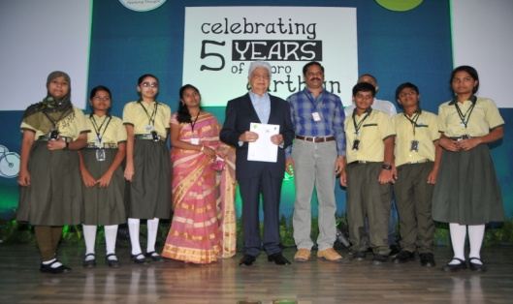**

**ACHARYA DEVO BHAVA AWARD** by Brainfeed Magazine in Vijayawada in 2015.

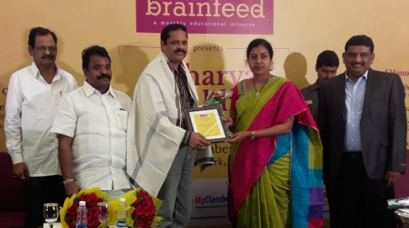

**INDIAN ACHIEVERS' AWARD FOR EXCELLENCE IN EDUCATION** by Indian Achievers' Forum, New Delhi in 2014.

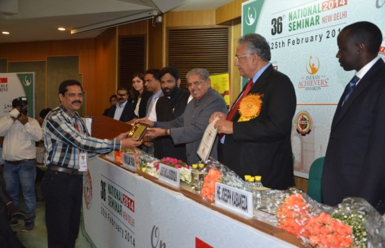

|  |  |
| --- | --- |
|  | **Languages** |

* English and Telugu

|  |  |
| --- | --- |
|  | **Personal Details** |

|  |  |  |  |
| --- | --- | --- | --- |
| Father’s Name:  Birthday:  Gender: | Mr. Chandra Reddy  August 24, 1970  Male | Marital Status:  Nationality: | Married  India |

**Declaration**

I, Challa Raghunath Reddy, hereby declare that the information contained herein is true and correct to the best of my knowledge and belief.

|  |  |
| --- | --- |
| Challa Raghunath Reddy | Warangal, Telangana  June 23, 2019 |