**RESUME** 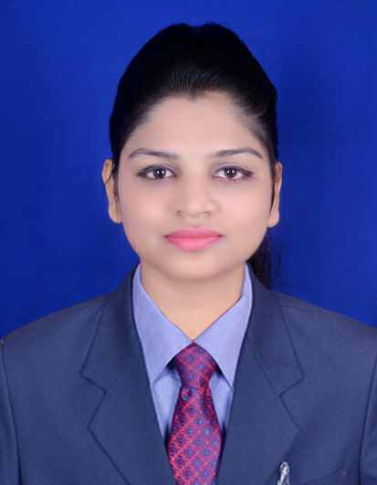

**SUCHISMITA MOHANTY**

Email : suchismita631@gmail.com

Mobile : +91-7008668949

|  |
| --- |
| **Career Objective** |
| * To pursue a challenging career in a progressive environment where learning, innovation and creativity are encouraged, where my skills & knowledge can be enhanced to their maximum potential to contribute to the overall success and growth of the organization |

**My Self**

I am a person with positive attitude, self-confidence, quick learner, who works whole-heartedly in each and every activity taken up and thereby achieves excellence. I consider myself to be a work-oriented person having assets of intellectual knowledge, sociability and a flavor to do work in any atmosphere.

**Education**

|  |  |  |  |  |  |
| --- | --- | --- | --- | --- | --- |
| **Degree** | **Branch** | **Year of Passing** | **College/School** | **University/Board** | **Percentage** |
| Bachelor of Technology | Electronics &communication | 2014 | Maharaja Institute Of Technology,Bhubaneswar | Bijupattnayak University Of Technology,Odisha | 68% |
| Diploma | Electronics & Telecommunication | 2010 | Bhubaneswar Polytechnic,Bhubaneswar | State Council For Technical Education & Vocational Training,Odisha | 67% |
| HSC | - | 2007 | Acharya Pearymohan Bidyaniketan,Cuttack | Board Of Secondary Education,Odisha | 57% |

**Technical Skill set**

|  |  |
| --- | --- |
| **Skills** | **Details** |
| Programming Languages | C,C++, .NET, coreJAVA, |
| Operating Systems | MS Windows XP, Windows 7,Windows 8 |
| Database | Oracle-SQL,PL-SQL |

**UG Engineering Project - Details**

|  |  |
| --- | --- |
| Project Title GSM BASED ROBOTIC CAR CONTROL | |
| Domain | * System is accessible in the remote areas |
| Project Description | In this project the robot is controlled by two mobile phones.One mobile is a sender or transmitter section and another one is receiver section.When a sender mobile is called to the receiver mobile then the receiver mobile receives the call automatically because the receiver mobile is set in automatic answering modes.The receiver mobiles receives the call automatically because there is an ear cord is connected.It can work anywhere in the World. |

**Mini Project - Details**

|  |  |
| --- | --- |
| **Project Title ACTIVE INFRARED MOTION DETECTOR FOR HOUSE SECURITY SYSTEM** | |
| **Project Description** | This project is focusing on developing a house security system with an active infrared motion detector which is controlled by microcontroller intel 8051.To develope of this whole project it consist of three methods which are the concept of security system,the electrical structure and the softwareprogramming. |

**Personal Skills**

* I have good communication skill and exceptional creative idea.
* Have good patience which I believe will lead to better human relation.
* Good in team work and team leading.

**Area of Interest**

* Telecom-Mobile Technology
* IT/Telecom-Software
* Software Developing
* Network Engineer

**Achievements**

* Obtained Zonal level Prize in Singing
* Organized school level functions and Sports meet.
* Participated in Singing, Quiz held in other Engineering colleges and seminars.

**Leisure Interest**

* Listening Music
* Search in google about different countries
* Travelling
* Sport

EXPERIENCE.1

**Customer Service Representative**

Feb 2019 to Sep 2019 (7 months)

**Communicate with customers through a variety of communication channels and make a positive difference in their day Gain experience, take TTEC University courses and develop new skills. Receive recognition, bonuses and performance-based rewards Build diverse friendships Participate in fun employee engagement activities.**

EXPERIENCE.2

**Customer Service Associate**

Tech Mahindra

Aug 2018 to Feb 2019 (6 months)

address customer issues and resolve them in a timely and efficient manner. Support reps interact with customers on a variety of channels such as phone, email, and social media, and ensure that all valid customer concerns are being dealt with immediately.

**PLACE : AHMEDABAD SIGNATURE**

**DATE :**  **[Suchismita Mohanty]**