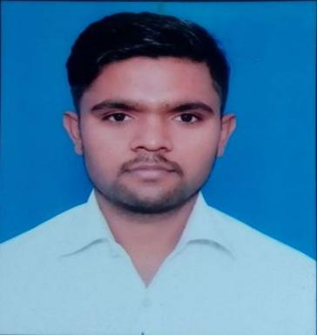**CURRICULUM-VITAE**

**SUBHASH BHARTI**

**Address:- B-2638 PH-2 METRO VIHAR**

**HOLAMBI KALAN DELHI 110082**

**E-MAIL ID:-[subhashbharti68@gmail.com](mailto:subhashbharti68@gmail.com)**

**Mob No:- +91 8826324930,9953111155**

# Career Objective

* To continuously learn and widen my experience by working in an organization that can promote both professional and personal growth, which acknowledge handwork & where I can apply my skills and knowledge so as to contribute towards the success of the organization.

# Education Qualification

* 10TH Passed From CBSE Board in 2009
* 12th Passed From CBSE Board in 2011
* Graduation B.A. From Delhi University in 2016

# Professional Qualification

* 6 Month Basic knowledge of Computer (Ms-Office) From MSME
* A+ & N+ From NIIT
* 6 Month Retail Course From NIFA

**AREA OF EXPERTISE**

* Search Engine Optimization, SEM, PPC, Digital Marketing.
* Customer Service, Time Management, Decision Making & Problem Solving ability.
* Vendor management & Building relationship.
* Stock management.
* Dealer & Distributer relationship and development.
* Advance Planning and cost reducing.
* Retail Sales Management. Channel Sales Management.
* Budgeting at store level & Inventory Management.
* Leadership & Motivational skill. Team Player.

JOB EXPERIENCE

* 1 year experience in EASYDAY (FUTRE GROUP LTD) as TEAM LEADER managing day to day operation activity, inventory, team handling, P&L, food safety FIFO FEFO, stock management, roaster management, cash-ring, MIS reports, daily reports file, cash management, handling home delivery, etc.
* 2 year experience in VODAFONE INDIA LIMITED as Customer Care Executive. Providing resolution via calls and emails and as well as direct interaction.
* 2 year 6 month experience in COSTA COFFEE As a Sr CSA. Making coffee and service to our customer, taking order as cashier and managing inventory on daily basis along with team handling.
* Six months experience in Web Creazzion as a SEO Executive at Pitam Pura, Delhi. Doing Off Page SEO online marketing for different type of products Directory Submission, Classifieds, Listing

**PERSONAL DETAILS**

* Father’s Name : Sh. Prem lal
* Date of Birth : 12th March 1994
* Gender : Male
* Nationality : Indian
* Marital Status : unmarried
* Language Known : Hindi & English
* Hobbies : Reading, Travelling, Shooting & Detectivty

**Date……………. Place…..………**

**Subhash**