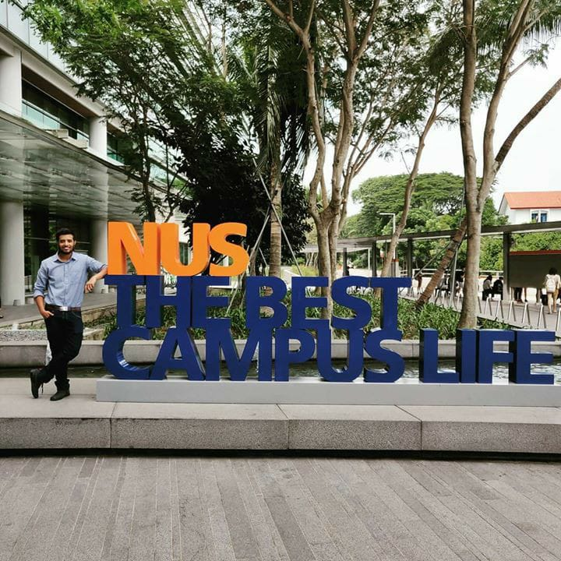

**Saurabh Padalikar**

+65 97155096| [saurabh.padalikar4@gmail.com|](mailto:saurabh.padalikar4@gmail.com|)

#03-23, Village @ Pasir Panjang,

463 Pasir Panjang Road,

Singapore 118684

**EXECUTIVE SUMMARY**

With extensive experience as a software development analyst through my previous work experiences in private sectors, I am highly organized, efficient and pro-active. After completing my Bachelor’s in computer science from University of Pune, I was placed in Accenture as a part of the campus recruitment process from the college. After working at Accenture for 2.7 years as a software developer, I was ready to dive deeper into the field of software engineering.

I opted for Master of Technology in Software Engineering at one of the Asia’s finest universities in National University of Singapore. As a part of the course, I studied a variety of modules DevOps, Big Data Engineering, Solution Architecture, also touched a base to CISSP. I was involved in various group projects during the course which involved all these amazing technologies. I completed an internship in the R&D department of Sivantos, who are into hearing aid manufacturing with their headquarters in Singapore.

**KEY SKILLS**

Java, Software Design Patterns, SOLID principles, Spring boot, MySQL, Hibernate, REST API, Web Services,

.net core, C#, Entity Core Framework, Apache Spark, Scala

Cloud: Microservice Architecture, Jenkins, Docker, Kubernetes, Microsoft Azure DevOps

**PROFESSIONAL EXPERIENCE**

**Intern Jan 2020 to April 2020**

**Sivantos Pvt. Ltd (Singapore)**

Achievements:

* Constructed multiple Proofs-of-Concepts in-order to build Big Data Solutions in software R&D team using .net core for building multiple microservices based on REST API and Apache Spark for data analytics. Swagger was used as the tool for API documentation.
* Deployed machine learning solution on an on-premise Nutanix Karbon Kubernetes solution with a CI/CD pipeline in Azure DevOps Server.
* This pipeline was configured to poll changes in a git repository, build docker images and push them to Azure Container Registry and later deploy these images in an on-premise Nutanix Karbon Kubernetes.

**Application Development Analyst Jan 2017 to July 2019**

**Accenture (India)**

Achievements:

* Devised development and maintenance of Web APIs for a proprietary pension solution which involved creating microservices leveraging Java Spring boot, Hibernate, MySql using tools such as Oracle DB, Swagger, Postman, SoapUI.
* Led the development team for design and maintenance of Devops CI/CD pipeline on a Jenkins sever where in code is getting pulled, built from a git repository and docker images getting built and deployed on client servers.
* Received award for Best Employee for half yearly period from clients in 2019.

**Intern July 2016 to Dec 2016**

**TechLeaper Technology (India)**

Achievements:

* Technologies used: Java, HTML, CSS, PHP.

**EDUCATION**

Master of Technology (Software Engineering) July 2019 to July 2020

National University of Singapore **(CAP: 3.86/5)**

Bachelor of Engineering (Computer Science) May 2011 to May 2016

University of Pune **(First Class)**

**PROJECTS**

**Online Cloud Compiler – (***Centralized Compiler for CUDA,*

*BeagleBone, java, C++***)**

* Developed a Centralized Compiler hosted on cloud for CUDA, Beaglebone, C++, Java.
* Technologies used: Java, MySQL, REST web services, PHP, HTML 5.

**Eat-n-Greet – (***A platform where people can meet over a meal*

*at the host’s place***)**

* Eat-n-Greet is a platform that tries to solve one of the many problems that an individual face when he/she moves into a new city/country. As nothing can beat the perfect blend of appetizing food and amicable company, our platform helps in finding both around you.
* Followed the microservice architecture with four major microservices each with its own database.
* The microservices interact with the frontend as well as amongst each other via REST calls.
* The DevOps pipeline is hosted in Jenkins on Microsoft Azure cloud. The pipeline is configured for building docker images and pushing them to Dockerhub followed by deploying them in Kubernetes cluster hosted on Microsoft Azure cloud.
* Technologies used : Microservice Architecture using Spring Boot, MySQL, REST API, Postman, Swagger, Jenkins, Docker, Microsoft Azure Kubernetes.

**Real-time logs processing**

* Built a data analytics engine based on stream processing principle using Apache Spark Stream Processing.
* Solely designed and devised the Spark engine including storing of the processed data and querying on it.
* Technologies used: Apache Kafka, Apache Spark Streaming, InfluxDB, Grafana.