CURRICULUM VITAE
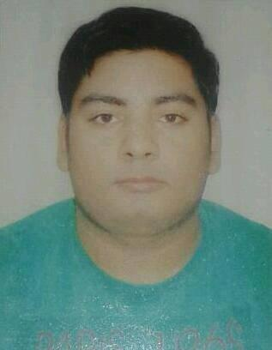
RAMKRISHNA CHAUBEY
Vishnu Nagar
Sarojani nagar,
Kanpur Road, Lucknow,
Mobile no:- 8853361051,
Email:- rchaubey969@gmail.com

CAREER OBJECTIVE:-

I am seeking a position so as to explore my ideas and balance towards the growth of the Organization I will join. I also want to utilise my skills and efficiency to the best possible level. I am willing to work as a key member in challenging and creative environment with committed and dedicated people.”

WORK EXPERIENCE:-

More than Six years of Experience.

NFLF Agency as a Accountant,Feb 2018 to till date

JOB PROFILE
DESIGNATION | Accountant
COMPANY | NFLF Agency
ROLE | Handling billing and company Account.

- Successfully handling of company works.

Maa Vaishnav Associate Agency as a MIS, Apr 2017 to Feb 2018.

JOB PROFILE
DESIGNATION | MIS
COMPANY | MVA Agency
ROLE | Handling Data and Company Work.

- Successfully handling Company Work and good performance.

Telenor as a CAO,May’2012 to March 2017.

JOB PROFILE
DESIGNATION | Customer Activation Officer
COMPANY | Telenor
ROLE | Uploading customers details in Telenor portal.

- Handling caf activation process (Unnao district).
- To get smooth activation as per company guideline.
- To implement the caf process at DTR Point.

ACADEMIC QULIFICATION:-

- High School passed from U.P. Board.
- Intermediate passed from U.P.Board.
- BA from Kanpur University.

COMPUTER SKILLS:-

- Basic knowledge in Computer.
- Diploma in computer science
- Three months certificate in computer application.
- Four months certificate in computer D.T.P course.
- MS OFFICE : Word 2003,2007 Excel 2003,2007 Power Point 2003,2007.
- Internet Oprations : All types of basic work an Office

STRENGTH:-

- Hard-working and try to give best during work.
- Very punctual and have the ability to generate ideas that is creative in nature.
- Enthusiastic & Creative Person, look the things in a different view.

HOBBIES AND PASSTIMES:-

- Travelling
- Play with Gadgets
- Reading stories and poems

PERSONAL DETAILS:-

Father’s Name : Lal Bahadur Chaubey
Language Known : English, Hindi
Nationality : Indian
Date of Birth : 05 feb 1992
Marital status : Married

DECLARATION:-

I hereby declare that all the satatements in this document are true,complete and correct to the best of my knowledge and believe.

DATE:
( RAMKRISHNA CHAUBEY )
PLACE: Lucknow

