**RESUME** 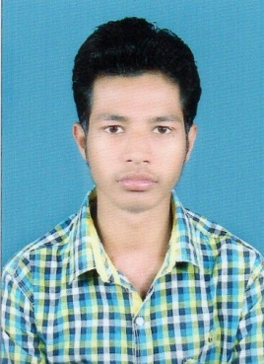

**NAME: PARWEZ ANSARI**

**ADDRESS: NEAR URDU LIBRARY, KULIPARA**

**CITY: SAHIBGANJ**

**PIN CODE: 816109**

**EMAIL ID:** [**ansaripawez787@gmail.com**](mailto:ansaripawez787@gmail.com)

**CARRER OBJECTIVE:**

**Looking forward to grow in a professional environment to the highest level and learn to excel in this trade with proper blend of knowledge, sincerity, hard work with full determination to achieve organizational as well as personal goal.**

**ACADEMIC QUALIFICATUON:**

|  |  |  |  |
| --- | --- | --- | --- |
| **NAME OF EXAMINATION** | **UNIVERSITY/BOARD** | **PASSING YEAR** | **PERCENTAGE GRADE**  **(%)** |
| **10th** | **JAC RANCHI** | **2013** | **53.4** |
| **12th** | **JAC RANCHI** | **2015** | **64.5** |
| **ITI** | **NCVT** | **2018** | **72** |
| **GRADUATION** | **IGNOU** | **2019** | **55** |

**EXPERIENCE:**

* **Worked with USHA MARTIN .Jamshedpur as a “PLUMBER” from “19th JULY 2016 till 11th MARCH 2019”.**
* **Working with BALAKRISHNA & COMAPNY ENGINEERS. Jamshedpur as a “PLUMBER” form 19th MAY 2019 till date.**

**STRENGTHS:**

* **Work with a positive attitude.**
* **Self – confident & great patience.**
* **Punctuality.**
* **Team work skills.**
* **Responsible**
* **Quick learner & a good listener.**

**Hobbies &Interests:**

* **Interacting with new people.**
* **Exploring new places.**
* **Listening to music.**
* **Cricket.**

**PERSONAL SKILL:**

* **Hard worker.**
* **Honesty.**
* **Punctual.**
* **Discipline.**
* **Optimistic.**

**PERSONAL DETAIL:**

* **Name : PARWEZ ANSARI**
* **Father’s name : Md.ISLAM ANSARI**
* **D.O.B: 24/05/1996**
* **MARITAL STATUS: SINGLE**
* **GENDER: MALE**
* **NATIONALITY: INDIAN**
* **LANGUAGE: ENGLISH, HINDI.**
* **Contact no. : 7903657357 ; 8936040882**

**DECLARATION: I hereby declare that the particulars of the information and facts stated herein above are true, and complete to the best of my knowledge and belief.**

**Dated: ........................ (PARWEZ)**