CURRICULUM-VITAE
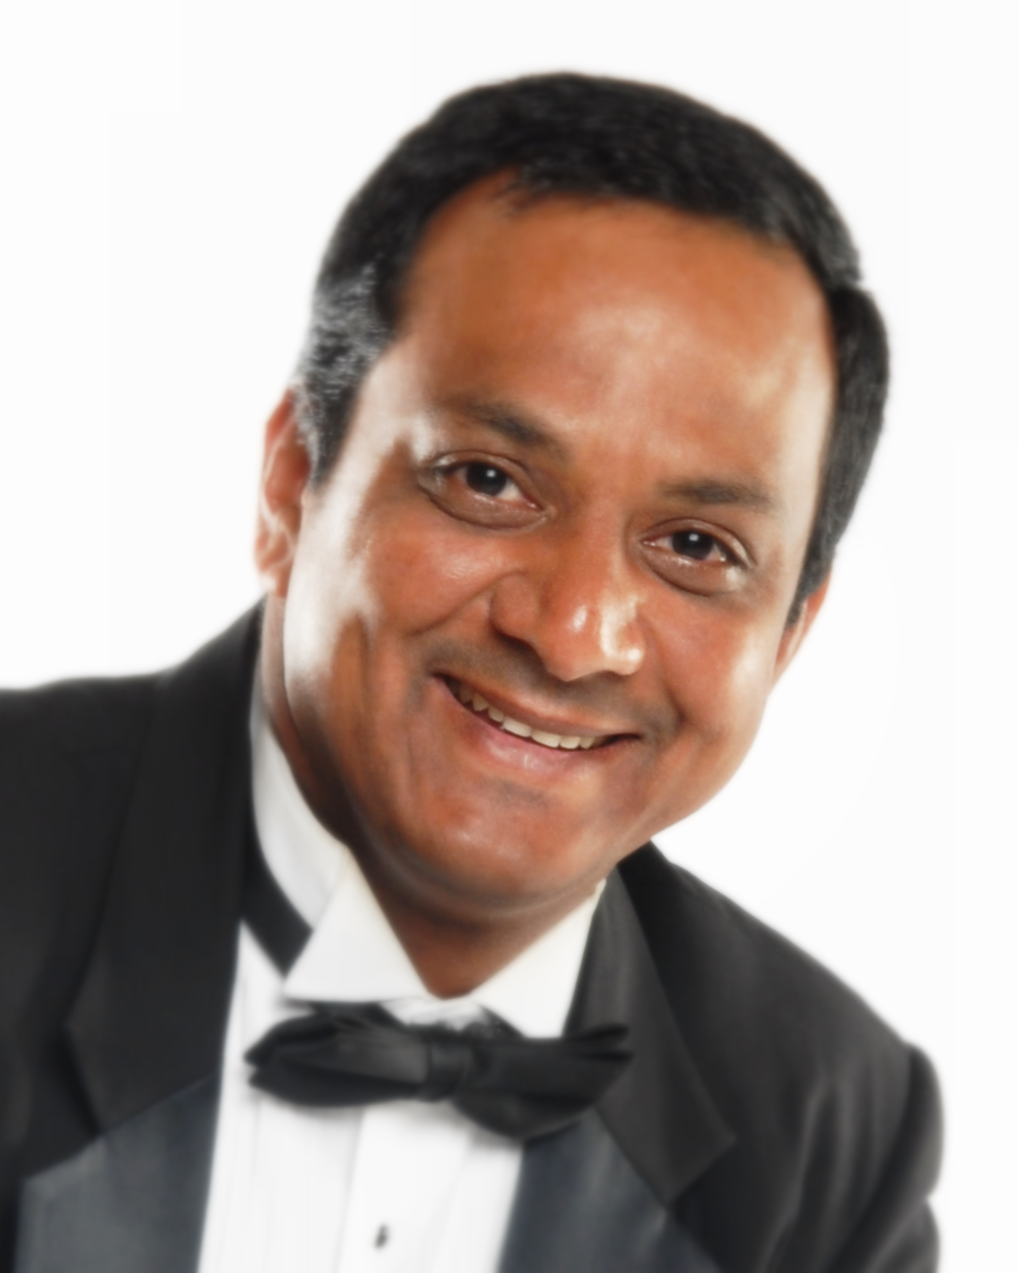

RAKESH CHAUHAN
ADD: House No. B-2, First Floor
Plot No. 62, Maidangarhi Ext.
New Delhi-110068 (INDIA)
PH: +91-9910540351
E-mail: rakeshphotog1@gmail.com

CAREER OBJECTIVES:
To initiate my career graph in a professional ambience, where I will get an opportunity to grow as well as contribute to my strength for the companies build up and achieving its goals.

ACADEMIC QUALIFICATION:
- Passed Delhi Senior Secondary School Examination from C.B.S.E, New Delhi.
- Graduate (B.A. Pass) from Delhi University.
- 3 Years Certificate course in Photography. (Ministry of Education, Bal Bhawan Society of India).
- Indian institute of Photography council Triveni Kala Sangam, New Delhi.
- Diploma course in Photography from Modern Institute New Delhi under the
supervision of Mr. T. Kashinath.

TECHNICAL QUALIFICATION:
Basic Safety Training Approved Safety training in compliance with STCW-95, Regulation V / 3-table AV / 2 including the following STCW-95 codes.USA
- A-VI/1-1 Personal Survival Techniques.
- A-VI/1-3 Elementary First Aid
- A-VI /1-4 Personnel Safety and Social Responsibilities:
Theoretical and Practical fire fighting.
- A-V/3-1 Crowd and Crisis Management training.
- A-V/3-3 Safety training for Personnel Providing:
Direct Service to Passengers in Passenger space.
- A-V/3-4 Passenger Safety
- A-V/3-5 Crisis Management and Human Behavior Training.
Crew safety and Security Awareness.
Drug and Narcotics Policy.
The Safety and Environmental Management System Hazardous Materials and Waste.
Theoretical Practical life raft and lifeboat training (2003).
- A-VI/1 Human Relationships, Survival Craft Basics.

WORK EXPERIENCE:

Done three contracts with image as senor photographer (Image Crop. Miami Florida USA) Royal Caribbean cruise line international.
Done two contracts with Ocean Images (U.K.) Celebrity Cruise line international
Done four contracts with Show Time Pictures M/s Norwegian Cruise line as Photo Gallery manger (Fort Lauderdale Florida USA)
Worked as main Photographer in News Men Features (Photo Feature Agency)
From Jan 91 till Dec 92.
- Worked as main Photographer in P.Q.R.S India (Tourism Photo Agency) from Jan 96 till Dec 97.
- Worked as Sports Photographer in Punjab Kesari (Daily Leading Newspaper India) from Jan 2010 to till Jan 2020.

PROFESSIONAL SKILLS:
- Sports, Fashion Industry, Politics, Journalism, Indoor Studio Work (Table top) Indoor - outdoor Shoot, Basic computer Photoshop CS4

PERSONAL PERSONALITY:
- Flair for Public relation and capability to convince and accept challenging assignments coupled with hard and sincere work and excellent communication skills.

SPECIAL ASSIGNMENTS IN NEWSPAPERS
Four Square River Rafting (Feb 1998 Shivpuri, Rishikesh)
- Kumb Mela (Feb 1998 Haridwar)
- Raid the Himalyan Car Rally (Sep 1998 Shimla to Ladakh)
- Kumbh Mela (Jan 2001 Allahabad)
- Cricket India V/s New Zealand (1999 New Delhi.)
- India V/s South Africa (2000 Faridabad , Nagpur & Baroda)
- Four Square River Rafting (March 2001 Devpryag to Rishikesh)
- India V/s Australia (Jan 2002 New Delhi)
- Sex workers, Eunuchs, Child Labor.
- Kumbh Mela (Jan 2013 Allahabad)

ASSIGNMENTS IN NEWSPAPERS:
- The Week, The Pioneer, Nav Bharat times, (Delhi) Khel Halchal, Aaj, Delhi Press, First City Parenting, Dainik Jagran (Delhi), Swagat, Namashkar, Discover India, Gulf News, Hindustan (Hindi) and Punjab Kesari.

ACHIEVEMENTS:
- Participated in Kumbh Mela Photo Exhibition organized by Uttar Pradesh State information Centre, New Delhi (INDIA).
- Solo Sports Photo Exhibition organized by Uttaranchal Sports Journalist Association and Delhi Sports Journalist Association New Delhi.

PERSONAL DETAILS:
Father's Name : Late Sh. B.S Chauhan
(Ex service man)
Date of Birth : 14-09-1971
Languages Known : English, Hindi
Address : House No. B-2, First Floor Plot No. 62,
Maidangarhi Ext. New Delhi-110068 (INDIA)
Passport no. : K 9522344 (Exp. on 20 Feb. 2023)
:
Marital Status : Married

(RAKESH CHAUHAN)

