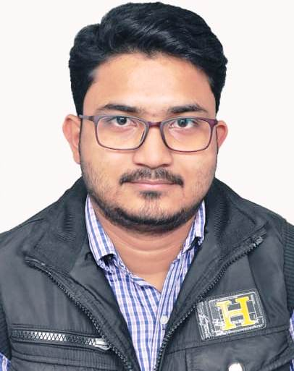
PRAVAT KUMAR PURKAIT (5.3Yr. Exp)
Contact No.: +91 8240245868(M) / +91 7278207633(M)
E-mail ID.: pkpurkait22@gmail.com / pravat.purkait91@gmail.com
Address.: 84, Monosa Bari Pirpukur road, Bansdroni,
Dist.: Kolkata; State: West Bengal; PIN: 700070

PROFILE SNAPSHOT

- Objective:
After complete 5.5yr. experience on Telecom sector looking for an opportunity with an Organization of reputation which will provide an opportunity to apply knowledge and skills and to be a part of the team working towards the growth of the organization which will be mutually beneficial for both. I want a challenging role to explore myself and contribute my knowledge and responsibility and also want to gain the same.

- Work Experience:

Employer’s Name | FROM | TO | PROJECT | ROLE
WELKIN TELECOM INFRA PVT. LTD. | SEP-2014 | SEP-2015 | Reliance JIO | SCFT and Cluster Drive Test by using XCAL
WELKIN TELECOM INFRA PVT. LTD. | OCT-2015 | FEB-2017 | Reliance JIO | RF Coordinator  (Planning & Team Coordinating & Analyze Report & Physical Optimization)
WELKIN TELECOM INFRA PVT. LTD. | MAR-2017 | DEC -2017 | VODAFONE  & AIRTEL  LTE | Team Coordinating and optimizing & report making(Post Processing by using TEMS Discovery & MapInfo)
LINKQUEST TELECOM INFRA PVT. LTD. | JAN -2018 | MAR-2018 | AIRTEL  LTE | Team Coordinating and optimizing network (Planning & Team Coordinating & Analyze Report & Physical Optimization).
BLUEBELLS SOLUTION PVT. LTD.  (SAMSUNG) OFF ROLE | APR-2018 | JUN-2019 | Reliance JIO | Optimizing Network (By E-tilt )& Analyze site( checking PRB Utilization,TA,Traffic,BBH) through JCP. .
WELKIN TELECOM INFRA PVT. LTD. | SEP-2019 | STILL NOW | VODAFONE  (VIL) | Report making of 2G 3G & 4G sites (Post Processing by using AZQ)

- Working Details :

- Optimizing network (E-Tilt & M-Tilt & Azimuth) & Analyze site to monitoring KPI, PRB Utilization, Traffic, Timing Analysis(TA) through JCP.
- Implemented E-Tilt (Validating From RJIL) for newly integrated site for ready to drive.
- Prepared PrePost Report after implementing site based on these KPI like SSSR, VDR, HOSR, CQI, Total traffic, Peak RRC Connected Users, Average DL PRB Utilization.
- Good experience in IMS Architecture with all the nodes (P-CSCF, I-CSCF, S-CSCF, HSS) and also having knowledge on end to end call flow including IMS registration.
- Optimization (Physical) of sites to meet signup KPI (RSRP, SINR, MAC Througput DL & UL, VOLTE set up time, Overlapping, Handover (Inter EnodeB, Intra EnodeB), etc.
- LOG FILE post processing by using MapInfo,TEMS DISCOVERY in all technology.

- Analyzing LOG FILEs to know the reason of Erab Block(Call), RRC Failure, High Latency, HOSR Failure (Inter EnodeB, Intra EnodeB), DL & UL Throughput issue, Quality issue of RSRP,SINR,CQI etc.
- Preparing and validating SCFT , CLUSTER and BENCHMARKING Reports .
- Planning and Team Coordinating.
- SCFT and CLUSTER DRIVE and BENCHMARKING.

- Telecom Tools Used :

- TEMS DISCOVERY
- TEMS Investigation: 12.1, 13.1, 15.3.4, 16, 17, 19.0.3 versions.
- MapInfo: 8, 8.5, 11.
- Google Earth.
- JCP.
- XCal.
- SIGMA ML.
- SIGMA PA.
- AZQ.
- Net Numen.

Trainings / Projects Undertaken:
Place of Internship | Duration | Concentration
ECLAT TECHNOLOGIES PVT LTD | 4 Months | Python (Core & Advance)  Cert No. 0045935
BHARAT SANCHAR NIGAM LIMITED | 4 Weeks | Tele communication
WEBEL ACA | 4 Weeks | Programmable Logic Circuit  (PLC)
CMC ACADEMY | 4 Weeks | Cisco Certified Network Administration (CCNA)  Cert No. ENT/1640/53045/201399001025

- Python Tools Used & Roles.:
- Python Framework Django, Pandas, Numpy, Scipy, Matplotlib.
- Databases MS SQL, MySQL.
- Used Python scripts to update the content in database and manipulate files
- Through knowledge of Object Oriented Programming.
- Exceptional ability to work independently with a team of Python coders.
- Ability to learn and adapt quickly and to correctly apply new tools and technologies.
- Self-starter who can prioritize in order to meet deadlines.
- Capable of working alone as well as a team player with strong interpersonal skills.

- Computer Knowledge:

MS Office, MapInfo, Google Earth.

ACADEMIC CREDENTIALS

Examination / Degree | Year of Passing | Name Of Institution | Name OF Board / Univ. | CGPA / % of the Marks
B.Tech. in Electronics & Communication Engineering | 2014 | Mallabhum Institute Of Technology; Bishnupur, Dist: Bankura (W.B.) - 722122 | West Bengal University of Technology | 7.31
Higher Secondary | 2010 | Khanpur Boys High School; P.O: Bansdroni, Dist: Kolkata (W.B.); PIN: 700 070 | W.B.C.H.S.E. | 51.6 %
Secondary | 2007 | - Do - | W.B.B.S.E. | - %

EXTRACURRICULAR ACTIVITIES

- Puzzle Solving
- Painting
- Playing Outdoor Games.

PERSONAL DOSSIER

- Father’s Name: Late Pannalal Purkait.
- Mother’s Name: Mrs. Ranjita Purkait.
- Gender: Male.
- Marital Status: Married.
- No of Dependency: 4 person.
- Nationality: Indian.
- Religion: Hindu

- Date of Birth: 22 / 09 / 1991

- Linguistic Abilities: English, Hindi, & Bengali.

- Preferred Job Location: Kolkata & anywhere in India.

DATE:
PLACE: Kolkata
(PRAVAT KUMAR PURKAIT)

