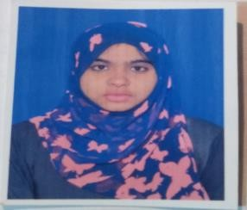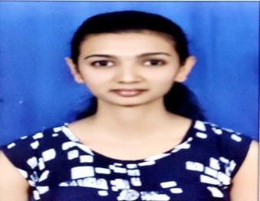

**JAYALAKSHMI N M**

Contact: (Mobile) +91 9108699116 E-mail: [jaya.napanda24@gmail.com](mailto:jaya.napanda24@gmail.com)

# CAREER OBJECTIVE

Hardworking candidate with leadership and organizational skills and seeking to apply my abilities to fill the position in your company. Using my professional skills and efficiency to communicate my ideas and views and commit myself for achieving organizational objectives with the team effort and my positive attitude and performance.

# ACADEMIC QUALIFICATION

|  |  |  |  |
| --- | --- | --- | --- |
| **Course** | **Discipline** | **Institute** | **Year of passing** |
| PG | MBA (HR & FIN) | Vidya Vikas Institute of Engineering &  Technology,Mysore | 2020 |
| UG | BCOM | Govt first grade college, Kushalnagar | 2018 |
| PUC | Commerce(CEBA) | Vivekananda pu college, kushalnagar | 2015 |
| SSLC | SSLC | Jnana bharathi high school, kushalnagar | 2013 |

**PROFESSIONAL SKILLS**

* Microsoft Office (Excel, Power Point, Word)
* Typing
* Tally

# HOBBIES

* Drawing
* Playing badminton

# ABILITIES

* Socially adjustable
* Positive thinking.

# PROJECT

* Internship on Organization study in "ELEPHANTTREE Technology Pvt Ltd" Mysore.
* Project, a study on Employee Welfare Measures with special reference to" SLN Coffee Pvt Ltd" Kushalnagar.

# ACHIEVEMENTS AND CERTIFICATION

* Attended “International conference on dynamic of entrepreneurship”.
* Certified “Domestic data entry operator”.

|  |  |  |
| --- | --- | --- |
| * Participated, workshop agencies”. | on | “Effective project proposal writing skills for funding |
| **PERSONAL DETAILS** |  |  |
| Name : |  | Jayalakshmi N M |
| D.O.B :  Gender :  Nationality :  Address :  Languages Known : |  | 24-02-1998  Female Indian  2nd block , basaweshwar extension mullusoge  Post kushalnagar  English , Kannada. |
| **DECLARATION** |  |  |

# I confirm that the information provided by me is true to the best of my knowledge and belief.

JAYALAKSHMI N M

# Date : Place: