RESUME

Dr. Mohammad Tarique Jamali
Email- mtjamali@gmail.com
jamali_tarique@ yahoo.co.in
jamali2@rediffmail.com,

Mobile No:- +919005240491.

Address:
Near Abdullah Boys Hostel
Opposite CRPF Gate No.3
Bijnour , Lucknow, UP India
PIN-226002
International Passport number- S9848647

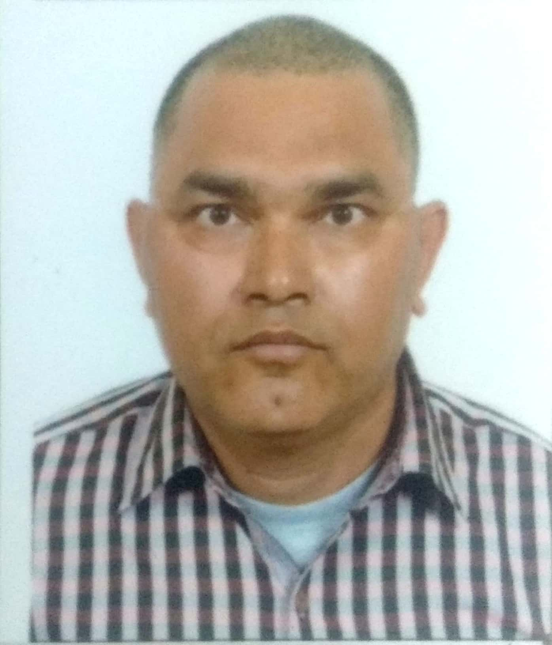

Objective:-To improve the ability of student through motivation, creativeness and give the quality education.
Experience:-
- 14+ yrs. as an Assistant Professor in Mechanical Engineering and Industrial Engineering.
- Worked as a Lecturer (Faculty) in Industrial Engineering in Department of Industrial Engineering in King Khalid University, Abha, Saudi Arabia since 1 March 2014 to 17 August 2019.
- Worked as an Assistant Professor in Azad Institute of Engineering and Technology (UP) India since 11August 2005 to 28 feb2014.
- High impact teaching skills certified by Carnegie and Associate Inc. Trainer and Wipro to increase the learning process of the students.

Field of Specialization:- Industrial and Production Engineering (Mechanical) .

Professional Qualification:-

- Ph.D. Industrial Engineering From UNIVERSITY OF ENTREPRENURESHIP & TECHNOLOGY , USA( IMA-INT-17-19 ADC-271051) 18 August 2020 with 4.0/4.0 marks scale
- Ph.D. Mechanical (Industrial and Production) Perusing From JJ TU, Chedula , Jhunjhnu Rajasthan Since June 2016. (Thesis Submitted) July 19, 2019
- M.Tech. in Mechanical Engineering (Industrial & Production) from AMU Aligarh (U.P) with percentage of 63.33 in 2002.
- B.Sc. Engineering in Mechanical Engineering from AMU Aligarh (U.P) with percentage of 68.20 in 1998 with first division
- Diploma in Drafting & Designing( Mechanical Engineering) on with honors from AMU Aligarh with percentage of 81.00 with first Position in class in 1994

Educational Qualification:-
Qualification | Board/ University | year | % marks | Remarks
Intermediate | UP Board | 1989 | 59.4 | II
High School | UP Board | 1987 | 63.33 | I

B.Sc. (Physics, Chemistry, Mathematics) from Kanpur university in 1989 to1991 (not completed)

Researcher ID Profile)
- Google Scholar ( https://scholar.google.com/citations?user=5towsJEAAAAJ&hl=en)
- Academia (https://kku-sa.academia.edu/JamaliMt)
- Research Gate (https://www.researchgate.net/profile/Mohammad_Jamali8)
- LinkedIn (https://www.linkedin.com/in/jamali-mt-7169aa3a/)

Member- International Book Market Service Ltd. OmniScriptum Publishing Group, LAP LAMBERT Academic Publishing Group, 17 Meldrum Street, Beau Bassin 71504, Mauritius

Member – Member International Society of Automation info@isa.org

67 T.W. Alexander Dr. | Research Triangle Park, NC 27709 | United States

International Society of Automation <isamemberinfo@email.isa.org

Certificate – Member and Reviewer (Reviewer Code: AJR03116) For Advance in Science , Technology and Engineering System Journal( ISSN:2415-6698) In a field of Environmental Engineering, Industrial Engineering , Manufacturing, Mechanical , Operation Research and Management.(www.astesj.com, editor@astej.com)

Certificate- Certified Training of “ Micro FMS Technology –Robotics and CNC” by Festo training program at King Khalid University in Abha , Saudi Arabia From 30th of Oct. to 3rd of Nov. 2016.

Certificate- Certificate in “ Arabic language for non-native speakers” From 01/ 02/2015 to 08/ 04 / 2015 From Kingdom of Saudi Arabia , Ministry of Higher Education, King Khalid University , Deanship of Community Service and Continuing Education.

Certificate- Certificate in “ Certificate course in Yoga and Science of Living “ From 17/7/18 to 5/8/18 Organized by department of Yoga and Natural Health Science in Shree JAGDISHPRASAD JHABERMAL TIBREWALA UNIVERSITY , Vidya Nagari, Jhunjhunu-Churu Road, Chudela , Jhunjhunu (Rajhastan )

Projects: - PhD. Thesis (University of Entrepreneurship & Technology ,USA)
Title: - TO DEVELOP THE ALTERNATE FORMULA FOR PRODUCTION RATE WHEN THE DEGREE OF IMBALANCE IS KNOWN IN UNPACED PRODUCTION LINE.
- To solve the problem of Un-paced Production /Assembly line based on Flexible Manufacturing Process.
- Used Six Sigma Limits to develop alternate formula.
- Formula is applicable when the Computer C programming is fail when workstation is more than 5.
- To calculate easily High and Worst Production rate or any Sequences of Workstation in Production line.
- This formula is help to design or to modify the production rate in Un-paced Production line in Flexible Manufacturing Process
- To develop the Mathematical Modeling and Solution of Un-paced Production Line
- Research is Published with 3 Research Papers See (ISBN 978-620-0-31199-3)(25/ 9 / 2019) } www.lap-publication.com” for more detail see book published portion in this resume

Projects: - M .Tech Dissertation (Aligarh Muslim University, Aligarh India)
Title: The effect of imbalance on the performance of the un-paced production line.
- Problem solving on un-paced production /assembly line
- How effective the assembly line in practical field
- To achieve High production rate through unbalancing
- To satisfy the bowl phenomenon
- To calculate efficiency of the production line
- To develop the mathematical modeling and solution

Mini Project: (Aligarh Muslim University, Aligarh India)
Title: To determine the microscopic structure of the different metal
- To prepare the Specimen for different metal
- To examine the microscopic structure of the different material

B.Sc. Engineering:- Project (Aligarh Muslim University, Aligarh India)
Title:- Optimized Design of Mechanical Elements
- To design the mechanical bearing
- To design the mechanical clutch

Diploma Engineering: - Project (Aligarh Muslim University, Aligarh India)
Title: Design of Screw Jack to uplifting the various machine components up to load of 120 tones
- Drawing and Design of Screw Jack
- Estimation of screw jack cost

Computer Knowledge:-
Fortran, C, CNC Programming, Fundamental of MATLAB, MS Office etc.

Subject proficiency:-
- Manufacturing Science 2- Product Development and Design
- Non- Conventional Energy Resources and Utilization 4- Strength of Material
- Operation Research/Optimization Technique 6- Industrial Engineering
- Automobile Engineering 8- Control System/ System Engineering
- Environmental Engineering 10-Total Quality Control 11- Robotics

Conferences:-
- One National Conference attends in Azad institute of engineering & technology on “Evolving role of Universities”.
- Successfully completed 5 day workshop on high impact teaching skills organized by Wipro mission 10X.
- International Conference attends in King Khalid University “Environmental Engineering” in 2016.
- 5th International Conference attends on “VIBRANT PLATFORM FOR SOCIAL ECONOMIC AND TECHNICAL DEVELOPMENT” In collaboration with Kathmandu University , Nepal Organized by shri Jagdishparsad Jhabermal Tibrewala university , Rajasthan, CSI 19468 (www.jjtu.ac.in) held on 8 September 2019
- National conference attends on “ROLE OF JAINISM TO MAKE PEACEFUL BUILDING AMONG WORLD” Organized by shri Jagdishparsad Jhabermal Tibrewala university , Rajasthan, (www.jjtu.ac.in) held on 27th july 2019
- National conference attends on “EMERGING TRENDS IN CHEMICALS SCINCES(ETCS2019)” Organized by shri Jagdishparsad Jhabermal Tibrewala university , Rajasthan, (www.jjtu.ac.in) held on 28th September 2019
- Workshop attends on “ Scope of Innovation in Engineering & Technology” organized by IIC-GKCEM Kolkata, West Bangal, India ( VW@GKCEM ) held on 11-12 January 2021

Book Publication-
- “Environmental Engineering” ISBN 978-3-330-08664-7 “ www.lap-publication.com” Lap- Lambert Academic publishing, OmniScriptum AraPers GmbH
Bahnhofstraße 28, D-66111 Saarbrücken Germany https://www.lap-publishing.com/

- “To Develop Production rate formula for un-paced production Line” LAP LAMBERT Academic Publishing (2019-04-10 ) “ (ISBN-13: 978-620-0-00015-6 , ISBN-10: 6200000158 , EAN: 9786200000156 ) “ www.lap-publication.com” Lap- Lambert Academic publishing, OmniScriptum AraPers GmbH
Bahnhofstraße 28, D-66111 Saarbrücken Germany https://www.lap-publishing.com/

- “To Develop Production rate formula for un-paced production Line” LAP LAMBERT Academic Publishing { (ISBN 978-620-0-31199-3)(25/ 9 / 2019) } www.lap-publication.com” Lap- Lambert Academic publishing, OmniScriptum AraPers GmbH
Bahnhofstraße 28, D-66111 Saarbrücken Germany https://www.lap-publishing.com/
- “ Design and Develop Production line Rate and Estimated cost of old Car” LAP LAMBERT Academic Publishing (ISBN 978-620-0-43535-4) (3/10/ 2019)
www.lap-publication.com” Lap- Lambert Academic publishing, OmniScriptum AraPers GmbH
Bahnhofstraße 28, D-66111 Saarbrücken Germany https://www.lap-publishing.com/

Patent – 3 (3 Thesis book)
Reviewed Article-
- Dr. Mohammad Tarique Jamali has reviewed the article ID Manuscript ID: 20M-11-1091 with Title: Analysis and Evaluation of Competitiveness in Medical Tourism Industry in Taiwan of Special Issue for Advances in Science, Technology and Engineering Systems Journal. ((ASTESJ) (ISSN: 2415-6698)2 Dec.2020) www.astesj.com
- Dr. Mohammad Tarique Jamali has reviewed the article ID Manuscript ID: 20M-12-1174 with Title- Factors influencing the use of artificial intelligence’s for financial investments services of Special Issue for Advances in Science, Technology and Engineering Systems Journal. ((ASTESJ) (ISSN: 2415-6698)19 Dec.2020) www.astesj.com
- Dr. Mohammad Tarique Jamali has reviewed the article ID 20M-12-1351 with Title A Dynamic Programming Approach for Optimizing an Inexact Rough Interval Investment Problem of Regular Issue for Advances in Science, Technology and Engineering Systems Journal. ((ASTESJ) (ISSN: 2415-6698)15 Jan.2021) www.astesj.com

Research paper publication
- M.T. Jamali, Mohd Ziaulhaq,Dr. A.Suhail, Mohammad Khalid (Jan- Feb. 2015),” The Effect of Imbalance on the Performance of Un-paced Production Line – A Mathematical Modeling Approach” , IOSR Journal of Mechanical and Civil Engineering (IOSR-JMCE), PP 14-19, Volume 12, Issue 1 Ver. I, www.iosrjournals.org
- M.T. Jamali, Mohd. Ziaulhaq,and others (Dec 2013),” Study of process parameters effect on
Surface finish in Al- alloy Sand casting by using Taguchi Method”, IJERT, Vol. 2-Issue 12, www.ijert.org
- M . T. Jamali, Prof. Arif Suhail “The Effect of Imbalance On the Performance Of Un- paced Production line when the optimal bowel known” www. academia.com”
- M .T Jamali , Prof Arif suhail”THE EFFECT OF IMBALANCE ON THE PERFORMANCE OF UN-PACED PRODUCTION LINE WHEN THE OPTIMAL BOWL UNKNOWN” International journal of core Engineering and management ( ISSN 2348-9510 , vol. 3, issue 8, Nov 2016) , www.ijcem.in
- Mohammad Tarique Jamali “Theoretical analysis at electrochemical machining what the current required when we know the Material removal Rate” International journal of current research (ISSN 09575-833X, Volume 09, Issue 01, Page No 44720 -44722 , Jan 2017), www.journalcra.com
- Mohammad Tarique Jamali “Waste management of damaged cars/ auto vehicle whose dumped in the warehouses (open Environment)” International journal of current research (ISSN 0975-833X,Volume 9, Issue5 , page no. 51035-51055, 31May 2017) , www.journalcra.com.
- Mohammad Tarique Jamali “To calculate The dis-assembly rate by using the production rate philosophy of a damaged cars/ auto vehicle whose dumped in the warehouses( A waste management philosophy )” Asian journal of Science and Technology ( ISSN0976-3376 ,Volume 8 Issue 6 pp4922- 4924, 30June 2017) www.journalajst.com.
- Mohammad Tarique Jamali “To estimate The dis-assembly cost and profit / loss occur when of a damaged cars/ auto vehicle components are dumped or reuse after remanufacturing / or not . (waste management philosophy )” Asian journal of Science and Technology (ISSN0976-3376 ,Volume 8 Issue pp 5181-5184 ,31 August 2017) www.journalajst.com.
- Mohammad Tarique Jamali “Utilization of fly ash (Coal ash) generated from thermal power plant in road / bricks through powder metallurgy process – A waste management strategies” International journal of current research (ISSN 0975-833X, Vol. 9 ,Issue 9, Page No. 56990-56991, 29September 2017) www.journalcra.com
- Mohammad Tarique Jamali “How to use the approximate linear system distribution model In Pendulum ocsilator ( system analysis and control design in old clock tower watch). A manually simultion process “International Journal of Development Research ( ISSN-2230-9926 ,Vol 7 Issue 09, PP14948 -14950 , 30Sep.17 ) www.journalijdr.com.
- Mohammad Tarique Jamali , “Development of Device ( Magneto Gravity Settlers Equipment ) To Absorb The Metal Like Fe, Ni , Cr, And Ni-Chrome, Lead And Its Alloy ,And Solid Contents Available In Air /Water ( An Air /Water Cleaning Strategies In Industries Where Machining Occur “IOSR Journal of Mechanical and Civil Engineering (IOSR-JMCE) ( e-ISSN: 2278-1684,p-ISSN: 2320-334X, Volume 15, Issue 5 Ver. III (Sep. - Oct. 2018), PP 70-73) www.iosrjournals.org
doi 10.9790/1684-1505037073.
- Mohammad Tarique Jamali , Abdul Rahaman “ To make artificial ponds ,lakes or canal , as a waste water treatment plants ( Sokhta) To absorbs the waste water to earth “ journal of advanced and scholarly research in allied Education .” ( Vol. 15, Issue11, ISSN: 2230-7540 , 1Nov. 2018 pp 248- 250) www.ignited.in DOI.10.29070/JASRAE .
- 13Mohammad Tarique Jamali , Prof. Dr Abhijeet Chakaraborty “ To find the alternate formula for production rates trends to design for unpaced production line when unbalancing the work loads“ journal of advanced and scholarly research in allied Education .” ( Vol. 15, Issue11, ISSN: 2230-7540 , 1Nov. 2018 pp 244-247) www.ignited.in DOI.10.29070/JASRAE.
- Mohammad Tarique Jamali, Prof. Dr. S N Poonawala “ A study of waste management of damaged car / auto vehicles those dumped in ware houses through production line and develop the formula for production rates and cost estimation “International Journal of Current Research www.journalcra.com (Vol. 11, Issue, 01, pp.339-350, January, 2019 , ISSN: 0975-833X)
DOI: https://doi.org/10.24941/ijcr.33857.01.2019.

- Mohammad Tarique Jamali , Prof. Dr Abhijeet Chakaraborty “To Calculate the Validity of Alternate Formula for Production Rate to Design for Un-Paced Production Line When Unbalancing the Workloads “
Journal of Advances and Scholarly Researches in Allied Education (Vol. 16, Issue No. 1, January-2019, ISSN 2230-7540 PP 24-27) www.ignited.in DOI.10.29070/JASRAE
- Mohammad Tarique Jamali , Prof. Dr Abhijeet Chakaraborty "To Calculate the Alternate Formula for Production Rate When the When the Degree of Imbalance (D) in A Un-Paced Production Line" "Journal of Advances and Scholarly Researches in Allied Education" (Vol. 16, Issue No. 1, January-2019, ISSN 2230-7540 PP 20-23) www.ignited.in DOI.10.29070/JASRAE.
- Mohammad Tarique Jamali, Prof S N Poonawala “A STUDY OF WASTE MANANAGEMENT OF DAMAGED CAR/ AUTO VEHICLE THOSE DUMPED IN WAREHOUSES THROUGH PRODUCTION LINE AND DEVELOP THE FORMULA FOR PRODUCTION RATE AND COST ESTIMATION “International Journal of Current Research (Vol. 11, Issue, 01, pp.339-350, January, 2019)
DOI: https://doi.org/10.24941/ijcr.33857.01.2019.
Available online at http://www.journalcra.com.

Other activities:-
- Former Member of Azad renewable energy resources
- Former Advisor of B.Tech (Mechanical Engineering) student
- Former Member of mission 10X. com
- Former Nodal officer in UPTU Examination Cell
- Lab In-charge and Maintenance Officer

Personal Information:-
Name : Mohammad Tarique Jamali
Date of Birth : 15 January 1972
Father Name : Dr . Mohammad Yousuf Arif
Prmanent Address : S/O Dr. Mohammad Yousuf Arif Vill- Shaikhpur P.O. Kamalganj
Distt . Farrukhabad -Pin: 209724
Nationality : Indian
Sex : Male
Marital Status : Married
Language known : Urdu, Hindi, English

Field of Interest:- Reading Literature, Games, finding new things, Advancing the thinking how the different things occurred etc.

Achievements:-
- scholarship holder at IX class to XII class from Akikirat Chatrwiratee Yojna, UP
- Quiz prize in SS(south ) common room quiz
- Different games prize up to 12th level.

References:
1. Professor (Dr) Abhijit Chakraborty
chakrabortyabhijit100@gmail.com
Global Institute Of Management and Technology, Krishnanagar West Bangal, India

2. Professor Dr. Mohamed A.Abdel-Fattah Mansour
neuoneall@yahoo.com
momansor@kku.edu.sa
Chairman ,
Department of Industrial Engineering , College of Engineering King Khalid University, Abha , Kingdom Of Saudi Arabia.

3. Professor Dr. El Sayed Abdo
dr_elsayed_abdo@yahoo.com
Zigzag University , Egypt.

4.Professor Dr. Mowafak Shakoor
mmshakoor@yahoo.com

Personality:- Positive thinking, not hostile at hard work, ability to do work with team as well as my self.

Date:-
(Mohammad Tarique Jamali)

