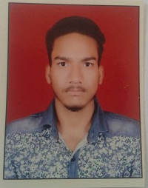 **UID NO-7931-7303-7831**

**Resume**

**MD SHAMEEM** Current Address

G-8/A House No.257/21

Sangam Vihar

New Delhi-110062

**Email:-ssalim.khan009@gmail.com Mobile No:-8860066333**

**Career Objective**

To work in such a challenging environment where apart from getting opportunity to display my skill. It should also enable me to explore my capabilities so that I prove my self-asset to the organization.

**Professional Qualification**

* Basic Computer Course

**Academic Qualifications**

* 10 from C.B.S.E
* 10+2 From CBSE
* Perusing Civil engineering (Diploma)

**Work Experience**

Working in Lab as sample collector cum Computer operator from feb 2019 to till date.

**Personal Information**

Name : Md Shameem

Father’s name : Aziz Ahmad

DOB : 06 May 1998

Religion : Islam

Marital status : Bachelor

Language Known : English, Urdu, Arabic & Hindi

Hobby : Watching TV, Play careme

**Md. Shameem**

**(Signature)**