**Resume RAJARAMAN L**

Room No. 1/235, Subramania Mastry Street, Jazir amma palayam,

Beside IIT, land mark Jeeva Nagar, Salem, Tamil Nadu 636302 India.

9324320502 | rajaramiyer23@yahoo.co.in

CAREER OBJECTIVE

Expand my knowledge and skills

EXPERIENCE EXCEEDING 14 YEARS

**BBCF Pvt. Ltd., (Mumbai, India)**

*01/06/1989 - 30/09/1996*

Oﬃce clerk

Writing despatched, customer subscription ledger, typing reminder, computer receipt preparation, as per

management, receipt acknowledgment for Bond surety form, bidding auction application entry and

franking machine postal/courier ledger written ,despatched,letters,sorting, punching, ﬁling to respective

box ﬁle. Group and series wise plus etc.,

**Perfect international Fzc.(Sharjah), & SJS Enersol LLC, (Ajman)**

*01/01/2007 and 01/01/2012 - 31/12/2007*

*and 31/12/2012*

accounts assistance

Manager for accounts and updated software Navision computer Sundry creditors plus remittance,data

entries, as on contract based, only for two years tasks at U. A. E (I. e. Sharjah and Ajman)

*01/10/1997 -*

**Freelancer, Pavilion&Interiors, SeaWorld Shipping and Logistics Pvt. Ltd**

*31/12/2020*

Computer operator remittance section (neft/rtgs)

Updated Tally software resolved accounts particular customer ledger accounts plus many more

responsible tasks as per Management,Superior and subordinate. Co ordinated

EDUCATION

**Mumbai University**

B.Commerce accounts

Pass

2003

TECHNICAL SKILLS

Typing 50wpm rec'd Government of India certiﬁcate

ACHIEVEMENTS & AWARDS

Certiﬁcates

INDUSTRIAL EXPOSURE

Social volunteer exhibition task

INTERESTS

Cycling

ACTIVITIES

Early morning pooja tasks

PERSONAL STRENGTHS

Diligence

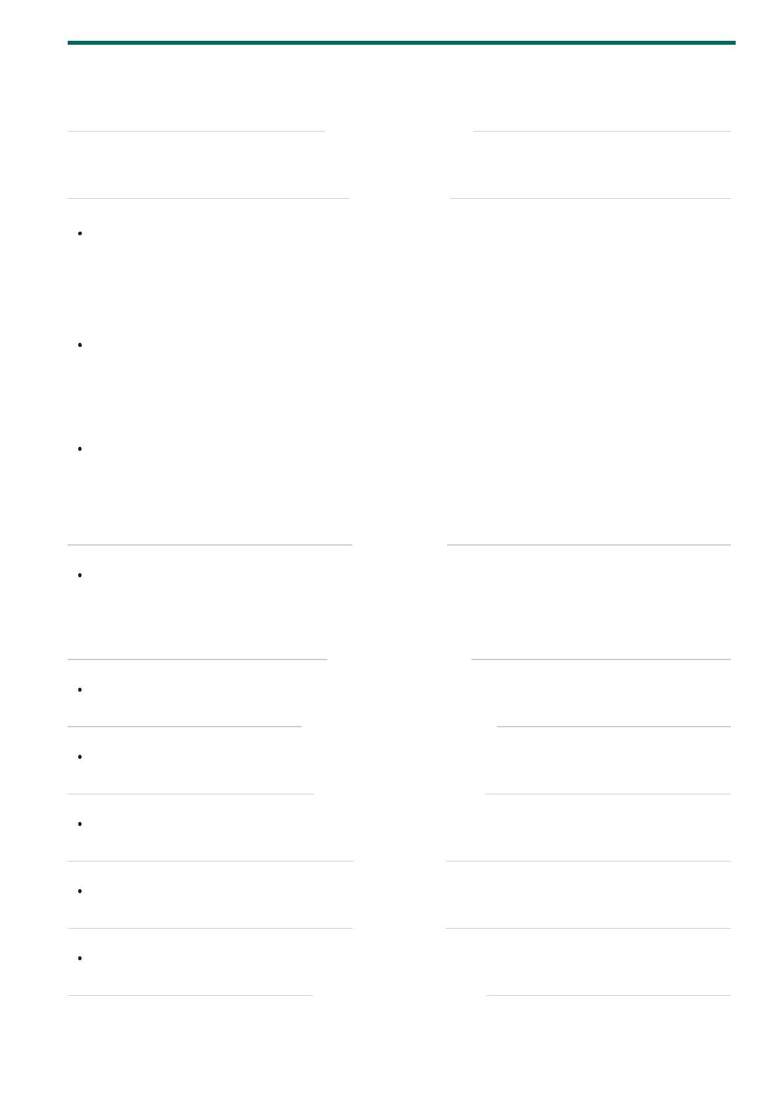

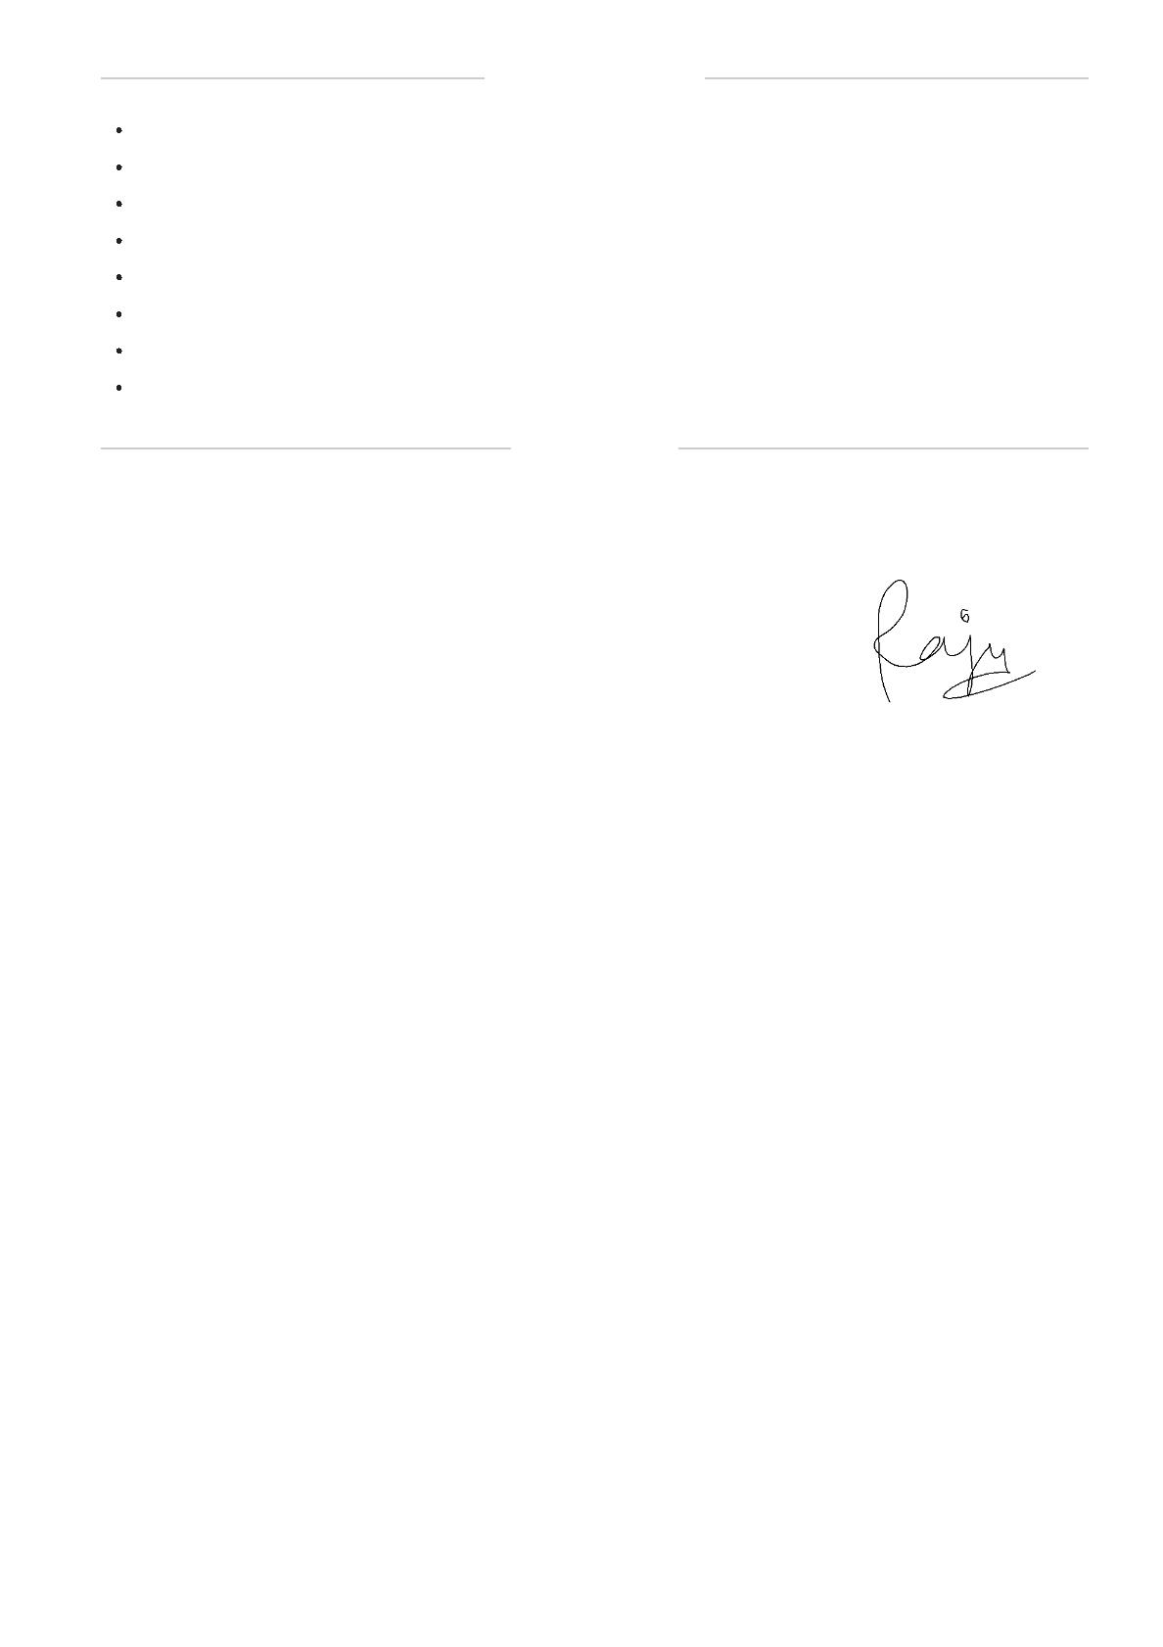

PERSONAL PROFILE

: 12/06/1970

Date of Birth

Marital Status

Nationality

: Married

: Indian

Known Languages

Hobby

: English, Marathi, Hindi and Tamil.

: Magazine Reading

: Z4783631

Passport

Computer Tally and Excel

Back oﬃce executive

: Certiﬁcate

: Above ﬁve years

DECLARATION

I do hereby declare that the above particulars of information and facts stated are true, correct and

complete to the best of my knowledge and belief,

Date : 5th January 2021,

Place : Salem

**RAJARAMAN L**