CURRICULUM VITAE

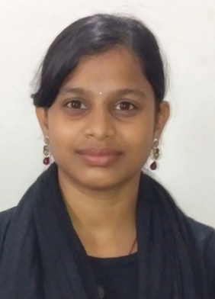
Sagarika Swain
C/O: Late.Bijay Kumar Swain
At- Chandagaon Majurai
Po-Nabapatana
Dist-Jagatsinghpur
Pin- 754103
Tel: 8338846438
E-mail Id: anuska630@gmail.com

Career Objective

To serve the organization with moral with provide my skill and my knowledge professionally contribute towards the growth and development of the organization. As well as personal growth. I have the ability to work under pressure to meet deadline and proof myself as the best among others.

Key Managerial Skills

  - Meeting objectives on time
  - A quick learner with ‘Can do’ attitude
  - Self confidence
  - Adaptability

Educational Qualification

- ContinuseMaster of Arts (Odisha State Open University) from Study in Ravenshwa University.
- Completed +3 Arts (Utkal University) from Alaka Mahavidyalaya, Anantabata, Jagatsinghpur in 2017.
- Completed +2 Arts (C.H.S.E) from Sidhabaranga junior college, Punanga, Jagatsinghpur in 2014.
- Completed 10th (B.S.E, Odisha) from Tarikund High School, Tarikund, Jagatsinghpur in 2010.
Extra Qualification

- PGDCA.
.

Experience

- Computer experience 1 Year in S.S. Software Company, Cuttack.
- Computer experience Four year in Radhakanta Printers, Jagatinsghpur

- Computer experience Six Month in Sri Jagannath Traders,Jagatsinghpur.

- Computer experience Continues in City Xerox College Chhak , Jagatsinghpur.

Hobbies

- Reading News Paper
- Making Friends
- Suffering internet
Personal Vitae

Father’s Name : Late.Bijay Kumar Swain
Date of Birth : 08/06/1995
Sex : Female
Religion : Hinduism
Nationality : Indian
Language Known : English, Hindi & Oriya
Marital Status : Unmarried

Declaration

I do hereby declare that all the information given above are true and correct to the best of my knowledge and belief.

Date :
Place :Jagatsinghpur Signature of the Candidate

