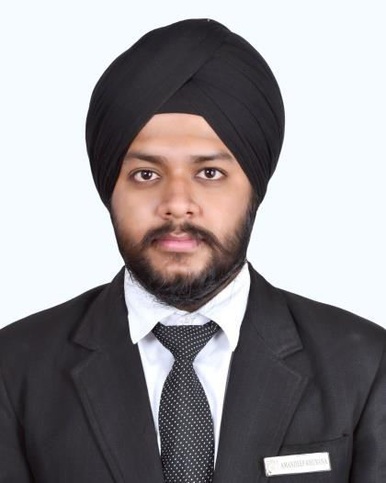Resume

**Name:** Amandeep Singh Khurana

**Current Address:** 132, Raniwala Compound, Civil Lines, Station Road, Kota (Raj.)-324002

**Mobile No:** +918107300733

**OBJECTIVE**

Seeking a deserving profile in the **Service Industry**, where I can deliver my customer relationship skills, while

maintaining the integrity and work ethics of the working environment, thereby maintaining the reputation of the organization.

**EDUCATION**

|  |  |  |
| --- | --- | --- |
| **Particulars** | **School or College** | **Year** |
| Bachelor of Hotel Management | Institute of Hotel Management, Catering and Tourism, Udaipur, Rajasthan | 2018 |
| Class XII | Central Academy Shikshantar, Kota, Rajasthan | 2014 |
| Class X | Central Academy Shikshantar, Kota, Rajasthan | 2012 |

**WORK EXPERIENCE**

|  |  |  |
| --- | --- | --- |
| **Particulars** | **Place** | **Year** |
| Hotel Management | Ramada Resort and Spa, Udaipur (Guest Service Associate) -3 months | 2019 |
| Event Management | Versatile Events, Kota (Field Volunteer Head) | 2018-19 |
| Industrial Training | J.W. Marriott, Chandigarh (General Management)-5 months | 2017 |
| Event Management | The Leela Palace, Udaipur, Rajasthan (Event in Food and Beverage)- 1 month | 2015 |

# ACHIEVEMENTS

|  |  |
| --- | --- |
| **Particulars** | **Year** |
| Appreciation Certificate (Front Office) | 2017 |
| Gold Medal for best photography by IHMC Udaipur | 2016 |
| Gold Medal for Special Appreciation by IHMC Udaipur | 2016 |

**COMPUTER SKILLS**

MS Office with intermediate skills in Excel and PowerPoint

**INTEREST**

Reading Novels, Adventure Like Tracking, Photography, Playing Cricket

**LANGUAGES**

English, Hindi, Punjabi

**Nationality:** Indian  
**Date of Birth:** 17 August 1995

**Marital Status:** Single

**Email:** amankhurana1995@gmail.com

**Skype Id:** amankhurana1995

I hereby declare that everything written in this document are true