**CURRICULUM VITAE**

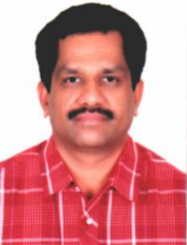

**Baburajan Madhavan Pillai**

**Indian**

**D.O.B: 09-05-1966**

**Email**: pillaimbaburajan@gmail.com

**Mobile**: **0504377318**

**Permanent Address** : Manimandiram, Kottara,

Meeyannoor (Post), Kollam,

Kerala-691537, India

Contact No: 0091 9895200327

**Education** : National Trade Certificate in Electronics

State Board of Technical Education

**WORK EXPERIENCE**

Total 31Years of Experience in Electronics, Telecommunication and Electrical Fields.

1997 - 2012 : A**hmad Haddad Al-Sulamy Est. (Motahdoon (United) Communication)**

Jeddah, K.S.A.

Position: **SENIOR TECHNICIAN** (In charge of Cellular Phones and central telephone

system Maintenance & Programming)

and **Finance controller** of eight Branches.

2012 – 2017 July: **Saudi Oger Ltd.**

Jeddah, K.S.A.

Position: **Engineer Electronics**

In charge of the Electronics workshop activities and supervision of all Electronics related works on sites of the Western Region.

The job includes:

* Repair & Maintenance of Electronics Items
* Calibration
* Coordination with outside workshops
* Purchasing of Spare Parts

2017 July 1st still : **SAFARI Co Ltd**

Jeddah, K.S.A

Position: **Supervisor Electronics**

**Equipment Operated/Installed**

* Television, Videos and VCD
* UPS
* Pneumatic Machines
* Satellite Receiver
* Cellular and Central telephone Phone system

**Instruments Operated**

* Multi Meter - Fluke 5500A Calibrator
* Clamp Meter - Fluke 5500A Calibrator
* Torque Wrench - Micro Controller based Torque Calibrator with 20 to 1000 Nm range.
* Megger - Kyoritsu 3005
* Thermometer - Fluke 51
* Tachometer - Testo 470 (Range Meter 370W Inverter with Motor)
* DB Meter (Field Length Meter Promax Prodig - 5)

Computer Skills - Excellent Knowledge in Hardware and Software.

Also Citrix and Maximo software have good working

experience.

Languages - English, Hindi, Arabic, Urdu, Tamil and Malayalam

Interests - Walking, Reading and Play Games (Chess)