RESUME



MOHAMED SATHAM HUSSAIN.A

ADDRESS FOR

COMMUNICATION

:

55

, Mohamadiyar Street,

B.P.Agraharam, Erode – 638005.

PHONE NUMBER

:

+91 7904094140

.

E-MAIL ID

:

satham.md.a@gmail.com

OBJECTIVE:

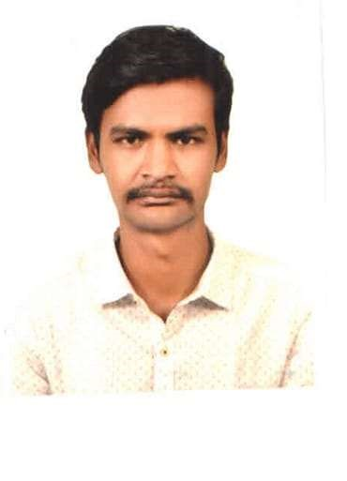

I Will contribute to the success of the company and to secure a challenging position where I can effectively contribute my skills as Professional, Possessing competent Technical Skills. Seeking a challenging environment that encourages continuous learning, creativity and providing exposure to new ideas that stimulate professional and personal growth.

EDUCATIONAL PROFILE:

|  |  |  |  |
| --- | --- | --- | --- |
| COURSE  B.E    HSC | INSTITUTION | % OF MARKS | YEAR OF  COMPLETION |
| Shree Venkateshwara  Hi-Tech Engineering College  Government Higher  Secondary  School,B.P.A.Erode | 8.5 CGPA      68% | 2021    2014 |
| SSLC | Government Higher  Secondary  School,B.P.A.Erode | 86% | 2012 |

AREA OF INTEREST:

* Design Engineer.
* Production Engineer.
* Customer Service.
* Store Operations & inventory management.

SOFTWARE SKILLS:

* Basics of C & C++.
* MS Office.
* SAP Works.
* Basics of ANSYS & AUTO CAD.

WORKED EXPERIENCE:

* Worked as Department Manager (DM) in Reliance Footprint in Erode for 3 years. ➢ Working as Store Manager in PEPE JEANS at Coimbatore till now.

OTHERS:

* Good Communication Strength.
* Problem solving ability.
* Flexibility in work.
* Basket Ball Player (Participated in District Level Competitions).
* Serviced in NSS.

PERSONAL DETAILS:

|  |  |
| --- | --- |
| Father’s Name | : Abuthahir.K.P.M. |
| Date of Birth | : 24.05.1997. |
| Nationality | : Indian. |
| Languages Known | : Tamil and English. |
| Hobbies | : Playing Cricket, Basket Ball and Listening Music. |
| Native | : Erode. |

DECLARATION:

I hereby declare that the Information furnished above are correct up to my knowledge and I bear the responsibility for the correctness of the above-mentioned particles. I will try my level best to satisfy you as well as company.

Date:

Place: [Mohamed Satham Hussain. A]