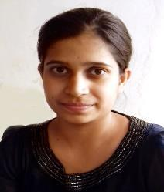

**Curriculum Vitae**

Vrinda

Near Bagga Studio,

Siwan Gate Gate,

Kaithal (HR.)

Cell: +91-94668-29009

mail: vrindavashisht1082@gmail.com

**Carrier Objective:**

➢ Looking for a dynamic industry and top institute to work where I can use

my skills and experience. Want to work with an environment which gives me

knowledge and promotions opportunities, I deserve.

**Academic Qualification:**

➢ Matriculation from HBSE with 76% in 2014.

➢ 12th from HBSE with 70% in 2016.

➢ Pursuing BCA 3rd year from Kurukshetra University Kurukshetra.

**Computer Literacy:**

➢ Basic knowledge of Computer MS Office, Word.

➢ Language C, C++, JAVA.

**Experiences:**

➢ Zeal to get some.

**Strengths:**

➢ Value to ethics.

➢ Energetic and passionate about my work.

➢ Able to work under workload.

➢ Quick learner.

**Hobbies:**

➢ Listening music and dancing.

➢ I always try to improve myself in my work whatever I do.

➢ Reading books.

**Skills:**

➢ Tally functioning.

**Language Known:**

➢ Hindi

➢ English

➢ Punjabi

**About me:**

Full Name:-

Father Name:-

Gender:-

Date of birth:-

Vrinda

Sanjeev Kumar

Female

21th Nov, 2000

Marital Status:- Unmarried

Date: July, 11, 2020

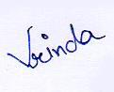 Sign……….………